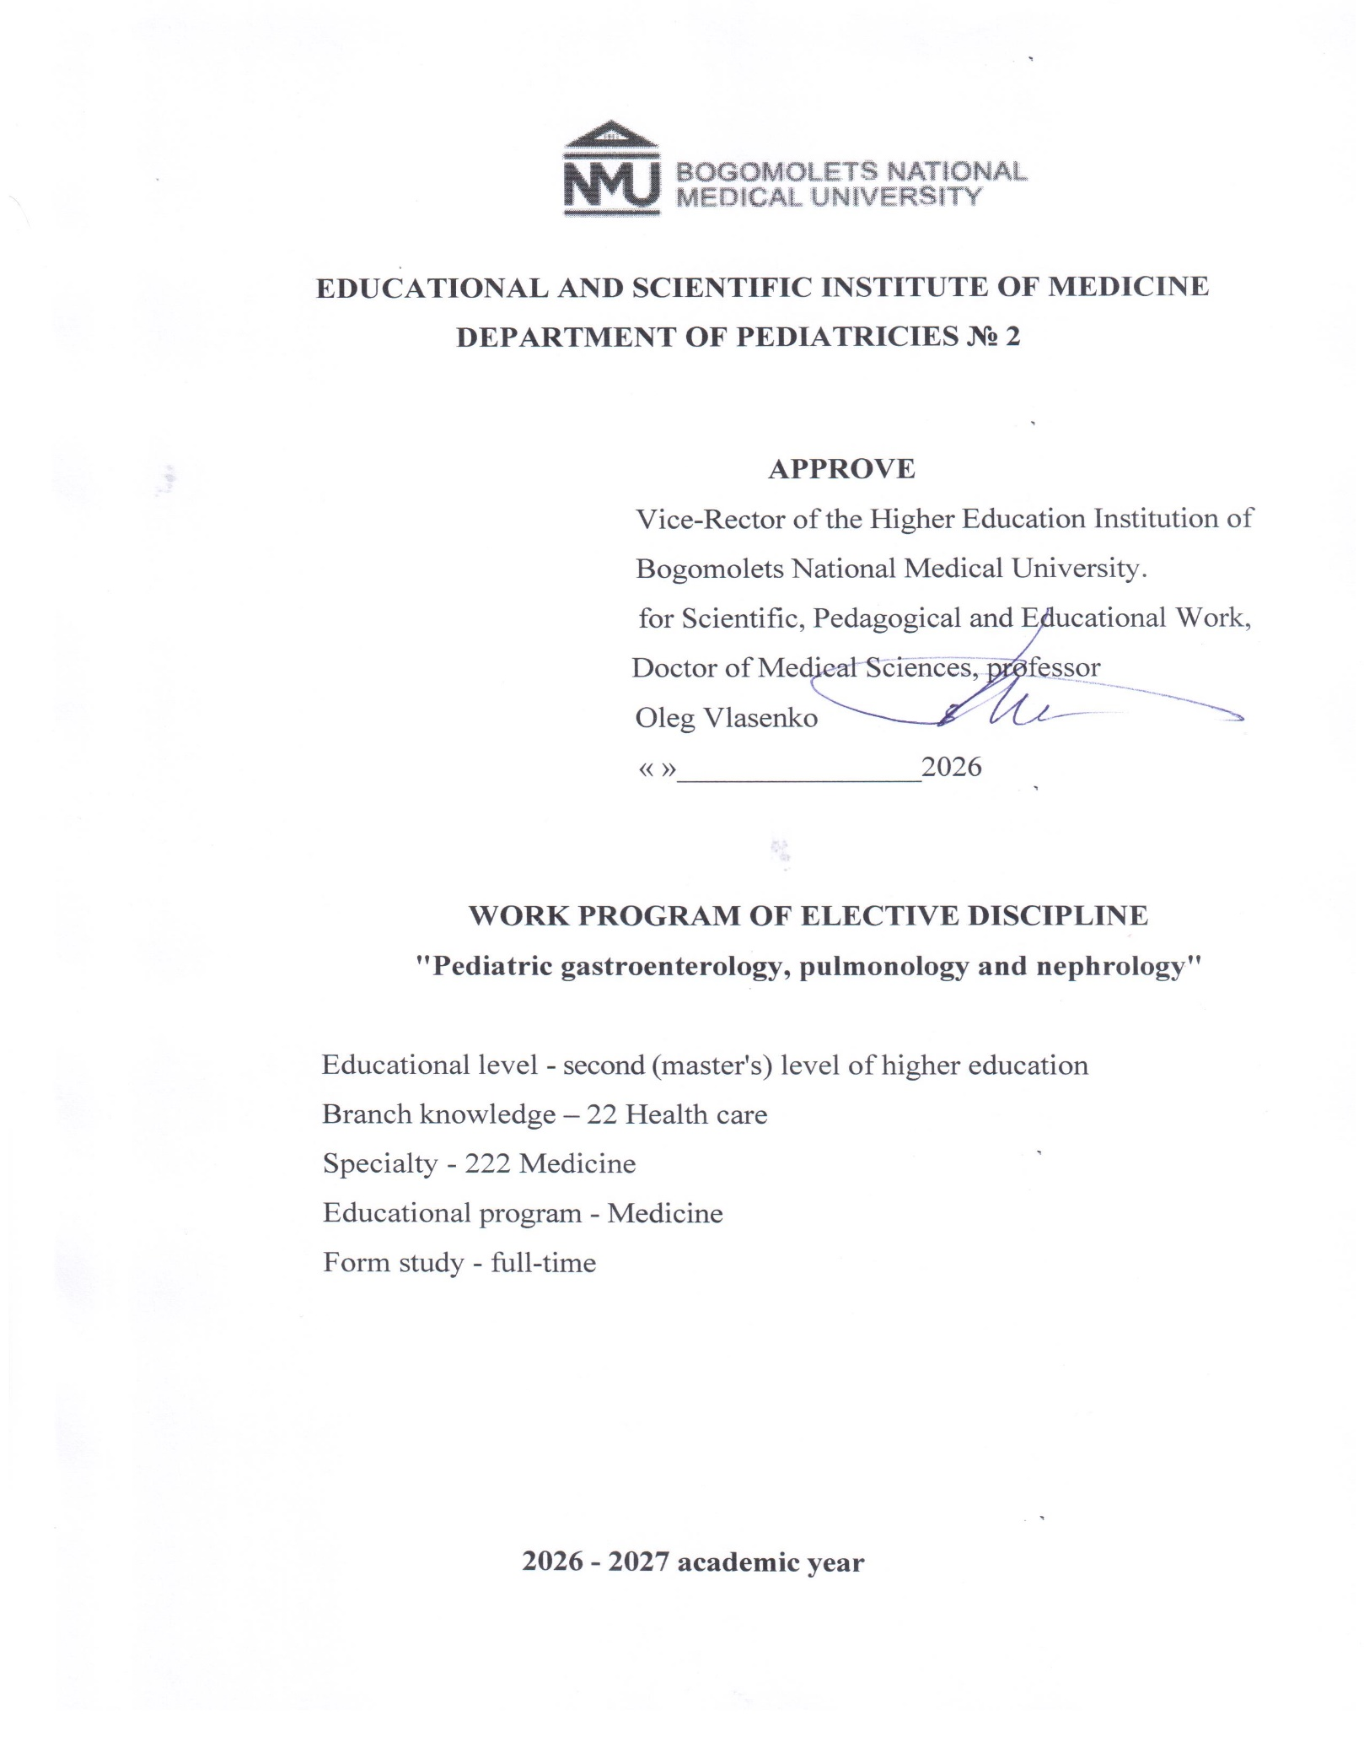

DEVELOPERS
who worked on developing the curriculum for the elective discipline EC 4.5.
"Pediatric Gastroenterology, Pulmonology and Nephrology" for 4th year students of the Educational and Scientific Institute of Medicine, 4th year of study in the field of training specialists second ( master's ) level of higher education education specialty 222 "Medicine":

Berezenko V.S. - Doctor of Medical Sciences, Professor, Head of the Department of Pediatrics No. 1
Volosovets O.P. - Corresponding Member of the National Academy of Medical Sciences of Ukraine, Doctor of Medical Sciences, Professor, Head of the Department of Pediatrics No. 2
Balatska N.I. - Doctor of Medical Sciences, Professor, Professor of the Department of Pediatrics No. 1
Bobrova V.I. - Doctor of Medical Sciences, Professor, Professor of the Department of Pediatrics No. 1
Pochynok T.V. - Doctor of Medical Sciences, Professor, Professor of the Department of Pediatrics No. 1
Kryvopustov S.P. - Doctor of Medical Sciences, Professor , Professor of the Department of Pediatrics No. 2
Mozyrska O.V. - Doctor of Medical Sciences, Professor , Associate Professor of the Department of Pediatrics No. 2
Gorobets N.I. - Candidate of Medical Sciences, Associate Professor, Associate Professor of the Department of Pediatrics No. 1
Horobets A.O. - Candidate of Medical Sciences, Associate Professor, Associate Professor of the Department of Pediatrics No. 1
Levadna L.O. - Candidate of Medical Sciences, Associate Professor, Associate Professor of the Department of Pediatrics No. 1
Cherniy O.F. - Candidate of Medical Sciences, Associate Professor, Associate Professor of the Department of Pediatrics No. 2
Grishchenko N.V. - Candidate of Medical Sciences, Associate Professor, Associate Professor of the Department of Pediatrics No. 2
Karulina Yu.V. - Candidate of Medical Sciences, Associate Professor, Associate Professor of the Department of Pediatrics No. 2

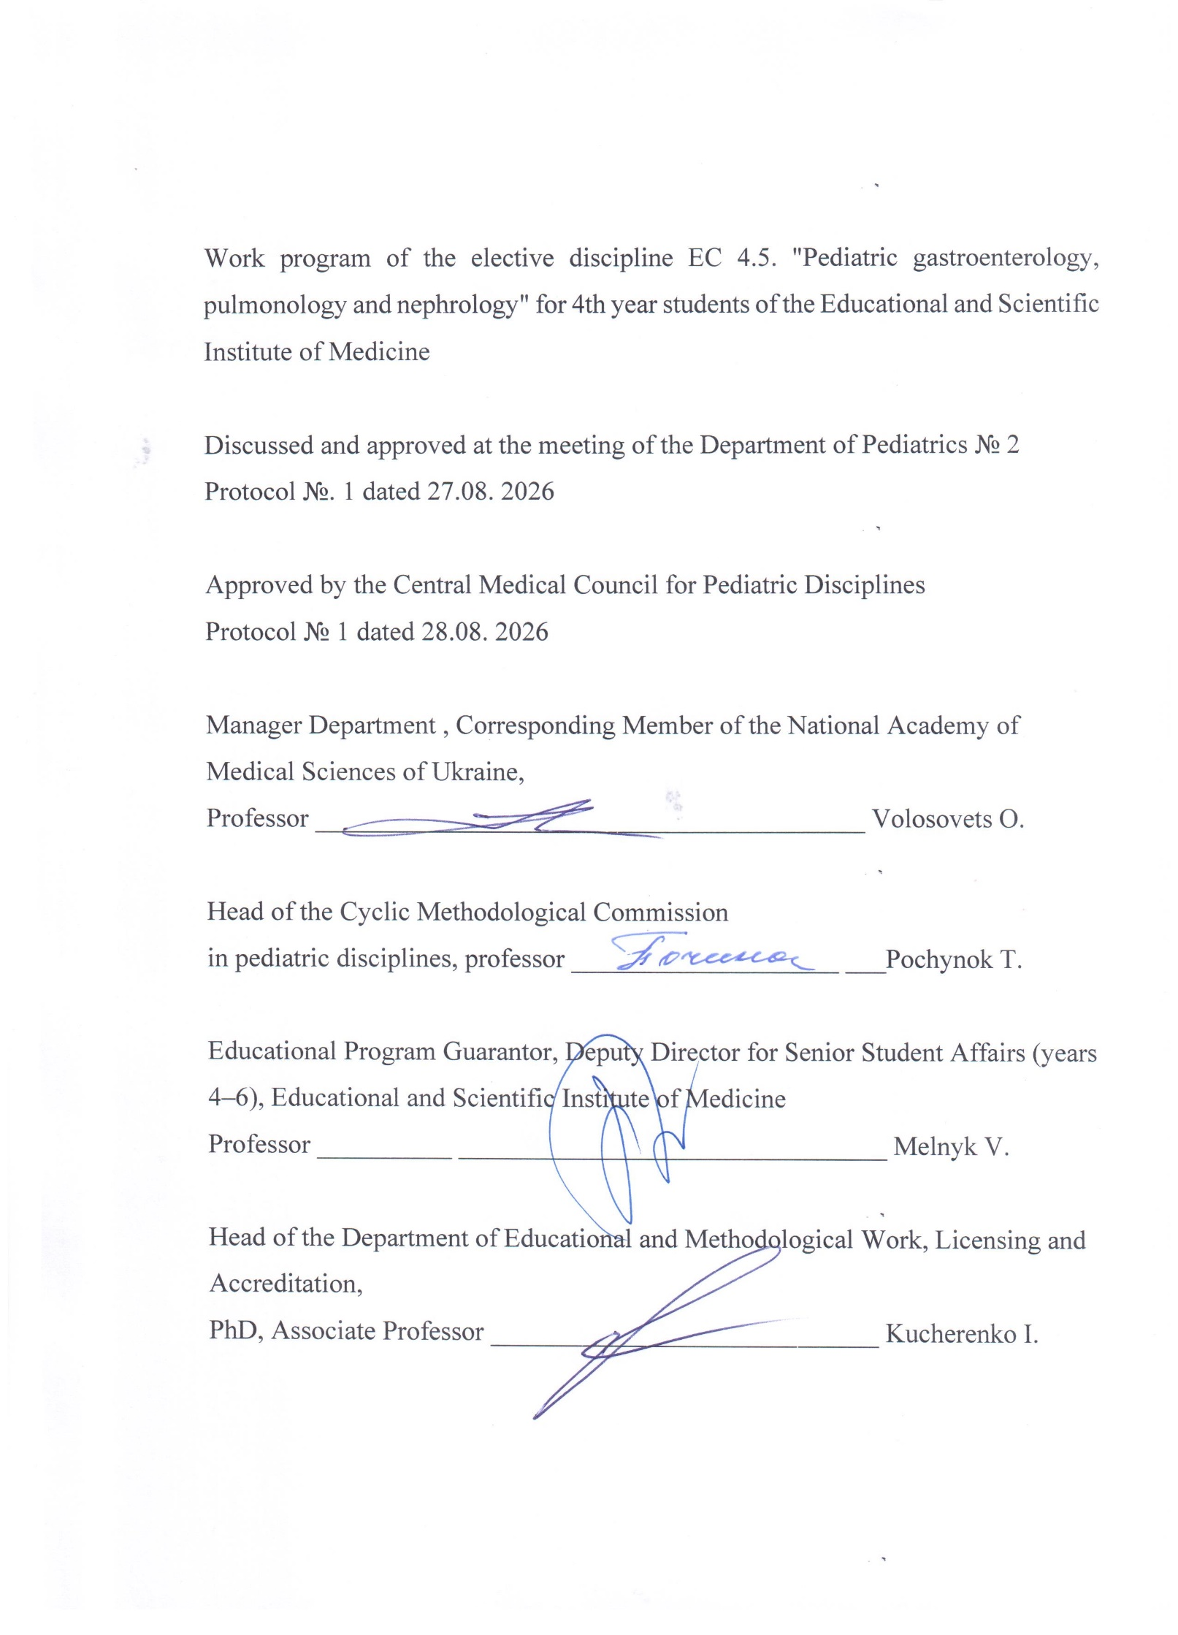

OF ELECTIVE EDUCATIONAL SUBJECT
Name of the discipline: "Pediatric gastroenterology, pulmonology and nephrology"
Code disciplines – EC 4.5
Number loans ECTS – 3 credits
General amount hours - 90 hours
Form control – differentiated credit

PURPOSE, EXPECTED LEARNING OUTCOMES AND CRITERIA FOR ASSESSING RESULTS TEACHING
The purpose of teaching the academic discipline VC 4.5 "Pediatric Gastroenterology, Pulmonology and Nephrology" is: to form the ability to use the acquired general and special professional competencies and achieved program learning outcomes regarding common gastroenterological , pulmonological , and nephrological pathologies in children to solve the professional tasks of a doctor in the field of healthcare.

According to the requirements of the EPP “Medicine”, studying the discipline EC 4.5. “Pediatric Gastroenterology, Pulmonology and Nephrology” ensures that students acquire the following competencies:
- Integral (IC):
Ability to solve complex problems, including those of a research and innovation nature in the field of medicine. Ability to continue learning with a high degree of autonomy .
- General (GC):
GC1. Ability for abstract thinking, analysis and synthesis.
GC2. Ability to learn and master modern knowledge.
GC3. Ability to apply knowledge in practical situations.
GC4. Knowledge and understanding of the subject area and understanding of professional activity.
GC5. Ability to adapt and act in a new situation.
GC6. Ability to make informed decisions.
GC7. Ability to work in a team.
GC8. Ability for interpersonal interaction.
GC10. Ability to use information and communication technologies.
GC 11. Ability to search, process and analyze information from various sources.
GC 12. Determination and persistence in relation to the tasks set and the responsibilities assumed.
GC13. Awareness of equal opportunities and gender issues.
GC 14. Ability to exercise one's rights and responsibilities as a member of society, to realize the values of a civil (free democratic) society and the need for its sustainable development, the rule of law, and the rights and freedoms of man and citizen in Ukraine.
GC 15. The ability to preserve and multiply the moral, cultural, scientific values and achievements of society based on understanding the history and patterns of development of the subject area, its place in the general system of knowledge about nature and society and in the development of society, technology and engineering, to use various types and forms of physical activity for active recreation and leading a healthy lifestyle.
- special (professional, subject) (SC):
SC1. Ability to collect medical information about the patient and analyze clinical data.
SC 2. Ability to determine the necessary list of laboratory and instrumental studies and evaluate their results.
SC 3. Ability to establish a preliminary and clinical diagnosis of the disease.
SC 4. Ability to determine the necessary work and rest regime in the treatment and prevention of diseases.
SC 5. Ability to determine the nature of nutrition in the treatment and prevention of diseases.
SC 6. Ability to determine the principles and nature of treatment and prevention of diseases.
SC 7. Ability to diagnose emergency conditions.
SC 8. Ability to determine tactics and provide emergency medical care.
SC 10. Ability to perform medical manipulations.
SC 13. Ability to carry out sanitary and hygienic and preventive measures.
SC 16. Ability to maintain medical records.
SC 17. Ability to assess the impact of the environment, socio-economic and biological determinants on the health of an individual, family, and population.
SC 21. Clearly and unambiguously communicate one's own knowledge, conclusions, and reasoning on health care problems and related issues to specialists and non-specialists, including students.
SC 24. Adherence to ethical principles when working with patients.
SC 25. Adherence to professional and academic integrity

Programmatic Learning Outcomes (PLO)
PLO 1. Have a thorough knowledge of the structure of professional activity. Be able to carry out professional activities that require updating and integration of knowledge. Be responsible for professional development, the ability to further professional learning with a high level of autonomy.
PLO 2. Understanding and knowledge basic and clinical biomedical sciences, on equal to sufficient for solving professional problems in the field of healthcare.
PLO 3. Specialized conceptual knowledge that includes scientific achievements in the field of health care and is the basis for conducting research, critical understanding problems in the field of medicine and related interdisciplinary problems.
PLO 4. To identify and identify the leading clinical symptoms and syndromes; using standard methods, using preliminary data from the patient's history, patient examination data, knowledge about the person, his organs and systems, to establish a preliminary clinical diagnosis of the disease.
PLO 5. Collect complaints, life and disease history, assess the patient's psychomotor and physical development, the condition of organs and body systems, and based on the results of laboratory and instrumental studies, evaluate information regarding the diagnosis, taking into account the patient's age.
PLO 6. Establish a final clinical diagnosis by making a reasoned decision and analyzing the obtained subjective and objective data of clinical, additional examination, and conducting differential diagnostics, adhering to relevant ethical and legal norms, under control a head physician in a healthcare facility.
PLO 7. To prescribe and analyze additional (mandatory and optional) examination methods (laboratory, functional and/or instrumental) (according to list 4) for patients with diseases of organs and body systems for differential diagnosis of diseases.
PLO 8. Define main clinical syndrome or than conditioned weight state the child by making a reasoned decision and assessing the condition person under any circumstances (in conditions institution security health, by its borders), in conditions of lack of information and limited time.
PLO 9. Determine the nature and principles of treatment of children (conservative, surgical) taking into account age, in the conditions of a healthcare institution, outside it, on basis previous clinical diagnosis, adhering to relevant ethical and legal norms, by making a reasoned decision based on existing algorithms and standard schemes, if necessary, be able to justify the expansion of the standard scheme personalized recommendations under control head physician in conditions medical institutions.
PLO 10. Determine the necessary work, rest, and nutrition regimen based on the final clinical diagnosis, adhering to relevant ethical and legal norms, by making a reasoned decision based on existing algorithms and standard schemes.
PLO 12. Assess the general condition of the newborn child by making an informed decision based on existing algorithms and standard schemes, adhering to relevant ethical and legal norms.
PLO 13. Assess and monitor the child's development, provide recommendations on feeding and nutritional characteristics of children depending on their age, and organize preventive vaccinations according to the calendar.
PLO 14. Determine tactics and provide emergency medical assistance in emergency situations with limited time according to existing clinical protocols and treatment standards.
PLO 17. Perform medical procedures based on a preliminary clinical diagnosis and/or indicators of the patient's condition by making an informed decision, adhering to relevant ethical and legal norms.
PLO 18. Determine the state of functioning and limitations of a person's vital activities and the duration of incapacity for work with the execution of relevant documents, in a healthcare facility based on data on the disease and its course.
PLO 21. Find the necessary information in professional literature and databases of other sources, analyze, evaluate and apply this information.
PLO 24. Organize the necessary level of individual safety (one's own and those in care) in in the event of typical dangerous situations in the individual field of activity.
PLO 25. Of course and definitely inform own knowledge, conclusions and argumentation with problems security health and related issues to specialists and non-specialists.
PLO 27. Communicate fluently in the state language and English, both orally and in writing, to discuss professional activities, research, and projects.
PLO 29. Plan, organize and conduct events from specific prevention infectious diseases, including according to the National Calendar of preventive vaccinations, both mandatory and recommended. Manage vaccine residues, organize additional vaccination campaigns, including immunoprophylaxis measures.

Criteria evaluation results teaching are determined by the Regulations on " The procedure for assessing students' knowledge during current and final control in the discipline at the O.O. Bogomolets National Medical University " (with amendments and additions approved by the Academic Council of the O.O. Bogomolets National Medical University No. 4 dated 11/28/2024).
Assessment of learning outcomes is carried out at each practical session in accordance with specific objectives for each topic, mutually agreed upon 5 ballroom (5 – "perfectly", 4 – "good", 3 – “satisfactory”, 2 – “unsatisfactory”) and a 200-point scale. The grade for the discipline is determined as the sum of the points for the current control and is ranked according to the ECTS scale and the national assessment scale.
Type of control – differentiated credit

ELECTIVE DISCIPLINE PROGRAM
"Pediatric gastroenterology, pulmonology and nephrology"
Content module 1. CHILDREN'S GASTROENTEROLOGY
Topic 1. The most common diseases of the esophagus, stomach and duodenum (DUP) in children ( gastroesophageal reflux disease ) reflux disease ( GERD), cyclic vomiting syndrome (CVS), chronic gastritis, chronic duodenitis). Definition, classification, etiology, pathogenesis, clinical features, diagnostics, treatment, prevention of functional and organic diseases of the esophagus, stomach and duodenum in children: GERD, CVS, chronic gastritis and duodenitis. Laboratory and instrumental diagnostics in gastroenterology.
Topic 2. Gallbladder and pancreas diseases in children ( cholelithiasis (CGL), absolute and relative exocrine pancreatic insufficiency in children). GCH in children. Features of the course, diagnosis and treatment. Absolute and relative exocrine pancreatic insufficiency. Definition, classification, etiology, pathogenesis, clinical features, diagnostics, treatment, prevention
Topic 3. Intestinal diseases in children (functional constipation in children, celiac disease). Definition, classification, etiology, pathogenesis, clinical features, diagnostics, treatment, prevention of functional constipation in children. Definition, classification, etiology, laboratory and instrumental diagnostics of celiac disease.
Topic 4. The most common hereditary liver diseases in children (Wilson's disease - WD, glycogenosis , etc.). Definition, classification, etiology, pathogenesis, diagnosis, treatment, prevention of the most common hereditary liver diseases in children. Typical clinical manifestations of the hepatic form of WD, glycogenosis , etc. Drug treatment of WD. Liver transplantation. Prognosis.
Content module 2. PEDIATRIC PULMONOLOGY
Topic 5. Upper respiratory tract infections in children. Acute infections of the nose, sinuses, throat, or larynx. Etiology, epidemiology, pathogenesis, clinical signs, prognosis, diagnosis, treatment, prevention, and emergency care for complications.
Topic 6. Wheezing syndrome in children. Foreign bodies in the respiratory tract in children. Etiology, pathogenesis, clinical features, diagnostics, treatment, prevention and emergency care for wheezing syndrome in children: episodic viral wheezing ( EVW , episodic viral wheezing ) and multi-trigger wheezing (MTW, multiple trigger wheezing ). Foreign bodies in the respiratory tract in children, emergency care for foreign bodies in the respiratory tract. Organization and provision of medical care at the pre-hospital stage
Topic 7. Complications of pneumonia in children. Definition, classification, etiology pathogenesis, clinical features, diagnostics and prevention of DN . Definition, classification, etiology of infectious and non-infectious (aseptic) pleurisy , pathogenesis, clinical features, diagnostics and prevention of various types of pleurisy. Diagnostic criteria for various types of pleurisy ( clinical, laboratory, radiological). Treatment of various types of pleurisy. Indications for pleural puncture with evacuation of fluid and for surgical treatment.
Topic 8. Cystic fibrosis . Protein-energy malnutrition in children. Definition, classification, etiology pathogenesis, clinical features, diagnostics and prevention of absolute insufficiency of exocrine pancreatic function. Main syndromes of pancreatic damage. Treatment of patients with cystic fibrosis taking into account the leading syndromes. Protein-energy malnutrition (PEM) in children: definition, classification, etiology Pathogenesis, clinical features, diagnostics and prevention of PEM. Treatment of patients with PEM. Fundamentals of diet therapy.
Content module 3. PEDIATRIC NEPHROLOGY
Topic 9. Neurogenic bladder (NB) in children. Dysmetabolic nephropathies in children. Definition, classification, etiology, pathogenesis, clinical features, diagnostics, treatment and prevention of NB in children; differential diagnosis of different types of NB ( hyporeflexor, hyperreflexor, areflexor). Prevention of possible complications of NB ( vesicoureteral reflux of varying degrees, peritonitis, hydronephrosis, arterial hypertension, nephrosclerosis, impaired blood flow in the kidneys and their shrinkage, cystitis, psychological problems). Definition, classification, etiology, pathogenesis, classification, clinical features, diagnostics and prognosis of various dysmetabolic nephropathies in children (primary and secondary; oxalate, phosphate, urate , mixed; preclinical (salt diathesis), clinical ( dysmetabolic nephropathy).
Topic 10. Chronic kidney disease (CKD) in children. Definition, classification, etiology, risk factors, stages of the disease, pathogenesis, clinical features, diagnostics, treatment, prevention, prognosis in chronic renal failure and CKD in children. To draw up an examination plan and analyze data from laboratory and instrumental examinations in CKD in children.

STRUCTURE OF ELECTIVE DISCIPLINE

"Pediatric gastroenterology, pulmonology and nephrology"
 | Topic names | Number of hours
 | Topic names | Total | Lectures |  | Practical exercises |  | CRC
Content module 1. Pediatric gastroenterology
1 | The most common diseases of the esophagus, stomach, and duodenum in children. | 9 |  |  | 3 |  | 6
2 | Diseases of the gallbladder and pancreas in children. | 9 |  |  | 3 |  | 6
3 | Intestinal diseases in children. Functional constipation in children. Celiac disease. | 9 |  |  | 3 |  | 6
4 | The most common hereditary liver diseases in children | 9 |  |  | 3 |  | 6
Content module 2. Pediatric pulmonology
5 | Upper respiratory tract infections in children | 9 |  |  |  | 3 |  | 6
6 | Wheezing syndrome in children. Foreign bodies in the respiratory tract in children . | 9 |  |  |  | 3 |  | 6
7 | Complications of pneumonia in children. | 9 |  |  |  | 3 |  | 6
8 | Cystic fibrosis. PEM. | 9 |  |  |  | 3 |  | 6
Content module 3. Pediatric nephrology
9 | Neurogenic bladder in children. Dysmetabolic nephropathy in children. | 9 |  |  |  | 3 |  | 6
10 | Chronic kidney disease in children. | 9 |  |  |  | 3 |  | 6
Total hours |  | 90 |  |  |  | 30 |  | 60

Control: differentiated assessment.

THEMATIC PLAN OF PRACTICAL CLASSES
No. s/n | Topic name | Number of hours
 | The most common diseases of the esophagus, stomach and duodenum in children | 3
 | Gallbladder and pancreas disease in children | 3
 | Intestinal diseases in children. Functional constipation in children. Celiac disease. | 3
 | The most common hereditary liver diseases in children | 3
 | Upper respiratory tract infections in children | 3
 | Wheezing syndrome in children. Foreign bodies in the respiratory tract in children . | 3
 | Complications of pneumonia in children. Pleurisy in children. | 3
 | Cystic fibrosis. PEM. | 3
 | Neurogenic bladder in children. Dysmetabolic nephropathy in children. | 3
 | Chronic kidney disease in children. | 3
Total from the discipline |  | 30

Student's independent work
No. of the company | Content of the work | Number of hours
 | Preparation for practical classes. Working with patients in a hospital | 60
Total from the discipline |  | 60

Teaching methods
case methods, problem-based learning, simulations, interactives , platform LIKAR_NMU etc.

When studying the elective discipline "Pediatric Gastroenterology, Pulmonology and Nephrology", various teaching methods recommended for higher education are used, namely:
- by sources of knowledge: verbal (explanation, lecture, conversation, discussion); visual (demonstration); practical (practical work, mastering practical skills);
- according to the logic of the educational process: analytical (determination of the general condition of the patient and the main signs of the disease), synthetic (clarification of the relationship between the main signs of diseases, determination of optimal measures for diagnosis, treatment and prevention), their combination - analytical-synthetic, as well as inductive method, and deductive method;
- by the level of independent mental activity: problem-based, partially search-based, research-based.
Combining and generalizing the above teaching methods, when studying the discipline, it is advisable to implement the following methods of organizing training sessions:
- clinical case method,
- problem-oriented method,
- method of individual educational, research and practical tasks,
- competitive group method,
- training technology method,
- "business game" method,
- brainstorming method,
- a method of holding conferences using interactive, interdisciplinary and information and computer technologies.
The types of student learning activities, according to the curriculum, are lectures, practical classes, independent work of students, and completion of individual tasks.
Thematic plans for lectures, practical classes, independent student work, and individual tasks ensure the implementation of all topics included in the program in the educational process.
Practical classes with the organization methodology are clinical, aimed at controlling the assimilation of theoretical material and the formation of practical skills and abilities, as well as the ability to analyze and apply the acquired knowledge to solve practical problems. They include:
- history taking;
- examination of a sick child;
- planning the examination of a sick child;
- interpretation of laboratory and instrumental research data;
- determination of a preliminary clinical diagnosis;
- determination of therapeutic tactics;
- prescribing therapeutic nutrition;
- providing emergency medical care;
- solving situational problems;
- practicing practical skills on dummies and at the bedside of a sick child;
- maintaining medical records.
Independent student work – is performed by the student independently outside of classroom sessions. Possible types of independent student work include: preparation for a practical session, filling out a workbook on the discipline, searching for and studying additional literature, creating algorithms, structural and logical diagrams, writing abstracts, annotations, reports for presentations at practical sessions, and working in the clinic outside of class time under the supervision of a department teacher.

METHODS AND FORMS OF CONTROL, STUDENT ASSESSMENT
When assessing students' knowledge, preference is given to standardized control methods: testing on the LIKAR _ NMU platform , structured written work, work with standard medical documentation, standardized control of practical skills according to the method of execution.
Control methods
Theoretical knowledge:
- computer testing ,​
- individual survey, interview,
- written works structured by content.
Practical skills and abilities:
- control over the implementation of standardized practical skills provided for in the student's practical training plan in the discipline:
- analysis of laboratory and instrumental studies;
- performing medical procedures in pediatrics;
- providing emergency care for children.
Forms of control
Current control Theoretical training and mastery of practical skills is carried out in each practical session in accordance with the specific goals of the topic.
Control of the implementation of independent work , which is provided for in the topic along with classroom work, is carried out during the current control of the topic at the corresponding classroom lesson.
Differentiated assessment involves assessing a student's academic achievements based on the sum of current control grades.

REGULATIONS FOR ASSESSING CURRENT STUDENT PERFORMANCE
Current control is carried out at each practical lesson in accordance with specific goals for each topic, provides for 100% surveying of students in the group, and evaluation of all components of the lesson - test control, control of the implementation of practical skills, solving situational tasks. Written performance of tasks in the process of preparing for the practical lesson is also taken into account.
For each stage of the lesson, the student receives a grade of "5-4-3-2", from which the teacher forms the arithmetic average grade for the lesson, which is converted into points, according to the scale. If the arithmetic average grade is "2", then this corresponds to 0 points. points .
Results of monitoring the level of knowledge of each component of the lesson.
1) The student's readiness for the lesson (initial stage) is checked based on the answers to 10 test questions . In the first practical lesson, these questions are included in the final control.
For correct answers to 9-10 tests, the student receives the traditional grade of "5"; for 7-8 correct answers - a grade of "4", for 5-6 correct answers - a grade of "3", for less than 5 correct answers - a grade of "2".
2) The student's oral interview is evaluated as follows:
- A grade of "5" is given when the student gives comprehensive, accurate and clear answers without any leading questions; presents the material without errors and inaccuracies;
- A grade of "4" is given if the student knows the content of the lesson and understands it well, presents the answers to the questions correctly, consistently and systematically, but they are not exhaustive, although the student answers additional questions without errors;
- A grade of "3" is given to a student based on his knowledge of the main content of the lesson and a satisfactory level of understanding, he gives answers using leading questions, but answers directly posed questions correctly.
- A grade of "2" is given in cases where the student's knowledge does not meet the requirements for a grade of "3 points";
3) Formation of professional competencies.
- A grade of "5" is given if the student demonstrates the ability to analyze and apply the results obtained during the examination of the patient to solve practical tasks, namely: collecting anamnesis, examining the child, planning the examination, interpreting laboratory and instrumental research data; correctly determines the clinical diagnosis in the typical course of the disease; prescribes the correct treatment in full; demonstrates excellent knowledge in providing emergency care.
- A grade of "4" is given if the student demonstrates the ability, with some inaccuracies, to analyze and apply the results obtained during the examination of the patient to solve practical problems; correctly determines the clinical diagnosis in the typical course of the disease; prescribes generally correct treatment, but may make some minor errors that are corrected independently; demonstrates good knowledge of emergency care.
- A grade of "3" is given to a student when he analyzes and applies the obtained results to solve practical problems with individual errors ; determines a clinical diagnosis in a typical course of the disease; prescribes generally correct, but not complete treatment and/or with minor errors; demonstrates satisfactory knowledge of emergency care;
- A grade of "2" is given in cases where the student is unable to make decisions and act in typical clinical situations, is unable to determine a clinical diagnosis, or prescribe the correct treatment.
4) To control the student's mastery of the topic, he is asked to answer the question situational problem .
- A grade of "5" is given when the student correctly and completely solves a complex situational problem and gives comprehensive answers to all the questions asked.
- A grade of "4" is given if the student correctly solves a complex situational problem, but may make individual minor errors that he corrects independently.
- A grade of "3" is given to a student who solves a situational problem with individual errors, experiencing difficulties in simple cases; is unable to independently systematically present the answer.
- A grade of "2" is given if the student has obvious difficulties in solving situational tasks and gives incorrect answers to questions.
Assessment of students' independent work in preparation for classroom practical classes is carried out during the current control of the topic at the corresponding classroom class.
The maximum number of points a student can earn for the current educational activity , is 200 points.
Differentiated assessment is carried out at the last classroom lesson by the teacher of the academic group of students based on the results of current control with the appropriate conversion of the sum of points into a traditional grade and ECTS credits .
To receive differentiated To pass the exam, a student must attend at least 75% of practical classes in the discipline . Classes missed for any reason (including illness ) are mastered by the student independently in extracurricular time . A student who has attended less than 75% (missed more than 25% of classes) of classroom classes is considered to have failed to complete the curriculum and plan for the discipline and therefore must re-study the discipline .

DISTRIBUTION OF POINTS,
which are assigned to students when assessing the discipline
№ | Topic name | Number of points corresponding to the traditional assessment
№ | Topic name | "5" | "4" | "3" | "2"
 | The most common diseases of the esophagus, stomach and duodenum in children | 17-20 | 14-16 | 11-13 | 0
 | Gallbladder and pancreas disease in children | 17-20 | 14-16 | 11-13 | 0
 | Intestinal diseases in children. Functional constipation in children. Celiac disease. | 17-20 | 14-16 | 11-13 | 0
 | The most common hereditary liver diseases in children | 17-20 | 14-16 | 11-13 | 0
 | Upper respiratory tract infections in children | 17-20 | 14-16 | 11-13 | 0
 | Wheezing syndrome in children. Foreign bodies in the respiratory tract in children . | 17-20 | 14-16 | 11-13 | 0
 | Complications of pneumonia in children. Pleurisy in children. | 17-20 | 14-16 | 11-13 | 0
 | Cystic fibrosis . PEM | 17-20 | 14-16 | 11-13 | 0
 | Neurogenic bladder in children. Dysmetabolic nephropathy in children. | 17-20 | 14-16 | 11-13 | 0
 | Chronic kidney disease in children. | 17-20 | 14-16 | 11-13 | 0
Total points for the discipline |  | Maximum – 200  Minimum – 111

Conversion of the number of points from the discipline into grades on the ECTS and four-point (traditional) scales.
Ranking on the ECTS scale with the assignment of grades "A", "B", "C", "D", "E" is carried out as follows:
National scale assessment | Score | ECTS scale assessment | Explanation
Perfectly | 170-200 | A | Excellent (excellent performance with only a few errors)
Good | 155-169 | B | Very good (above average with a few errors)
Good | 140-154 | V | Good (generally correct execution with a certain number of significant errors)
Satisfactorily | 125-139 | D | Satisfactory (with a significant number of shortcomings)
Satisfactorily | 111-124 | E | Sufficient (performance meets minimum criteria)
Unsatisfactorily | 60-110 | FX | Unsatisfactory (with the possibility of reassembly)
Unsatisfactorily | 1-59 | F | Unsatisfactory (with mandatory re-study of the discipline)

Also, the department converts points from the discipline into a traditional four-point scale using absolute criteria as follows:
Discipline points | Rating on a four-point scale
From 170 to 200 points | 5
From 140 to 169 points | 4
From 139 to 111 points | 3
- points and below | 2

Procedure for liquidating academic debt
If a student receives an unsatisfactory grade in a discipline within the range of 60-110 points (FX), he/she has the right to retake it 2 times: once - by the departmental commission with the participation of the head of the department, and the last time - by the commission with the participation of the head of the department and the dean.
Retaking of subjects with unsatisfactory grades is carried out according to the schedule drawn up by the department and agreed with the dean (the interval between attempts or subjects is at least 3 days). Subjects studied in the relevant course must be completed before the beginning of the new academic year. The presence of academic debt before the beginning of the new academic year is grounds for expelling a student from the university for failure to fulfill the requirements of the curriculum (or for issuing an academic leave and retaking the course due to health reasons).
If a student receives an unsatisfactory grade in a discipline within the range of 1-59 points (F), he/she is required to re-study it outside of class time on a paid basis. If a student receives an unsatisfactory grade again as a result of re-studying it, taking into account two retakes of the discipline or unsatisfactory grades in 3 disciplines, as well as missed classroom classes without good reason, the sum of which is 120 hours or more, leads to his/her expulsion from the university for failure to complete the curriculum.

Methodological support
Methodological support for practical classes:
- Methodological developments of practical classes for teachers.
- Methodological instructions for practical classes for students.
- Variants of test questions and tasks to check the initial level of knowledge on each topic.
- Variants of situational tasks to check the mastery of topics.
During practical classes, didactic materials are used materials and teaching aids :
- Treatment algorithms and emergency care (according to evidence-based medicine standards)
- Algorithms for performing practical skills, medical manipulations, videos
- Results of laboratory and instrumental research methods
- Dummies, phantoms, etc.
- Simulators, electronic educational content
Methodological support for students' independent work:
- Methodological guidelines for pre-audit preparation for practical classes.
- Workbook for pre-audit preparation.
- Methodical instructions for performing practical skills.
- Task options for independent work by students.
- Online course on LIKAR_NMU distance learning platform

Tools for diagnosing learning success
The following tools are used to diagnose learning success:
- Format A test tasks
- Structured tasks for written work
- Practical tasks to test mastery of practical skills
- Situational tasks.
The development of test-control questions, the formation of structured tasks for written works, situational tasks for interviews and practical tasks used to diagnose the success of learning are based on a list of questions and practical skills that a student must master when studying the discipline "Pediatric Gastroenterology, Pulmonology and Nephrology". Sets of practical tasks are formed from a list of practical skills that a student must master while studying the discipline, and represent practical work standardized in terms of performance methodology.

INDICATIVE LIST OF PRACTICAL WORKS AND TASKS for students in elective subjects
"Pediatric gastroenterology, pulmonology and nephrology"
- Working with the child and/or the child's parents/guardians.
- Collection of complaints, medical history, and life history.
- Assessment of the general condition of a sick child
- Clinical examination of a sick child according to the organs and systems of the body.
- Establishing a preliminary diagnosis of the disease.
- Appointment and justification of laboratory and/or instrumental examination of the patient.
- Interpretation of laboratory and instrumental research results.
- Establishing a clinical diagnosis, determining the underlying disease, complications of the underlying and concomitant diseases.
- Determine the necessary treatment regimen and diet for a sick child.
- Determine the principles and nature of treatment (conservative, surgical) of diseases.
- Provide emergency care in emergency situations
- Perform medical procedures.
- Determine the tactics of secondary prevention in patients who are subject to dispensary supervision.

LIST OF PRACTICAL SKILLS,
the assimilation of which is monitored during the current control in the discipline "Pediatric Gastroenterology, Pulmonology and Nephrology"
I. Analysis of laboratory and instrumental studies
1. Complete blood count
2. General urine analysis
3. Complete stool analysis
4. Serological reactions in autoimmune diseases
5. Microbiological examination of biological fluids and secretions
6. Urine analysis according to Zimnitsky
7. Urine analysis for diastase
8. Acute phase indicators, blood protein and its fractions
9. Creatinine , blood urea​
10. Blood electrolytes​
11. Blood alkaline phosphatase
1 2 . Rapid tests for viral diseases
13. Study of the function of external respiration
12. ECG
13. Endoscopic examination of the digestive tract
1 4. Echocardiography​
1 5. Radiological examination of the thoracic and abdominal organs cavities , genitourinary system
II. Medical manipulations
- To conduct registration standard 12- lead ECG
- Provide peripheral venous access​
- Measure blood pressure
- In icon indirect heart massage
- In icon artificial respiration
III. Defining the tactics of providing emergency medical care for emergencies in children
  - Dehydration in children
  - Acute respiratory insufficiency
  - Hyperthermic and convulsive syndrome
  - Severe asthma attack (status asthmaticus)
  - Acute urinary retention
  - Bleeding in gastric and duodenal ulcers

POLICY COURSE
Mandatory adherence to academic integrity by students, namely:
- independent performance of all types of work , tasks, and forms of control provided for by the work program of this academic discipline;
- references to sources of information in case of using ideas, developments, statements, information;
- compliance with the norms of legislation on copyright and related rights;
- providing reliable information about the results of one's own educational (scientific) activities, research methods used and sources of information.

Recommended reading
- Maydannik's Pediatrics: a textbook. In 3 books . Book . 1. Diseases of young children, pediatric nephrology, pediatric hematology / academician V. G. Maydannik, prof. I. O. Mityuryaeva -Korniyko, prof. A. V. Churylina , prof. T. P. Borisova, associate professor L. P. Glebova; edited by prof. I. O. Mityuryaeva -Korniyko – Lviv: Publishing house “Magnolia 2006”, 2025. – 484 p. : ill .
- Pediatrics: in 3 volumes: a textbook for students of higher medical educational institutions of the IV level of accreditation / Edited by O. Katilov , A. Varzar , A. Valiulis , D. Dmitriev. - Vinnytsia: Nova Knyga, 2023. - T1 - 656 p., T2 - 712 p.
- Diseases of the stomach and duodenum in children: educational and methodological manual / V.I. Bobrova - Kyiv: Kniga plus, 2024. – 96 p.
- Nelson's Fundamentals of Pediatrics: in 2 volumes. Volume 1 / Karen J. Markdante , Robert M. Kligman ; translation of the 8th English edition. Scientific editors of the translation V.S. Berezenko , T.V. Pochynok. Kyiv: VSV "Medicine", ( 2020) . T1-378p., T2- 426 p.
- Nelson textbook 2 1st Edition by Robert M. Kliegman , MD , Joseph​ St.​ Geme , Nathan J. Blum, Samair S. Shan, Robert C. Tasker, Karen M. Wilson, Richard E. Behrman Publisher: Elsevier, ( 2020 ) . 848 ISBN 978032351145
- Abdulla R, Anderson RH, Backer CL, Berger S, Blom NA, Holzer RJ, Robinson JD (2024) Publisher Springer Cham . 2024. Published : 3059. ISBN978-3-031-07562-9. https://doi.org/10.1007/978-3-031-07563-6
- Bradley JS, Nelson JD; Barnett ED; Cantey JB; Kimberlin DW; Palumbo PE; Sauberan J.; Howard Smart J.; Steinbach William J. ( 2024). Nelson's Pediatric Antimicrobial Therapy . Itasca , IL: American Academy of Pediatrics. Published : : 383. ISBN-13: 978-1-61002-697-0.
- Bunik M .; Hay WW .; Levin MJ .; Abzug MJ . (2022) . CURRENT Diagnosis & Treatment Pediatrics, Twenty-Sixth Edition . Published by McGraw Hill / Medical. 2022. Publisher: 1504. ISBN 10: 1264269986 / ISBN 13: 9781264269983 .
- Francesco E., Stuart L. Goldstein AB, Bates CM, Shroff R., Cham S. (2022). Pediatric Nephrology . 2022. Published : 2134. https://doi.org/10.1007/978-3-030-52719-8. eBook ISBN978-3-030-52719-8. ISBN978-3-030-52718-1.

Guandalini S., Dhawan A. ( 2022) . Textbook of Pediatric Gastroenterology, Hepatology and Nutrition. A Comprehensive Guide to Practice. PublisherSpringer Cham. eBook Packages Medicine , Medicine (R0) . 2022. Edition Number 2. Published : 1095. ISBN978-3-030-80067-3. https://doi.org/10.1007/978-3-030-80068-0.
- Kamat D. 2024. Quick Reference Guide to Pediatric Care . ( 2024). American Academy of Pediatrics, 2010. (2024) . Published : 1323. https://doi.org/ 10.1542/9781610027137. EISBN: 978-1-61002-713-7
- Light M., Van Hook K. Pediatric Pulmonology (2nd ^{Edition} ) By American Academy of Pediatrics Section on Pediatric Pulmonology and Sleep Medicine . 2023 . https://doi.org/10.1542/9781610026536 . ISBN electronic : 978-1-61002-653-6 . ISBN print : 978-1-61002-652-9

Pediatric Clinical Practice Guidelines & Policies, 24th Edition. (2024). American Academy of Pediatrics. Publication Date: May 15, 2024. Published: 1159. https:// doi .org/10.1542/9781610027335; ISBN electronic: 978-1-61002-733-5.
- Rezaei N. Pediatric Allergy . ( 2020). Book SubtitleA Case-Based Collection with MCQs , Volume 1. Springer Cham . 2020. Published : 318 ISBN978-3-030-18284-7. https://doi.org/10.1007/978-3-030-18282-3.

Electronic information resources of the Ministry of Health of Ukraine
- moz.noreply@gmail.com
- https://www.dec.gov.ua/cat_mtd/pediatriya/
- Normative and methodological materials. https://www.dec.gov.ua/cat_mtd/normativni-ta-metodichni-materiali/
- Industry standards and clinical guidelines. https://www.dec.gov.ua/cat_mtd/galuzevi-standarti-ta-klinichni-nastanovi/
- International sources. https://www.dec.gov.ua/cat_mtd/mizhnarodni-dzherela/

