O.O. BOGOMOLETS NATIONAL MEDICAL UNIVERSITY

Educational and Research Institute of Medicine

Department of Pediatrics No 2

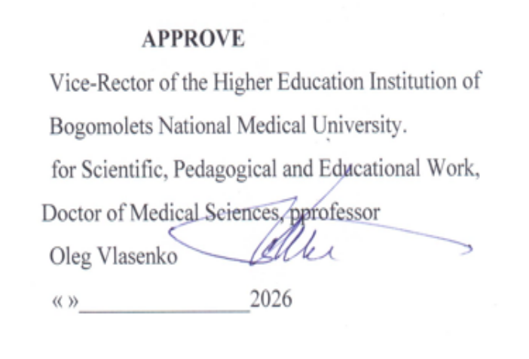

CURRICULUM OF ELECTIVE DISCIPLINE
«BASICS OF HEALTHY CHILD CARE»

Educational level: the second (master's) level of higher education

Field of knowledge: I «Health Care and Social Welfare»
Specialty: I2 "MEDICINE"
Educational program: Educational-professional program "Medicine" of the second (master's) level of higher education in the specialty I2 "Medicine"
Mode of study: Full-time (in-person)

2026–2027 academic year

DEVELOPERS
of the Curriculum for the elective discipline "Basics of Healthy Child Care" for second-year students of the Educational and Research Institute of Medicine, pursuing a degree at the second (master's) level of higher education in the specialty I2 "Medicine":

Volosovets O.P., Corresponding Member of the National Academy of Medical Sciences of Ukraine, Doctor of Medical Sciences, Professor, Head of the Department of Pediatrics No 2
Kryvopustov S. P., Doctor of Medical Sciences, Professor of the Department of Pediatrics No. 2
Chernii O. F., Candidate of Medical Sciences, Associate Professor of the Department of Pediatrics No. 2
Grischenko N.V., Candidate of Medical Sciences, Associate Professor of the Department of Pediatrics No. 2
Saltanova S. D., Candidate of Medical Sciences, Associate Professor of the Department of Pediatrics No. 2

The curriculum for the elective discipline "Basics of Healthy Child Care" for second-year students of the Educational and Research Institute of Medicine, pursuing a degree at the second (master's) level of higher education in the specialty I2 "Medicine"

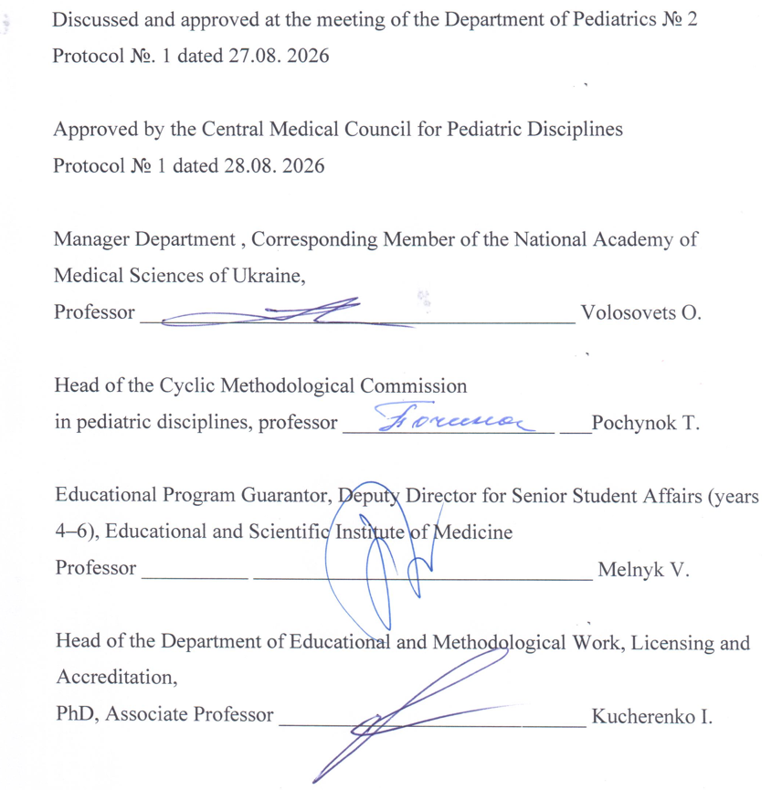

1. DESCRIPTION OF THE DISCIPLINE

Discipline Title: "Basics of Healthy Child Care"
Discipline Code: EC 2.15
Number of ECTS Credits: 3 credits
Total number of hours: 90 hours
Form of discipline assessment: Graded pass/fail

2. PURPOSE, EXPECTED RESULTS AND EVALUATION CRITERIA

The aim of the elective discipline EC 2.15, "Basics of Healthy Child Care" is to develop the ability to apply acquired knowledge, skills, and understanding regarding the care of healthy children of various ages to address typical professional tasks encountered by physicians in the healthcare sector.

Expected learning outcomes: mastery of diverse competencies to achieve the final learning outcomes.
In accordance with the requirements of the Educational and Professional Program "Medicine," the study of the elective discipline EC 2.15 "Basics of Healthy Child Care" enables students to acquire the following competencies:

Integral competence
Ability to solve complex problems, including research and innovation in the field of medicine. Ability to continue learning with a high degree of autonomy.
General Competencies (GC)
GC 1. Ability to abstract thinking, analysis, and synthesis.
GC 2. Ability to learn and master modern knowledge.
GC 3. Ability to apply knowledge in practical situations.
GC 4. Knowledge and understanding of the subject area and understanding of professional activities.
GC 5. Ability to adapt and act in a new situation.
GC 6. Ability to make informed decisions
GC 7. Ability to work in a team.
GC 8. Interpersonal skills.
GC 9. Ability to communicate in a foreign language;
GC 10.Ability to use information and communication technologies.
GC 11.Ability to search, process and analyze information from various sources
GC 12.Certainty and perseverance in relation to the tasks and responsibilities assumed.
GC 13. Awareness of equal opportunities and gender issues.
GC 14. Ability to exercise their rights and responsibilities as a member of society, to realize the values of civil (free democratic) society and the need for its sustainable development, the rule of law, human and civil rights and freedoms in Ukraine.
GC 15. The ability to preserve and multiply moral, cultural, scientific values and achievements of society based on an understanding of the history and patterns of development of the subject area, its place in the general system of knowledge about nature and society and in the development of society, equipment and technology, to use various types and forms of physical activity for active recreation and a healthy lifestyle.
Special (professional, subject) competencies (SC)
SC 1. Ability to collect medical information about the patient and analyze clinical data.
SC 11. Ability to solve medical problems in new or unfamiliar environments with incomplete or limited information, taking into account aspects of social and ethical responsibility.
SC 13.Ability to carry out sanitary, hygienic and preventive measures.
SC 16. Ability to maintain medical records, including electronic forms.
SC 17. Ability to assess the impact of the environment, socio-economic and biological determinants on the health of an individual, family, population.
SC 21. It is clear and ambiguous to convey one's own knowledge, conclusions and arguments on health care problems and related issues to specialists and non-specialists, in particular to students.
SC 24. Compliance with ethical principles when working with patients and laboratory animals.
SC 25. Compliance with professional and academic integrity, be responsible for the reliability of the scientific results obtained
Programmatic Learning Outcomes (PLO)
PLO 1. Have a thorough knowledge of the structure of professional activity. Be able to carry out professional activities that require updating and integration of knowledge. Be responsible for professional development, the ability to further professional training with a high level of autonomy.
PLO 2. Understanding and knowledge of basic and clinical biomedical sciences at a level sufficient to solve professional problems in the field of health care.
PLO 3. Specialized conceptual knowledge that includes scientific achievements in the field of health care and is the basis for research, critical understanding of problems in the field of medicine and related interdisciplinary problems.
PLO 21. Find the necessary information in professional literature and databases and other sources, analyze, evaluate and apply this information.
PLO 22. Apply modern digital technologies, specialized software, statistical methods of data analysis to solve complex health care problems.
PLO 25. Clearly and unambiguously convey your own knowledge, conclusions and arguments on health care problems and related issues to specialists and non-specialists.
PLO 27. Communicate fluently in the state language and English, both orally and
in writing to discuss professional activities, research, and projects.

Criteria for assessing learning outcomes

Assessment of learning outcomes is conducted during every practical session in accordance with specific objectives for each topic; it entails questioning 100% of the students in the group and evaluating all components of the session, including tests, the demonstration of practical skills, the resolution of case-based problems, and written assignments completed in preparation for the practical class.
For each stage of the lesson, the student receives a traditional grade of "5-4-3-2" points, from which the teacher determines the arithmetic mean score, and puts it in the form of a traditional grade, rounding according to mathematical rules 1-4 after the decimal point downwards, 5-9 – upwards.
To receive credit for the course, a student must attend at least 75% of the practical classes and obtain a minimum of 111 points on a 200-point scale.

STRUCTURE OF THE ELECTIVE DISCIPLINE
Topic Name | Number of hours
Topic Name | Just | Lecture | Practical classes | Independent work
 |  |  |  | Self. (preparation for the lesson) | Develo-ping practical skills
Topic 1. Bathing children of different ages. | 9 |  | 2 | 3 | 4
Topic 2. Successful breastfeeding – practical tips. | 9 | 1 | 2 | 3 | 3
Topic 3. How to introduce complementary foods correctly - healthy and tasty. | 9 |  | 2 | 3 | 4
Topic 4. Games with children – age-dependent aspects. | 9 | 1 | 2 | 3 | 3
Topic 5. Child and gadgets – benefits vs risks. | 9 | 1 | 2 | 3 | 3
Topic 6. Hardening of children. | 9 | 1 | 2 | 3 | 3
Topic 7. Prevention of childhood injuries. | 9 |  | 2 | 3 | 4
Topic 8. Vaccination – protection against infections. | 9 |  | 2 | 3 | 4
Topic 9. Child's readiness for school. | 9 | 1 | 2 | 3 | 3
Topic 10. Teenagers – features of relationships and communication. | 9 | 1 | 2 | 3 | 3
TOTALLY | 90 | 6 | 20 | 30 | 34
 |  |  |  | 64

ELECTIVE DISCIPLINE THEMATIC PLAN

Topic 1. Bathing children of different ages
The use of water procedures as an integral part of the formation of the child's health. Rules for carrying out hygienic water procedures (washing, showering, hygienic bath (bathing), washing) for children of different ages.
Topic 2. Successful breastfeeding – practical tips
Breastfeeding as a guarantee of the child's health, positive psycho-emotional state of the mother and effective prevention of malignant neoplasms of the mammary glands, uterus and ovaries of a nursing woman. Rules of breastfeeding.
Topic 3. How to introduce complementary foods correctly - healthy and tasty
Complementary foods: introducing the baby to new tastes (products) and enriching his diet. Timely introduction of complementary foods as a tool for the optimal development of all systems and organs of the child. Rules for introducing complementary foods to children in the first year of life.
Topic 4. Games with children – age-dependent aspects
Play as a source of joy, a means of learning and personality formation. Active and educational games for children of different ages. Safety rules for children's games.
Topic 5. Child and gadgets – benefits vs risks
The role of gadgets in expanding the possibility of obtaining new knowledge, online education, stimulating the development of intelligence, logic, orientation in space, etc. The negative impact of computers, tablets, smartphones, etc., on the child's health. Rules for using gadgets for children of different ages. Prevention of Internet addiction.
Topic 6. Hardening children
Hardening of the child as a means of improving the resistance of the child's body to environmental factors, improving health and preventing many diseases. Methods, types and principles of hardening children of different ages.
Topic 7. Prevention of childhood injuries
Children's injuries: types, causes, preventive measures. Basics of safe behavior of a child in natural disasters and emergencies.
Topic 8. Vaccination – protection against infections
Vaccination as a simple, safe and effective way to protect a child from diseases before he meets their pathogen. Preparation and rules for preventive vaccinations in children.
Topic 9. Child's readiness for school
Criteria for a child's readiness for school: physiological, emotional, social, intellectual. Developmental exercises as a method of preparing a child for school.
Topic 10. Teenagers – features of relationships and communication
The boundaries of adolescence and its characteristics. A teenager's relationships with peers and adults.

Thematic lecture plan
Salary No. | Lecture Title | Number of hours
1 | Principles of effective feeding for infants in their first year of life | 1
2 | Developmental games with children as a method of strengthening the key components of health | 1
3 | Rational use of gadgets by children of different ages | 1
4 | Age-related aspects of key methods for hardening children. Prevention of childhood injuries | 1
5 | Criteria for a child's school readiness. Prevention of the most common childhood infectious diseases | 1
6 | Physiological aspects of a child's maturation during adolescence | 1
TOTALLY |  | 6

Topics of practical classes

Salary No. | Topic Name | Number of hours
1 | Bathing children of different ages. | 2
2 | Successful breastfeeding – practical advice. | 2
3 | How to introduce complementary foods properly - healthy and tasty. | 2
4 | Games with children – age-dependent aspects. | 2
5 | Child and gadgets – benefits vs risks. | 2
6 | Hardening of children. | 2
7 | Prevention of childhood injuries. | 2
8 | Vaccination – protection against infections. | 2
9 | Child's readiness for school. | 2
10 | Teenagers – features of relationships and communication. | 2
TOTALLY |  | 20

Independent work

Salary No. | Content of the work | Number of hours
1 | Preparation for practical classes. | 30
2 | Development of practical skills (simulation training). | 34
TOTALLY |  | 64

METHODS AND TYPES OF TRAINING
Teaching methods
When studying an elective discipline, the varieties of teaching methods recommended for higher education are used, namely:
• by sources of knowledge: verbal (explanation, lecture, conversation, discussion), visual (demonstration), practical (practical work, mastering practical skills);
• according to the logic of the educational process: analytical, synthetic, their combination – analytical-synthetic, as well as inductive method, deductive, their combination;
• by the level of independent mental activity: problem-based, partially-searching, exploratory.
Combining and summarizing the above teaching methods, when studying the discipline, it is advisable to introduce such methods of organizing training sessions as:
• method of clinical cases;
• problem-oriented method;
• method of individual educational, research and practical tasks;
• "business game" method;
• Brainstorming method.
Forms of education
• oral discussion of the issues of the topic with the involvement of the majority of students in the group;
• discussions on problem situations;
• work with patients and their parents (legal representatives);
•testing.
- Blitz surveys.
Types of training according to the curriculum:
• practical classes;
• independent work of students.
Practical classes
According to the methodology of organization, they are clinical, aimed at controlling the assimilation of theoretical material and the formation of practical skills and abilities, as well as the ability to analyze and apply the knowledge gained to solve practical problems.
The duration of one practical lesson is 2 academic hours.
Student's independent work
It is performed by the student independently outside the classroom and includes preparation for a practical lesson, search and study of additional literature, development of practical skills.
METHODS AND FORMS OF CONTROL
Theoretical knowledge:
•testing;
• individual survey, interview;
• structured written works.
Practical skills and abilities:
• performing water procedures for children of different ages;
• ability to explain information about the benefits of breastfeeding;
• ability to explain the rules for introducing complementary foods to children in the first year of life;
• ability to identify/choose games appropriate for the child's age;
• rules for using gadgets by children of different ages;
• carrying out various types of hardening;
• demonstration of measures to prevent child injuries;
• ability to convey information about vaccination, preparation and rules for preventive vaccinations in children;
• methods for assessing a child's readiness for school;
• understanding and ability to convey information about the peculiarities of adolescence.
The form of final assessment is graded credit
It is given at the last classroom lesson by the teacher of the academic group to the student based on the results of his studies as the sum of points on a 200-point scale with the appropriate conversion on the traditional scale.

REGULATION ON CONTINUOUS ASSESSMENT

Ongoing student assessment is conducted during every practical class in accordance with the specific objectives of each topic.
A grade of "5" is awarded if the student provides exhaustively accurate and clear answers without any additional questions; answers the material without errors and inaccuracies; performs the skills proposed for study without mistakes and under different conditions, correct answers in tests 90% - 100%
A grade "4" is given on the condition that the student knows the content of the lesson and understands it well, answers the questions correctly, consistently and systematically, but they are not exhaustive, although the student answers additional questions without errors; performs the skills proposed for study according to standard conditions, makes mistakes when there are changes in the situation, but can correct themselves when asking additional questions, the correct answers in tests are 75%-89%
A grade "3" is given to the student on the basis of his knowledge of the main content of the lesson and at a satisfactory level of his understanding, gives answers with the help of leading questions, but answers directly asked questions correctly. Not able to fully perform practical skills, but in the presence of corrective actions of the teacher, successfully overcomes practical tasks, correct answers in tests are not less than 60%-74%
A grade "2" is given in cases where the student's knowledge does not meet the requirements of the grade "3 points"; in the test control, the correct answers are 59% or less,

Distribution of points, assessment:
Current assessment of students on the relevant topics is carried out at each practical lesson in accordance with specific goals on each topic according to the traditional 4-point system (excellent, good, satisfactory, unsatisfactory) with subsequent recalculation into a multi-point scale.
Salary No. | Topic Name | Number of points corresponding to the traditional assessment
Salary No. | Topic Name | «5» | «4» | «3» | «2»
1 | Bathing children of different ages. | 20 | 16 | 12 | 0
2 | Successful breastfeeding – practical advice. | 20 | 16 | 12 | 0
3 | How to introduce complementary foods properly - healthy and tasty. | 20 | 16 | 12 | 0
4 | Games with children – age-dependent aspects. | 20 | 16 | 12 | 0
5 | Child and gadgets – benefits vs risks. | 20 | 16 | 12 | 0
6 | Hardening of children. | 20 | 16 | 12 | 0
7 | Prevention of childhood injuries. | 20 | 16 | 12 | 0
8 | Vaccination – protection against infections. | 20 | 16 | 12 | 0
9 | Child's readiness for school. | 20 | 16 | 12 | 0
10 | Teenagers – features of relationships and communication. | 20 | 16 | 12 | 0
Total Discipline Points |  | The maximal score is 200 points
 |  | The minimal score is 111 points

Converting the number of points from a discipline into grades
on ECTS scales and four-point (traditional)
Discipline scores are independently converted into both the ECTS scale and the four-point scale. Ranking on the ECTS scale with the assignment of grades "A", "B", "C", "D", "E" is carried out as follows:
Score  in Points | Score  according to the traditional  Scale | Score | Score  according to the ECTS scale
170–200 | Perfectly | A | Excellent (excellent performance with only a negligible number of errors)
155–169 | Good | B | Very good (above average with a few soaps)
140–154 | Good | C | Good (generally correct execution with a certain number of significant errors)
125–139 | Satisfactory | D | Satisfactory (not bad, but with a significant number of flaws)
111–124 | Satisfactory | E | Sufficient (fulfillment satisfies minimum criteria)
60–-11 0 | Unsatisfac-tory | FX | Unsatisfactory (reassembling)
1-59 | Unsatisfac-tory | F | Unsatisfactory (with mandatory re-study of the discipline)

Course Policy:
mandatory observance of academic integrity by students, namely:
- independent performance of all types of work, tasks, forms of control provided for by the work program of the discipline;
- references to sources of information in the case of using ideas, developments, statements, information;
- compliance with the legislation on copyright and related rights;
- providing reliable information about the results of educational (scientific, creative) activities, research methods used and sources of information.

METHODOLOGICAL SUPPORT

1. Online course on the LIKAR_NMU distance learning platform
2. Video recordings of lectures
3. Methodological recommendations for practical classes
4. Methodological guidelines for independent student work
5. Test assignments for ongoing knowledge assessment
6. Case-based tasks to verify comprehension of topics
7. Practical tasks to assess mastery of practical skills

RECOMMENDED LITERATURE and INFORMATION RESOURSES
1. Nelson Textbook of Pediatrics, 2-Volume set, 22-nd edition. By Robert M. Kliegman, Bonita M.D. Stanton, Joseph St. Geme and Nina F Schor. – Philadelphia, PA : Elsevier Inc., 2024 - 4472 p. ISBN-10‏ :‎ 032352950X ISBN-13 :‎ 978-0323529501
2. Skin Care for Infants: Best Practices and Common Concerns https://www.alliedacademies.org/articles/skin-care-for-infants-best-practices-and-common-concerns-32266.html
3. World Health Organization’s Breastfeeding Guide 2022 https://resourcecentre.savethechildren.net/document/world-health-organizations-breastfeeding-guide
4. WHO/UNICEF BABY-FRIENDLY Initiative Staff Manual
https://www.babyfreundlich.org/fileadmin/BFHI/Dokumente/Fachinformationen/leitfaden-mitarbeitende/Leitfaden_f%C3%BCr_Mitarbeitende_uk.pdf
5. ABM protocols. https://www.bfmed.org/protocols
6. WHO Guideline for complementary feeding of infants and young children 6-23 months of age. https://www.who.int/publications/i/item/9789240081864
7. World Health Organization (WHO) guideline on the complementary feeding of infants and young children aged 6−23 months 2023: A multisociety response. ESPGHAN Position Statement. DOI: 10.1002/jpn3.12248
8. Brain-Building Through Play: Activities for Infants, Toddlers, and Children. Center on the Developing Child Harward University. https://developingchild.harvard.edu/resources/handouts-tools/brainbuildingthroughplay/
9. 10 playful activities for children with disabilities https://www.unicef.org/parenting/child-care/10-playful-educational-activities-children-disabilities
10. Best Montessori Developmental Toys by Activity: 2026 Guide

https://wonderkidstoy.com/blogs/news/unlock-your-childs-potential-the-best-montessori-and-developmental-toys-for-early-learning?srsltid=AU7gw4U0Jau2p3p790HNyELZyYd1OO0vsoIMoTAnVqryJ1Q6BK9adPM-

11. Zain, Z. M., Jasmani, F. N., Haris, N. H., & Nurudin, S. M. (2022). Gadgets and Their Impact on Child Development. Proceedings, 82(1), 6. https://doi.org/10.3390/proceedings2022082006

12. Muppalla SK, Vuppalapati S, Reddy Pulliahgaru A, Sreenivasulu H. Effects of Excessive Screen Time on Child Development: An Updated Review and Strategies for Management. Cureus. 2023 Jun 18;15(6):e40608. doi: 10.7759/cureus.40608.

13. Child and adolescent injuries. UNICEF. https://www.unicef.org/health/injuries

14. 10 Common Childhood Accidents and How to Avoid Them in Your Home

https://www.nationalfosteringgroup.co.uk/news-and-blog/10-common-childhood-accidents-and-how-to-avoid-them-in-your-home/

15. Vaccines and immunization https://www.who.int/health-topics/vaccines-and-immunization#tab=tab_1

16. Vaccines, thiomersal and autism spectrum disorder: evidence review 2010-2025 https://www.who.int/publications/i/item/9789240123533

17. Six Ways to Support Early Childhood Mental Health. American Montessory Society. https://amshq.org/blog/uncategorized/2022-11-04-6-ways-to-support-early-childhood-mental-health/

18. Bassok D, Latham S; EdPolicyWorks. Kids today: changes in school-readiness in an early childhood era. https://education.virginia.edu/documents/epw35kids-today2016-02pdf

19. Teens: communicating & relationships https://raisingchildren.net.au/teens/communicating-relationships

20. Parent guide to talking about sex: 9-11 years https://raisingchildren.net.au/pre-teens/development/puberty-sexual-development/sex-education

21. Menstrual health https://www.who.int/news-room/fact-sheets/detail/menstrual-health

A Teenager’s Nutritional Needs https://www.healthychildren.org/English/ages-stages/teen/nutrition/Pages/A-Teenagers-Nutritional-Needs.aspx

22. HEEADSSS Assessment – OSCE Guide

https://geekymedics.com/heeadsss-assessment-osce-guide/
23. Kiselova M, Antipkin Y, Volosovets O, Rubin BK. (2026). Children Are Victims in the War on Ukraine. Pediatric Clinics of North America. Available online 28 July 2026 https://doi.org/10.1016/j.pcl.2026.05.007

