BOGOMOLETS NATIONAL MEDICAL UNIVERSITY

Educational and Scientific Institute of Medicine

Pediatrics Department No 2

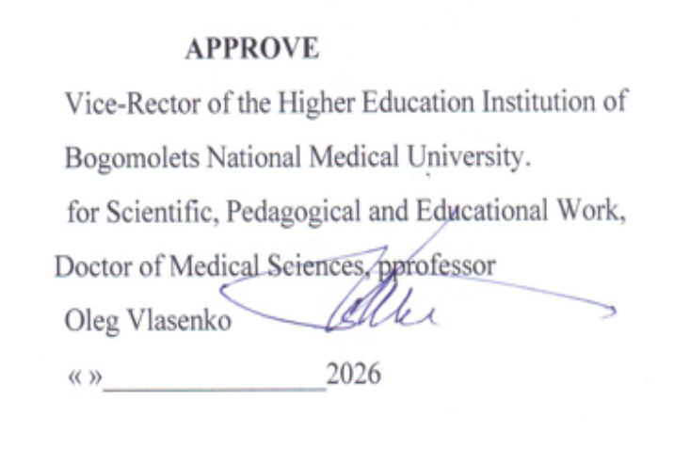

WORKING PROGRAMME OF THE ELECTIVE ACADEMIC DISCIPLINE
“Fundamentals of Communication with Children”
Level of higher education – second (Master’s) level of higher education
Field of study – I Healthcare and Social Welfare
Specialty – I2 Medicine
Educational programme – Medicine
Mode of study – full-time

2026 - 2027

AUTHORING TEAM
that developed the working programme of the elective academic discipline “Fundamentals of Communication with Children” for first-year students of the Educational and Scientific Institute of Medicine.
Oleksandr Volosovets – Head of the Department of Pediatrics No. 2, Corresponding Member of the National Academy of Medical Sciences of Ukraine, Doctor of Medical Sciences, Professor
Olena Mozyrska – Associate Professor of the Department of Pediatrics No. 2, Doctor of Medical Sciences, Professor
Oksana Yemets – Associate Professor of the Department of Pediatrics No. 2, Candidate of Medical Sciences, Associate Professor
Mariia Kryvopustova – Associate Professor of the Department of Pediatrics No. 2, PhD, Associate Professor

The working programme of the elective academic discipline “Fundamentals of Communication with Children” for first-year students of the Educational and Scientific Institute of Medicine.
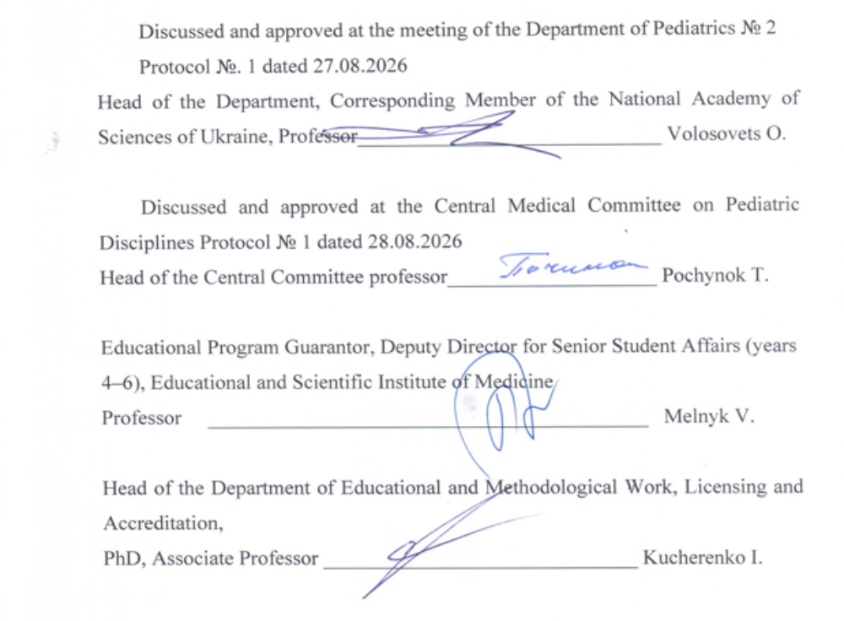

Description of the Elective Academic Discipline “Fundamentals of Communication with Children”
Discipline code – EC 1.15
Number of ECTS credits – 3 credits
Total workload – 90 hours (lectures – 6 hours, practical classes – 20 hours, independent student work – 64 hours)
Form of final assessment – graded credit
Number of academic weeks – 10

1. DESCRIPTION OF THE EDUCATIONAL DISCIPLINE

Name of indicators | Field of knowledge, specialty, educational and qualification level | Characteristics of the academic discipline
Name of indicators |  | full-time education
The number of credits is 3 | Branch of knowledge  I Healthcare and Social Welfare | Discipline is selective
There are no modules | Specialty:  I2 Medicine | Course 1
There are no content modules | Specialty:  I2 Medicine | Course 1
It does not have an individual research task | Specialty:  I2 Medicine | Semester 1-2
the total number of  credits/hours 3/90 | Specialty:  I2 Medicine | Semester 1-2
the total number of  credits/hours 3/90 | Specialty:  I2 Medicine | Lectures (hours): 6
Weekly hours for full-time education:  classrooms – 90  independent work - 64 | Education level:  II (master's) | Lectures (hours): 6
 | Education level:  II (master's) | Practical classes (hours): 20
 | Education level:  II (master's) | Independent work (hours): 64
 | Education level:  II (master's) | Type of final control:  Differential calculation

2. PURPOSE, EXPECTED RESULTS AND EVALUATION CRITERIA

2.1. The purpose of teaching the optional discipline: students acquiring knowledge and mastering professional communication skills with healthy and sick children of different ages

2.2 Expected results: mastery of competences of various directions to achieve the final learning results

Integral :
Ability to communicate effectively with healthy and sick children of different ages in the process of training and in the professional activity of a doctor in the field of 22 "Health care"

General competence (GC):
GC 1. Ability to abstract thinking, analysis and synthesis.
GC 2. The ability to learn and master modern knowledge.
GC 3. Ability to apply knowledge in practical situations.
GC 4. Knowledge and understanding of the subject field and understanding of professional activity.
GC 5. Ability to adapt and act in a new situation.
GC 7. Ability to work in a team.
GC 8. Ability to interpersonal interaction.
GC 9. Ability to communicate in a foreign language.
GC 10. Ability to use information and communication technologies.
GC 11. Ability to search, process and analyze information from various sources.
GC 12. Determination and persistence in relation to assigned tasks and assumed responsibilities.
GC 13. Awareness of equal opportunities and gender issues.
GC 14. The ability to realize one's rights and responsibilities as a member of society, to realize the values of civil (free democratic) society and the need for its sustainable development, the rule of law, the rights and freedoms of a person and a citizen in Ukraine.

Special (professional, substantive) competence (SC)

SC 1. Ability to collect medical information about the patient and analyze clinical data.

SC 5. The ability to determine the nature of nutrition in the treatment and prevention of diseases.

SC 11. Ability to solve medical problems in new or unfamiliar environments in the presence of incomplete or limited information, taking into account aspects of social and ethical responsibility.

SC 17. Ability to assess the impact of the environment, socio-economic and biological determinants on the state of health of an individual, family, population.

SC 24. Compliance with ethical principles when working with patients and laboratory animals.

SC 25. Observance of professional and academic integrity, bear responsibility for the reliability of the obtained scientific results

List of program learning outcomes (according to program I2 Medicine)

PLO 1. Have thorough knowledge of the structure of professional activity. To be able to carry out professional activities that require updating and integration of knowledge. To be responsible for professional development, the ability for further professional training with a high level of autonomy.
PLO 2. Understanding and knowledge of fundamental and clinical biomedical sciences, at a level sufficient for solving professional tasks in the field of health care.
PLO 3. Specialized conceptual knowledge, which includes scientific achievements in the field of health care and is the basis for conducting research, critical understanding of problems in the field of medicine and related interdisciplinary problems.
PLO 24. To organize the necessary level of individual safety (own and the persons they care about) in case of typical dangerous situations in the individual field of activity.
PLO 25. It is clear and unambiguous to convey one's own knowledge, conclusions and arguments on health care problems and related issues to specialists and non-specialists.
PLO 27. Communicate freely in the state language and in English, both orally and in writing to discuss professional activities, research and projects.

2.3. Criteria for evaluating learning outcomes

Evaluation of the learning results in the practical session is carried out in each practical session in accordance with the specific goals of each topic, involves a 100% survey of the students of the group, and the evaluation of all the components of the session - test control, control of the performance of practical skills, solving situational tasks, written tasks in the preparation process to practical training.
For each stage of the lesson, the student receives a traditional grade of "5-4-3-2" points, from which the teacher determines the average arithmetic grade , and presents it in the form of a traditional grade, rounding according to mathematical rules 1-4 after the decimal point downwards, 5-9 - in the direction of increasing the estimate.
A grade of "5" is assigned when the student gives exhaustively accurate and clear answers without any additional questions; corresponds to the material without errors and inaccuracies; performs the proposed skills without errors and under different conditions, correct answers in tests 90%-100%
The grade "4" is given on the condition that the student knows the content of the lesson and understands it well, answers questions correctly, consistently and systematically, but they are not exhaustive, although the student answers additional questions without errors; performs the proposed skills under standard conditions, makes mistakes when the situation changes, but can correct himself when additional questions are asked, correct answers in tests 75%-89%
The grade "3" is given to the student on the basis of his knowledge of the main content of the lesson and at a satisfactory level of his understanding, he gives answers with the help of leading questions, but he answers the directly asked questions correctly, can not fully perform practical skills, but in the presence of corrective actions of the teacher, successfully overcomes practical tasks, correct answers in tests are not less than 60%-74%
A grade of "2" is given in cases where the student's knowledge does not meet the requirements of the grade of "3 points"; in the test control, the correct answers are 59% or less,

3. ELECTIVE DISCIPLINE PROGRAM

Topic 1. General principles of effective communication of a medical worker with a child patient and his parents (legal representatives).
Language techniques that can be used at the beginning of counseling, gathering information, during physical examination, explanation and planning. Active listening. Calgary-Cambridge model of medical consultation.

Topic 2 . Features communication medical an employee with an infant .
Communications related to breastfeeding support . Communications within the scope of counseling on nutrition and care for the development of a sick and healthy child.

Topic 3 . Peculiarities of communication between a medical worker and a child aged 1-3 years.
Communications within the scope of counseling regarding nutrition and care for the development of a sick and healthy child, taking into account age characteristics.

Topic 4 . Peculiarities of communication between a medical worker and a child aged 3-6 years.
Communications within the scope of counseling regarding nutrition and care for the development of a sick and healthy child, taking into account age characteristics and individual psychological characteristics.

Topic 5 . Peculiarities of communication of a medical worker with children of primary school age.
Communication taking into account age characteristics and individual psychological characteristics, school adaptation.

Topic 6 . Peculiarities of a medical worker's communication with teenagers.
Communications taking into account age characteristics and individual psychological characteristics, puberty. Empathic listening to a child.

Topic 7. Peculiarities of a medical worker's communication with children with special needs.
Communication with a child with a disability, hearing impairment, visual impairment, developmental delay, speech impairment, musculoskeletal disorder.

Topic 8. Mistakes in the communication of a medical worker with a child patient and his parents (legal representatives).
Mistakes in establishing initial rapport, information gathering, and communication. Violation of medical ethics. Crisis and conflict situations in the doctor-patient interaction.

Topic 9 . Peculiarities of communication between a medical worker and parents of a newborn child.
How to ensure proper communication with parents of a newborn child. Communication within the scope of caring for a newborn baby, correct attachment to the breast.

Topic 10. Peculiarities of a medical worker's communication with a child and his parents in emergency situations.
Stress and its influence on effective communication with parents of a healthy and sick child. How to establish contact with the child and parents in stressful and emergency situations.

4. STRUCTURE OF ELECTIVE DISCIPLINE

Names of topics | Number of hours
Names of topics | That's all | Lectures | Practical training | SRS
 |  |  |  | Individual. | Self  (preparation for class)
Topic 1. General principles of effective communication of a medical worker with a child patient and his parents (legal representatives). | 4.5 | 1 | 2 |  | 2.5
Topic 2. Peculiarities of communication between a medical worker and the parents of a newborn child. | 4.5 |  | 2 |  | 2.5
Topic 3. Peculiarities of communication between a medical worker and an infant. | 4.5 | 1 | 2 |  | 2.5
Topic 4. Peculiarities of communication between a medical worker and a child aged 1-3 years. | 4.5 | 1 | 2 |  | 2.5
Topic 5. Peculiarities of communication between a medical worker and a child aged 3-6 years. | 4.5 |  | 2 |  | 2.5
Topic 6. Peculiarities of a medical worker's communication with children of primary school age. | 4.5 | 1 | 2 |  | 2.5
Topic 7. Peculiarities of a medical worker's communication with teenagers. | 4.5 | 1 | 2 |  | 2.5
Topic 8. Peculiarities of a medical worker's communication with children with special needs. | 4.5 |  | 2 |  | 2.5
Topic 9. Errors in the communication of a medical worker with a child patient and his parents (legal representatives). | 4.5 |  | 2 |  | 2.5
Topic 10. Peculiarities of a medical worker's communication with a child and his parents in emergency situations. | 4.5 | 1 | 2 |  | 2.5
Development of practical skills. |  |  |  |  | 34
EVERYTHING FROM THE DISCIPLINE | 90 | 6 | 20 | - | 64

4.1. Topics of lectures.

No. z/p | Topic name | Number of hours
1. | General principles of effective communication of a medical worker with a child patient and his parents (legal representatives). | 1
2. | Peculiarities of communication between a medical worker and an infant. | 1
3. | Peculiarities of communication between a medical worker and a child aged 1-6 years. | 1
4. | Peculiarities of communication of a medical worker with children of primary school age. | 1
5. | Peculiarities of a medical worker's communication with teenagers. | 1
6. | Peculiarities of a medical worker's communication with a child and his parents in emergency situations. | 1
All about discipline |  | 6

4.2. Topics of practical classes

No. z/p | Topic name | Number of hours
1. | General principles of effective communication of a medical worker with a child patient and his parents (legal representatives). | 2
2. | Peculiarities of communication between a medical worker and an infant. | 2
3. | Peculiarities of communication between a medical worker and a child aged 1-3 years. | 2
4. | Peculiarities of communication between a medical worker and a child aged 3-6 years. | 2
5. | Peculiarities of communication of a medical worker with children of primary school age. | 2
6. | Peculiarities of a medical worker's communication with teenagers. | 2
7. | Peculiarities of a medical worker's communication with children with special needs. | 2
8. | Errors in the communication of a medical worker with a child patient and his parents (legal representatives). | 2
9. | Peculiarities of communication between a medical worker and parents of a newborn child. | 2
10. | Peculiarities of a medical worker's communication with a child and his parents in emergency situations. | 2
All about discipline |  | 20

4.3. According to the curriculum, laboratory work is not provided.

4.4. Independent work

No. z/p | The content of the work | Number of hours
1. | Preparation for practical classes. | 30
2. | Development of practical skills. | 34
is about discipline |  | 64

4.5. According to the curriculum, individual assignments are not provided

5. METHODS AND TYPES OF TEACHING

Methods:
When studying a selective discipline, various teaching methods recommended for higher education are used, namely:
- by sources of knowledge: verbal (explanation, lecture, conversation, discussion), visual (demonstration), practical (practical work, mastering practical skills);
- according to the logic of the educational process: analytical, synthetic, their combination - analytical-synthetic, as well as inductive method, deductive, their combination;
- according to the level of independent mental activity: problematic, partially exploratory, research.
By combining and summarizing the above teaching methods, when studying the discipline, it is advisable to implement such methods of organizing educational classes as:
- method of clinical cases;
- problem-oriented method;
- method of individual educational and research and practical tasks;
- "business game" method;
- the "brainstorming" method.

Forms training:
- oral discussion of issues engaging topics the majority students groups;
- discussions with problem situations;
- work with patients and their parents (legal representatives);
- testing;
- blitz survey.

Types of student's educational activities, according to the curriculum:
- practical training;
- independent work of students.

Practical training
According to the method of organization, they are clinical, aimed at controlling the assimilation of theoretical material and the formation of practical skills and abilities, as well as the ability to analyze and apply the acquired knowledge to solve practical tasks.
The duration of one practical lesson is 3 academic hours.

Independent work of student
It is carried out by the student independently outside classroom classes and includes preparation for a practical class, search and study of additional literature, and also includes the development of practical skills.

6. METHODS AND FORMS OF CONTROL

Theoretical knowledge:
- testing;
- individual survey, interview;
- content-structured written works.

Practical skills and abilities:
- control of communication skills of a medical worker with healthy and sick children of different ages.

The form of final control is a differential settlement.
It is presented at the last classroom session by the teacher of the academic group to the student according to the results of his studies as the sum of points on a 200-point scale with the corresponding conversion on the traditional scale.

Distribution of points, evaluation:
The current evaluation of students on the relevant topics is carried out at each practical session according to the specific goals of each topic according to the traditional 4-point system (excellent, good, satisfactory, unsatisfactory) with subsequent conversion into a multi-point scale.

No. z/p | Topic name |  | The number of points corresponding to the traditional assessment
No. z/p |  |  | "5" | "4" | "3" | "2"
1. | General principles of effective communication of a medical worker with a child patient and his parents (legal representatives). |  | 20 | 16 | 12 | 0
2. | Peculiarities of communication between a medical worker and an infant. |  | 20 | 16 | 12 | 0
3. | Peculiarities of communication between a medical worker and a child aged 1-3 years. |  | 20 | 16 | 12 | 0
4. | Peculiarities of communication between a medical worker and a child aged 3-6 years. |  | 20 | 16 | 12 | 0
5. | Peculiarities of communication of a medical worker with children of primary school age. |  | 20 | 16 | 12 | 0
6. | Peculiarities of a medical worker's communication with teenagers. |  | 20 | 16 | 12 | 0
7. | Principles of communication between the doctor and the parents (legal representatives) of the child. |  | 20 | 16 | 12 | 0
8. | Peculiarities of a medical worker's communication with children with special needs. |  | 20 | 16 | 12 | 0
9. | Peculiarities of communication between a medical worker and parents of a newborn child. |  | 20 | 16 | 12 | 0
10. | Peculiarities of a medical worker's communication with a child and his parents in emergency situations. |  | 20 | 16 | 12 | 0
Total points for discipline |  | The maximum score is 200 points
 |  | The minimum score is 120 points

Conversion the number of points from the discipline in the assessment
according to the ЕСTS and four-point ( traditional ) scales

Discipline points regardless are converted both to the ECTS scale and to the four-point scale.
Ranking on the ЕСTS scale with assignment grades "A", "B", "C", "D", "E" are made as follows:

Rating  in points | Rating  by national  scale | Rating | Rating  according to the ECTS scale
170-200 | Perfectly | A | Excellent (excellent implementation only insignificant quantity errors )
155-169 | Fine | B | Very good (above average with a few by mistakes)
140-154 | Fine | C | Good (in general correct performance with a certain quantity essential errors)
125-139 | Satisfactorily | D | With Satisfactory (not bad, but with significant quantity disadvantages)
111-124 | Satisfactorily | E | Enough (execution satisfies minimal criteria)
60-11 0 | Unsatisfactorily | FX | Unsatisfactory (with the possibility of reassembly)
1-59 | Unsatisfactorily | F | Unsatisfactory (with mandatory repeated study disciplines)

Policy: mandatory compliance with academic integrity by students, namely:
- independent implementation everyone species works, tasks, forms of control provided for working the program of the academic discipline;
- references to sources information in the case of using ideas, developments, statements, information;
- compliance with the legislation on copyright and related rights;
- granting reliable information about the results of educational (scientific, creative) activities, used research methods and sources information.

7. METHODOLOGICAL SECURITY

1. Methodical recommendations for practical classes.
2. Variants of test questions and tasks to check the entry level of knowledge on each topic (test tasks of A format).
3. Variants of situational tasks to check mastery of topics.
4. Practical tasks to check mastery of practical skills.

8. LITERATURE

Main:
- Комунікативні навички лікаря: підручник / Колектив авторів за заг. ред. О.С. Чабан. – К.: Медкнига, 2025 – 528 с.
- Бронікова С. Практики комунікативної культури в медичному закладі. Пацієнт-центрований підхід, 2020. 72 с.

Additional:
- Стефанишин К.Л. (2022). Професійна комунікація педіатра з дитиною та її батьками: методична розробка практичного заняття для викладача. Медична освіта, (4), 107–116. https://doi.org/10.11603/m.2414-5998.2021.4.12699
- Марія Титаренко «Комунікація від нуля. Есеї для Мані». Видавництво Старого Лева. 2019.
- Hildenbrand G.M., Perrault E.K., Keller P.E. (2020) Evaluating a health literacy communication training for medical students: Using plain language. J. Health Communication, 25(8): 624–631. doі.org/10.1080/10810730.2020.1827098.
- Page M., Crampton P., Viney R. et al. (2020) Teaching medical professionalism: a qualitative exploration of persuasive communication as an educational strategy. BMC Med. Education, 20(1): 1–11. dx.doі.org/10.1186/s12909-020-1993-0.
- Karnieli-Miller O. (2020) Reflective practice in the teaching of communication skills. Patient Education and Counseling, 103(10): 2166–2172. doі.org/10.1016/j.pec.2020.06.021. Посилання: (www.umj.com.ua/uk/publikatsia-243480-komunikatsiya-v-medichnij-galuzi-problemi-ta-pidhodi)
- Kiselova M., Antipkin Y., Volosovets O., Rubin B. K. Children Are Victims in the War on Ukraine. Pediatric Clinics of North America. 2026. DOI: 10.1016/j.pcl.2026.05.007.
- Волосовець О. П., Кривопустова М. В., Кривопустов С. П., Грищенко Н. В., Пилипко К. І. Формування комунікативних навичок у студентів-медиків: досвід викладання курсу «Основи спілкування з дитиною». Неонатологія, хірургія та перинатальна медицина. 2025. Т. 15, № 4(58). С. 14–19. DOI: 10.24061/2413-4260.XV.4.58.2025.2

Information resources:
https://clincasequest.academy/calgary-cambridge-guide/

