 EDUCATIONAL AND SCIENTIFIC INSTITUTE OF MEDICINE
DEPARTMENT OF PEDIATRICIES № 2

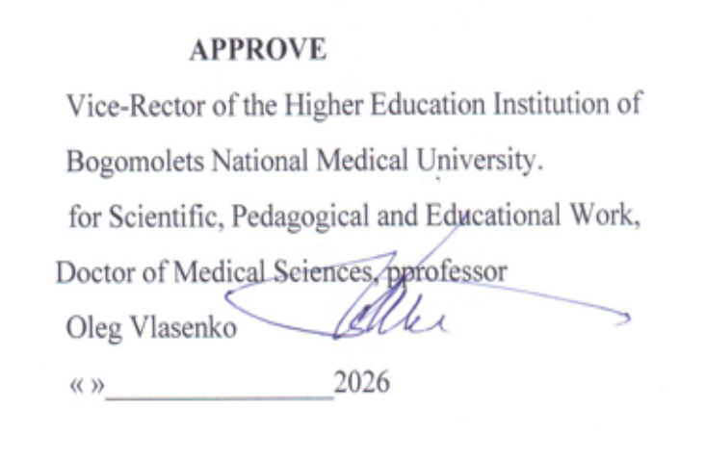

WORK PROGRAM OF ELECTIVE COURSE
"FUNDAMENTALS OF NEONATOLOGY"

Еducational level - second (master's) level of higher education
Branch knowledge – 22 Health care and social security
Specialty - 222 Medicine,
Educational program - Medicine
Form study - full-time

2026 - 2027 academic year

AUTHOR TEAM
who worked on the development of the work program of the elective discipline "Fundamentals of Neonatology " for 5th year students of Faculty for training of
foreign citizens.

Volosovets O.P., Corresponding Member of the National Academy of Medical Sciences of Ukraine, Doctor of Medical Sciences, Professor, Head of the Department of Pediatrics No. 2
Krivopustov S.P., Doctor of Medical Sciences, Professor of the Department of Pediatrics No. 2
Mozyrska O.V., Doctor of Medical Sciences, Professor of the Department of Pediatrics No. 2
Grishchenko N.V., Candidate of Medical Sciences, Associate Professor of the Department of Pediatrics No. 2
Karulina Y.V., Candidate of Medical Sciences, Associate Professor of the Department of Pediatrics No. 2
Loginova I.O., Candidate of Medical Sciences, Associate Professor of the Department of Pediatrics No. 2
Cherniy O.F., Candidate of Medical Sciences, Associate Professor of the Department of Pediatrics No. 2
Shevtsova T.I., Candidate of Medical Sciences, Associate Professor of the Department of Pediatrics No. 2

Work program of the elective discipline "Fundamentals of Neonatology " for 5th year students of Faculty for training of foreign citizens

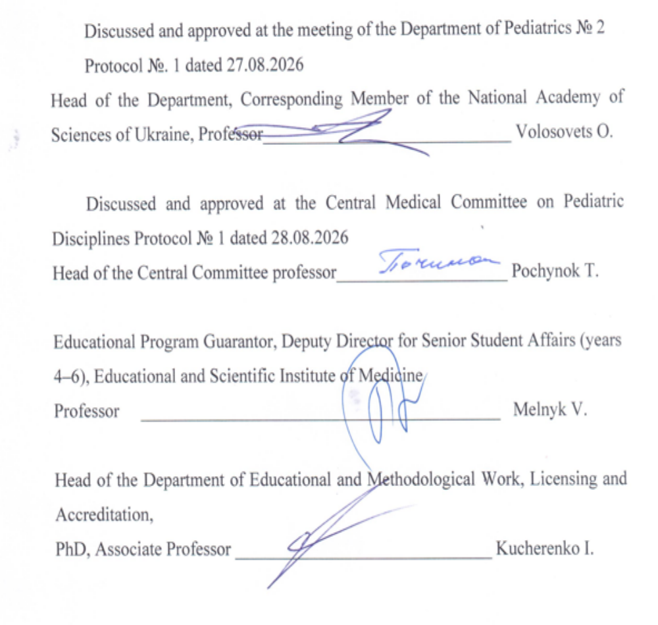
Description of the initial elective discipline "Fundamentals of Neonatology "
Code disciplines – CD 5.1.
Number loans ECTS - 3 credits
General amount hours - 90 hours (Practical classes - 30 hours, IWS - 60 hours)
Form control - differentiated credit
Training weeks - 2

Name of indicators | Field of knowledge, specialty, educational level | Characteristics of selective discipline
Name of indicators | Field of knowledge, specialty, educational level | full-time education
Number of credits – 3 | Discipline  I Health care and social security | Selective
Total number of hours – 90 | Specialty:  I2 medicine | Year of preparation  5th
Total number of hours – 90 | Specialty:  I2 medicine | Semester  9th, 10th
Total number of hours – 90 | Specialty:  I2 medicine | Lectures  0 hours
Weekly hours for full-time study:  classrooms – 90  student's independent work – 60 | Educational level: second (master's) | Lectures  0 hours
 | Educational level: second (master's) | Practical  30 hours.
 | Educational level: second (master's) | Laboratory  0 hours
 | Educational level: second (master's) | Independent work  60 hours.
 | Educational level: second (master's) | Individual assignments: 0 hours.
 | Educational level: second (master's) | Type of control: Differential assessment

Purpose, expected learning outcomes and criteria for evaluating results teaching
The purpose of teaching the academic discipline "Fundamentals of Neonatology " is:
formation of the ability to use acquired knowledge, skills, abilities, general and special competencies to solve professional tasks of a doctor in the field of healthcare, acquisition of general and special competencies to achieve program learning outcomes on the most common symptoms and syndromes in newborns.

According to the requirements of the “Medicine”, the discipline ensures that students acquire the following competencies:
• And integral (IC):
Ability to solve complex problems, including those of a research and innovation nature in the field of medicine. Ability to continue learning with a high degree of autonomy.
• General (GC):
GC1. Ability for abstract thinking, analysis and synthesis.
GC 2. Ability to learn and master modern knowledge.
GC 3. Ability to apply knowledge in practical situations.
GC 4. Knowledge and understanding of the subject area and understanding of professional activity.
GC 5. Ability to adapt and act in a new situation.
GC 6. Ability to make informed decisions.
GC 7. Ability to work in a team.
GC 8. Ability for interpersonal interaction.
GC 10. Ability to use information and communication technologies.
GC 11. Ability to search, process and analyze information from various sources.
GC 12. Determination and persistence in achieving assigned tasks and assumed responsibilities.
GC 13. Awareness of equal opportunities and gender issues.
GC 14. The ability to exercise one's rights and obligations as a member of society, to realize the values of a civil (free democratic) society and the need for its sustainable development, the rule of law, and the rights and freedoms of man and citizen in Ukraine.
GC 15. The ability to preserve and multiply moral, cultural, scientific values and achievements of society based on understanding the history and patterns of development of the subject area, its place in the general system of knowledge about nature and society and in the development of society, technology and engineering, to use various types and forms of physical activity for active recreation and leading a healthy lifestyle.

• special (professional, subject) (SC):
SC 1. Ability to collect medical information about the patient and analyze clinical data.
SC 2. Ability to determine the necessary list of laboratory and instrumental studies and evaluate their results.
SC 3. Ability to establish a preliminary and clinical diagnosis of the disease.
SC 4. Ability to determine the necessary work and rest regime in the treatment and prevention of diseases.
SC 5. Ability to determine the nature of nutrition in the treatment and prevention of diseases.
SC 6. Ability to determine the principles and nature of treatment and prevention of diseases.
SC 7. Ability to diagnose emergency conditions.
SC 8. Ability to determine tactics and provide emergency medical care.
SC 9. Ability to conduct medical evacuation measures.
SC 10. Ability to perform medical manipulations.
SC 11. Ability to solve medical problems in new or unfamiliar environments with incomplete or limited information, taking into account aspects of social and ethical responsibility.
SC 13. Ability to carry out sanitary and hygienic and preventive measures.
SC 14. Ability to plan and implement preventive and anti-epidemic measures against infectious diseases.
SC 16. Ability to maintain medical records, including electronic forms.
SC 21. Clearly and unambiguously communicate one's own knowledge, conclusions, and reasoning on health care problems and related issues to specialists and non-specialists, including students.
SC 23. Ability to develop and implement scientific and applied projects in the field of health care.
SC 24. Compliance with ethical principles when working with patients and laboratory animals.
SC 25. Adherence to professional and academic integrity, responsibility for the reliability of the obtained scientific results.
Program Learning Outcomes (PLO):
PLO 1. Have a thorough knowledge of the structure of professional activity. Be able to carry out professional activities that require updating and integration of knowledge. Be responsible for professional development, the ability to further professional learning with a high level of autonomy.
PLO 2. Understanding and knowledge of fundamental and clinical biomedical sciences, at a level sufficient to solve professional tasks in the field of healthcare.
PLO 3. Specialized conceptual knowledge that includes scientific achievements in the field of health care and is the basis for conducting research, critical understanding of problems in the field of medicine and related interdisciplinary problems.
PLO 4. To identify and identify the leading clinical symptoms and syndromes; according to standard methods, using preliminary data from the patient's history, patient examination data, knowledge about the person, his organs and systems, to establish a preliminary clinical diagnosis of the disease.
PLO 5. Collect complaints, life and disease history, assess the patient's psychomotor and physical development, the condition of organs and body systems, and based on the results of laboratory and instrumental studies, evaluate information regarding the diagnosis, taking into account the patient's age.
PLO 6. Establish a final clinical diagnosis by making a reasoned decision and analyzing the obtained subjective and objective data of clinical, additional examination, conducting differential diagnostics, adhering to relevant ethical and legal norms, under the supervision of a head physician in a healthcare facility.
PLO 7. To prescribe and analyze additional (mandatory and optional) examination methods (laboratory, functional and/or instrumental) (according to list 4) for patients with diseases of organs and body systems for differential diagnosis of diseases.
PLO 8. Determine the main clinical syndrome or what determines the severity of the victim's condition by making a reasoned decision and assessing the person's condition under any circumstances (in a healthcare facility, outside it), including in emergency situations and combat operations, in field conditions, in conditions of lack of information and limited time.
PLO 9. Determine the nature and principles of treatment of patients (conservative, surgical) with diseases, taking into account the patient's age, in the conditions of a healthcare institution, outside it and at the stages of medical evacuation, including in field conditions, based on a preliminary clinical diagnosis, adhering to relevant ethical and legal norms, by making a reasoned decision according to existing algorithms and standard schemes, if necessary, expand the standard scheme, be able to substantiate personalized recommendations under the supervision of a head physician in a medical institution.
PLO 10. Determine the necessary work, rest, and nutrition regimen based on the final clinical diagnosis, adhering to relevant ethical and legal norms, by making a reasoned decision based on existing algorithms and standard schemes.
PlO 12. Assess the general condition of the newborn child by making an informed decision based on existing algorithms and standard schemes, adhering to relevant ethical and legal norms.
PLO 13. Assess and monitor the child's development, provide recommendations on feeding and nutritional characteristics depending on age, and organize preventive vaccinations according to the calendar.
PLO 14. Determine tactics and provide emergency medical care in emergencies in limited time conditions in accordance with existing clinical protocols and treatment standards.
PLO 17. Perform medical manipulations in a medical facility, at home, or at work based on a preliminary clinical diagnosis and/or indicators of the patient's condition by making an informed decision, adhering to relevant ethical and legal norms.
PLO 19. Plan and implement a system of anti-epidemic and preventive measures regarding the occurrence and spread of diseases among the population.
PlO 20. Analyze the epidemiological situation and carry out measures for mass and individual, general and local prevention of infectious diseases.
PLO 21. Find the necessary information in professional literature and databases of other sources, analyze, evaluate and apply this information.
PlO 23. Assess the impact of the environment on human health to assess the morbidity of the population.
PLO 24. Organize the necessary level of individual safety (one's own and those in one's care) in the event of typical dangerous situations in one's individual field of activity.
PLO 25. Clearly and unambiguously communicate one's own knowledge, conclusions, and arguments on health care problems and related issues to specialists and non-specialists.
PLO 26. Manage work processes in the healthcare sector that are complex, unpredictable and require new strategic approaches, organize the work and professional development of staff taking into account the acquired skills of effective teamwork, leadership positions, proper quality, accessibility and fairness, ensuring the provision of integrated medical care.
PLO 27. Communicate fluently in the state language and English, both orally and in writing, to discuss professional activities, research, and projects .
PLO 29. Plan, organize and conduct activities for the specific prevention of infectious diseases, including in accordance with the National Calendar of Preventive Vaccinations, both mandatory and recommended. Manage vaccine residues, organize additional vaccination campaigns, including immunoprophylaxis activities.

Criteria evaluation results teaching
The student's academic achievements are assessed according to mutually agreed 5 ball (5 – "perfectly", 4 – "good", 3 – “satisfactory”, 2 – “unsatisfactory”) and verbal (“passed”, “not passed”) systems, the educational institution scale (from 0 to 200 points), the national ECTS scale (A, B, C, D, E, FX, F).

COURSE PROGRAM
"Fundamentals of Neonatology "
Total hours - 90 hours
Lectures -0 hours; Practical classes - 30 hours, CRC - 60 hours.
Topic 1. Modern perinatal technologies. Medical care for a premature baby with very low and extremely low birth weight.
Principles of perinatal care. Main stages of providing medical care to prematurely born children. Pathological conditions inherent in prematurely born children: prevention and intensive therapy. Enteral and parenteral nutrition. Consultative and follow-up observation of a prematurely born child. Topic 2. Modern concept of perinatal infections. Tactics of managing children born to HIV-infected mothers.
Topic 2. Modern concept of perinatal infections. Tactics of managing children born to HIV-infected mothers.
Definitions: intrauterine infection, intrauterine infection, perinatal infection, vertical infection. Etiopathogenesis, clinical features, diagnostics, principles of prevention and treatment. Medical care for children born to HIV-infected mothers: prescription of antiretroviral drugs and artificial feeding. Choice of ARV therapy regimen. Prognosis. Medical observation.
Topic 3. Neonatal problems related to the respiratory system.
Tachypnea, cyanosis, retractions, expiratory groan, nasal flaring, apnea in neborns: causes, management tactics, emergency care.

Topic 4. Neonatal problems related to the central nervous system.

Neurological examination of the newborn. Causes of perinatal lesions of the central nervous system. Hypoxic -ischemic encephalopathy, stages according to the Sarnat scale. Intracranial hemorrhages. Cerebral leukomalacia. Factors of the development of convulsive syndrome in the neonatal period. Dependence of the term of onset of seizures on the cause. Emergency care.

Topic 5. Neonatal problems related to the cardiovascular system.

Cyanosis, arterial hypo- and hypertension, bradycardia, tachycardia: causes, management tactics, emergency care.

Topic 6. Hematological problems of the neonatal period.

Anemia and polycythemia: diagnostic criteria, causes, clinical manifestations, management tactics, emergency care.

Topic 7. Neonatal jaundice.

Features of bilirubin metabolism in newborns. Conjugated and unconjugated hyperbilirubinemia . Tactics of managing newborns with jaundice.

Topic 8. Neonatal problems related to the digestive system.

Regurgitation, vomiting, bloating, delayed bowel movements in newborns: management tactics depending on the cause. Congenital malformations of the gastrointestinal tract (esophageal atresia, intestinal obstruction, pyloric stenosis, Hirschsprung's disease, meconium ileus). Necrotizing enterocolitis: pathogenesis, stages, diagnostic methods, prevention and treatment. Congenital metabolic disorders.

Topic 9. Neonatal problems of the urinary system.

Oliguria, proteinuria, leukocyturia, hematuria: causes, management tactics. Acute kidney injury: risk factors, diagnostic criteria, treatment.

Topic 10. Neonatal metabolic problems .

Features of glucose metabolism in newborns. Hypo- and hyperglycemia: causes, manifestations, emergency therapy. The main functions of potassium and sodium in the body of a newborn child. Hypo- and hypernatremia, hypo- and hyperkalemia: causes, diagnostic criteria, treatment.

STRUCTURE OF ELECTIVE DISCIPLINE

"Fundamentals of Neonatology "
Topic | Hours
Topic | Total | Lectures | Practical classes | IWS
 |  |  |  | Individual. | Self-study
1. Modern perinatal technologies. Medical care for premature born a baby with very low and extremely low birth weight . | 6 |  | 3 |  | 3
2. Modern concept of perinatal infections. Tactics of management of children born to HIV-infected mothers | 6 |  | 3 |  | 3
3. Neonatal problems related to the respiratory system | 6 |  | 3 |  | 3
4. Neonatal problems related to the central nervous system | 6 |  | 3 |  | 3
5. Neonatal problems related to the cardiovascular system. | 6 |  | 3 |  | 3
6. Hematological problems period newborns | 6 |  | 3 |  | 3
7. Neonatal jaundice | 6 |  | 3 |  | 3
8. Neonatal problems related to the digestive system. | 6 |  | 3 |  | 3
9. Neonatal urinary system problems. | 6 |  | 3 |  | 3
10. Neonatal metabolic problems. | 6 |  | 3 |  | 3
Working on practical skills (simulation training) | 30 |  |  |  | 30
TOTAL | 90 | 0 | 30 | - | 60

Control: differentiated assessment.

THEMATIC PLAN OF PRACTICAL CLASSES

Elective discipline "Fundamentals of Neonatology "
No | Topic name | Hours
1. | Modern perinatal technologies. Medical care for a premature baby with very low and extremely low birth weight. | 3
2. | Modern concept of perinatal infections. Tactics of management of children born to HIV-infected mothers. | 3
3. | Neonatal problems related to the respiratory system. | 3
4. | Neonatal problems related to the central nervous system. | 3
5. | Neonatal problems related to the cardiovascular system. | 3
6. | Hematological problems of the neonatal period . | 3
7. | Neonatal jaundice . | 3
8. | Neonatal problems related to the digestive system. | 3
9. | Neonatal urinary system problems. | 3
10. | Neonatal metabolic problems. | 3
Total |  | 3 0

Student's independent work
N. | Content of the work | Hours
1. | Preparation for practical classes. | 30
2. | Working on practical skills ( simulation training). | 30
Total |  | 60

TEACHING METHODS
Traditional and modern methods are used: lectures, case methods, problem-based learning, simulations, interactives, the LIKAR_NMU platform, etc.

When studying the elective discipline "Fundamentals of Neonatology " , various teaching methods recommended for higher education are used, namely:
- by sources of knowledge: verbal (explanation, lecture, conversation, discussion); visual (demonstration); practical (practical work, mastering practical skills);
- according to the logic of the educational process: analytical (determination of the general condition of the patient and the main signs of the disease), synthetic (clarification of the relationship between the main signs of diseases, determination of optimal measures for diagnosis, treatment and prevention), their combination - analytical-synthetic, as well as inductive method, and deductive method;
- by the level of independent mental activity: problem-based, partially search-based, research-based.
Combining and generalizing the above teaching methods, when studying the discipline, it is advisable to implement the following methods of organizing training sessions:
- clinical case method,
- problem-oriented method,
- method of individual educational, research and practical tasks,
- competitive group method,
- training technology method,
- "business game" method,
- brainstorming method,
- a method of holding conferences using interactive, interdisciplinary and information and computer technologies.
Practical classes with the organization methodology are clinical, aimed at controlling the assimilation of theoretical material and the formation of practical skills and abilities, as well as the ability to analyze and apply the acquired knowledge to solve practical problems. They include:
- history taking;
- examination of a sick child;
- planning the examination of a sick child;
- interpretation of laboratory and instrumental research data;
- determination of a preliminary clinical diagnosis;
- determination of therapeutic tactics;
- providing emergency medical care;
- solving situational problems;
- practicing practical skills on dummies;
- maintaining medical records.
Student's independent work
It is carried out by the student independently outside of classroom sessions and includes preparation for practical classes, searching for and studying additional literature, and also includes working on practical skills in a simulation room.

METHODS AND FORMS OF CONTROL, DISTRIBUTION OF POINTS RECEIVED BY STUDENTS, ASSESSMENT

Control methods
Theoretical knowledge:
- written and computer-based testing,
- individual survey, interview,
- written works structured by content.
Practical skills and abilities:
- control over the implementation of standardized practical skills provided for in the student's practical training plan in the discipline:
- analysis of laboratory and instrumental studies;
- performing medical procedures in pediatrics;
- providing emergency care for newborns using dummies.

Forms of control
Current control is carried out at each practical lesson in accordance with the specific goals of the topic. All practical lessons use objective control of theoretical preparation and mastery of practical skills (standardized by the methodology of implementation).
Differentiated credit
It is assigned at the last classroom lesson by the teacher of the academic group to the student based on the results of his studies as the sum of points on a 200-point scale with the corresponding conversion on a traditional scale.
Control of the implementation of independent work , which is provided for in the topic along with classroom work, is carried out during the current control of the topic at the corresponding classroom lesson. Control of the acquisition of practical skills on the corresponding topic of the lesson is carried out during the current control.

REGULATIONS FOR ASSESSING CURRENT STUDENT PERFORMANCE
Current control is carried out at each practical lesson in accordance with specific goals for each topic, provides for 100% surveying of students in the group, and evaluation of all components of the lesson - test control, control of the implementation of practical skills, solving situational tasks. Written performance of tasks in the process of preparing for the practical lesson is also taken into account.
For each stage of the lesson, the student receives a grade of "5-4-3-2", from which the teacher forms the arithmetic average grade for the lesson, which is converted into points, according to the scale. If the arithmetic average grade is "2", then this corresponds to 0 points. points.
Criteria for assessing the level of knowledge of each component of the lesson.
1). The student's readiness for the lesson (initial stage) is checked based on the answers to 10 test tasks using the LIKAR_NMU platform.
For correct answers to 9-10 tests, the student receives the traditional grade of "5"; for 7-8 correct answers - a grade of "4", for 5-6 correct answers - a grade of "3", for less than 5 correct answers - a grade of "2".
2). The student's oral interview is evaluated as follows:
- A grade of "5" is given when the student gives comprehensive, accurate and clear answers without any leading questions; presents the material without errors and inaccuracies;
- A grade of "4" is given if the student knows the content of the lesson and understands it well, presents the answers to the questions correctly, consistently and systematically, but they are not exhaustive, although the student answers additional questions without errors;
- A grade of "3" is given to a student based on his knowledge of the main content of the lesson and a satisfactory level of understanding, he gives answers using leading questions, but answers directly posed questions correctly.
- A grade of "2" is given in cases where the student's knowledge does not meet the requirements for a grade of "3 points";
3) Formation of professional competencies.
- A grade of "5" is given when the student demonstrates the ability to analyze and apply the results obtained during the examination of the patient to solve practical problems, namely: collecting anamnesis, examining the child, planning the examination, interpreting laboratory and instrumental research data; correctly determines the clinical diagnosis in the typical course of the disease; prescribes the correct treatment in full; demonstrates excellent knowledge in providing emergency care.
- A grade of "4" is given if the student demonstrates the ability, with some inaccuracies , to analyze and apply the results obtained during the examination of the patient to solve practical problems; correctly determines the clinical diagnosis in the typical course of the disease; prescribes generally correct treatment, but may make some minor errors that are corrected independently; demonstrates good knowledge of emergency care.
- A grade of "3" is given to a student when he analyzes and applies the obtained results to solve practical problems with individual errors; determines a clinical diagnosis in a typical course of the disease; prescribes generally correct, but not complete treatment and/or with minor errors; demonstrates satisfactory knowledge of emergency care;
- A grade of "2" is given in cases where the student is unable to make decisions and act in typical clinical situations, is unable to determine a clinical diagnosis, or prescribe the correct treatment.
4) To control the student's mastery of the topic, he is asked to answer the question situational problem.
- A grade of "5" is given when the student correctly and completely solves a complex situational problem and gives comprehensive answers to all the questions asked.
- A grade of "4" is given if the student correctly solves a complex situational problem, but may make individual minor errors that he corrects independently.
- A grade of "3" is given to a student who solves a situational problem with individual errors, experiencing difficulties in simple cases; is unable to independently systematically present the answer.
- A grade of "2" is given if the student has obvious difficulties in solving situational tasks and gives incorrect answers to questions.
Assessment of students' independent work in preparation for classroom practical classes is carried out during the current control of the topic at the corresponding classroom class.
Maximum number points that can to recruit a student for the current educational activity, is 200 points .
Differentiated assessment is carried out at the last classroom lesson by the teacher of the academic group of students based on the results of current control with the appropriate conversion of the sum of points into a traditional grade and ECTS credits.

DISTRIBUTION OF POINTS,
which are assigned to students when assessing the discipline
No | Topic name |  | Number of points corresponding to the traditional assessment
No |  |  | "5" | "4" | "3" | "2"
1. | Modern perinatal technologies. Medical care for a premature baby with very and extremely low birth weight. |  | 20 | 16 | 12 | 0
2. | Modern concept of perinatal infections. Tactics of management of children born to HIV-infected mothers. |  | 20 | 16 | 12 | 0
3. | Neonatal problems related to the respiratory system. |  | 20 | 16 | 12 | 0
4. | Neonatal problems related to the central nervous system. |  | 20 | 16 | 12 | 0
5. | Neonatal problems related to the cardiovascular system. |  | 20 | 16 | 12 | 0
6. | Hematological problems of the neonatal period . |  | 20 | 16 | 12 | 0
7. | Neonatal jaundice . |  | 20 | 16 | 12 | 0
8. | Neonatal problems related to the digestive system. |  | 20 | 16 | 12 | 0
9. | Neonatal urinary system problems. |  | 20 | 16 | 12 | 0
10. | Neonatal metabolic problems. |  | 20 | 16 | 12 | 0
Total |  | Maximum score – 200 points
 |  | Minimum score – 111 points

Conversion of the number of points from the discipline into grades on the ECTS and four-point (traditional) scales.
Points from the discipline are converted into both the ECTS scale and the four-point scale.
Ranking on the ECTS scale with the assignment of grades "A", "B", "C", "D", "E" is carried out as follows:

National scale assessment | Score | ECTS scale assessment | Explanation
Perfectly | 170-200 | A | Excellent (excellent performance with only a few errors)
Good | 155-169 | B | Very good (above average with a few errors)
Good | 140-154 | C | Good (generally correct execution with a certain number of significant errors)
Satisfactorily | 125-139 | D | Satisfactory (with a significant number of shortcomings)
Satisfactorily | 111-124 | E | Sufficient (performance meets minimum criteria)
Unsatisfactorily | 60-110 | FX | Unsatisfactory (with the possibility of reassembly)
Unsatisfactorily | 1-59 | F | Unsatisfactory (with mandatory re-study of the discipline)

Also, the department converts points from the discipline into a traditional four-point scale using absolute criteria as follows:
Discipline points | Rating on a four-point scale
From 170 to 200 points | 5
From 140 to 169 points | 4
From 139 to 1 11 points | 3
1 1 0 points and below | 2

Tools for diagnosing learning success
The following tools are used to diagnose learning success:
1. Test tasks of format A
2. Structured tasks for written work
3. Practical tasks to test mastery of practical skills
4. Situational tasks.
The development of test control questions, the formation of structured tasks for written papers, situational tasks for interviews, and practical tasks used to diagnose learning success are based on a list of questions and practical skills that a student must master when studying the discipline.
List of practical skills, the acquisition of which is monitored during current control:
1. Perform indirect heart massage on a newborn baby.
2. Perform artificial ventilation of the lungs of a newborn baby using a mask and an Ambu bag with air.
3. Restore airway patency in a newborn baby.
4. Place a nasogastric tube and an orogastric tube in a newborn baby.
5. Perform the technique of skin-to-skin contact of the newborn and early breastfeeding.
6. Initial and resuscitation care for a newborn baby

Course Policy: Mandatory adherence to academic integrity by students, namely:
- independent performance of all types of work, tasks, and forms of control provided for by the work program of this academic discipline;
- references to sources of information in case of using ideas, developments, statements, information;
- compliance with the norms of legislation on copyright and related rights;
- providing reliable information about the results of one's own educational (scientific) activities, research methods used and sources of information.

METHODOLOGICAL SUPPORT
Methodological support for practical classes:
- Methodological developments of practical classes for teachers.
- Methodological instructions for practical classes for students.
- Variants of test questions and tasks to check the initial level of knowledge on each topic.
- Variants of situational tasks to check the mastery of topics.
3. Variants of situational tasks to check the mastery of topics.
● treatment algorithms and emergency care (according to evidence-based medicine standards)
● algorithms for performing practical skills, medical manipulations, videos
● results of laboratory and instrumental research methods
● dummies, phantoms, etc.
● simulators, electronic guides, computers with appropriate information support

Methodological support for students' independent work:
- Methodological recommendations for preparing for practical classes.
- Methodical instructions for performing practical skills.
- Task options for independent work by students.

RECOMMENDED READING
1.Pediatrics (neonatology, hematology, endocrinology): Teaching and methodological manual / Edited by O.P. Volosovets. – Kyiv: MEDPRINT, 2023. – 410 p.
2. Neonatology: textbook: in 3 volumes / [T. K. Znamenska, Yu. G. Antipkin, M. L. Aryaev and others]; edited by T. K. Znamenska. – Lviv: Publisher Marchenko T. V., 2020. – T. 1. – 408 p., T2- 456 p., T3- 380 p.
3. Nelson's Fundamentals of Pediatrics: in 2 volumes. Volume 1 / Karen J. Markdante, Robert M. Kligman; translation of the 8th English edition. Scientific editors of the translation V.S. Berezenko, T.V. Pochynok. Kyiv: VSV "Medicine", (2020). T1-378p., T2- 426 p.
4. Clinical Pediatrics: Textbook [V.M. Dudnik, I.I. Andrikevich, R.I. Mantak, etc.]; edited by Prof. V.M. Dudnik. – Vinnytsia: Nova Knyga, 2021. - 648 p.
5. Academic lectures on pediatrics/ed. Y.G. Antipkin.-Kyiv: RA-GARMONIYA LLC, 2020 –624 p.
6. Nelson textbook 21st Edition by Robert M. Kliegman, MD, Joseph St.​ Geme, Nathan J. Blum, Samair S. Shan, Robert C. Tasker, Karen M. Wilson, Richard E. Behrman Publisher: Elsevier, (2020). 848. ISBN 978032351145
Recommended electronic resources:
1. Unified clinical protocol for secondary (specialized) and tertiary (highly specialized) medical care “Respiratory distress syndrome in premature infants”, approved by Order of the Ministry of Health of Ukraine dated 05.05.2021 No. 873 https://zakon.rada.gov.ua/rada/show/ v0873282-21#Text
2. Order of the Ministry of Health No. 991 dated 09.06.2022 “Procedure for conducting expanded neonatal screening”
https://zakononline.com.ua/documents/show/502471697043
3. Unified clinical protocol for secondary (specialized) and tertiary (highly specialized) medical care "Parenteral nutrition of newborns", approved by Order of the Ministry of Health of Ukraine dated 04/18/2022 No. 650https://www.dec.gov.ua/wpcontent/uploads/2022/04/2022_650_ykpmd_pex_novonar.pdf
4. Unified clinical protocol for secondary (specialized) and tertiary (highly specialized) medical care " Enteral nutrition of premature infants" (2021) https://www.dec.gov.ua/wp-content/uploads/2021/05/2021_870_ykpmd_ehnn_dit.pdf
5. Unified clinical protocol of specialized medical care "Jaundice of newborns", approved by Order of the Ministry of Health of Ukraine dated 04/27/2023 No. 783 https://www.dec.gov.ua/wp-content/uploads/2023/04/ukpmd_783_27042023_zhovt.pdf
6. Unified clinical protocol "Initial, resuscitation and post-resuscitation care for newborns in Ukraine", approved by the Order of the Ministry of Health of Ukraine dated March 26, 2025 No. 536 https://www.dec.gov.ua/mtd/pochatkova-reanimaczijna-ta-pislyareanimaczijna-dopomoga-novonarodzhenym/

