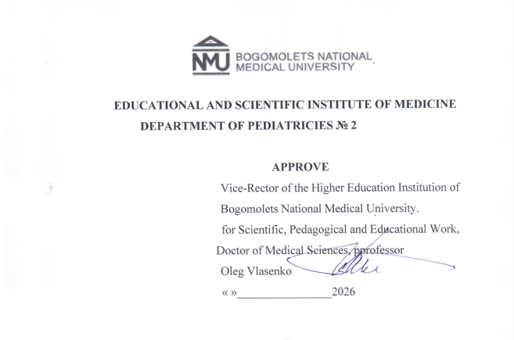

WORK PROGRAM OF WORK PROGRAM OF THE ACADEMIC DISCIPLINE

Propaedeutics of pediatrics including nursing practice, basic medical skills in the pediatric department
Еducational level - second (master's) level of higher education
Branch knowledge – 22 Health care
Specialty - 222 Medicine,
Educational program - Medicine
Form study - full-time

2026 - 2027 academic year

AUTHOR'S TEAM who worked on the development of the working program of the academic discipline "Propaedeutics of Pediatrics including Nursing Practice, Basic Medical Skills in the Pediatric Department" for 3rd year students of the Educational and Scientific Institute of Medicine of the 3rd year of study in the direction of training specialists of the second (master's) level of higher education in the specialty 222 "Medicine".
Volosovets O.P. - Corresponding Member of the National Academy of MedicalSciences of Ukraine, Doctor of Medical Sciences, Professor, Head of the Department of Pediatrics No. 2
Kryvopustov S.P. - Doctor of Medical Sciences, Professor, Professor of the Department of Pediatrics No. 2
Grishchenko N.V., Candidate of Medical Sciences, Associate Professor, Associate Professor of the Department of Pediatrics No. 2
Karulina Y.V. - Candidate of Medical Sciences, Associate Professor, Associate Professor of the Department of Pediatrics No. 2
Cherniy O.F. - Candidate of Medical Sciences, Associate Professor, Associate Professor of the Department of Pediatrics No. 2

Work program for the discipline CC 25 Propaedeutics of Pediatrics, including nursing practice, basic medical skills in the pediatric department for students of the Educational and Scientific Institute of Medicine in the 3rd year of study.
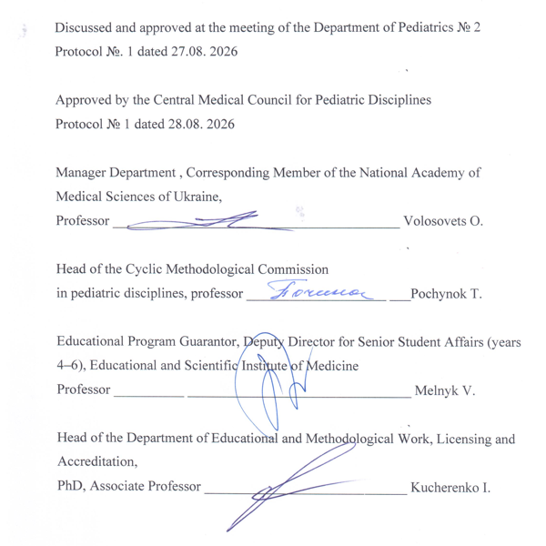

DESCRIPTION OF THE ACADEMIC DISCIPLINE
Name of the academic discipline -
According to the EPP - "Propaedeutics of Pediatrics, Basic Medical Skills in the Pediatric Department"
According to the Curriculum – “Propaedeutics of Pediatrics including nursing practice, basic medical skills in the pediatric department”
Code disciplines – CC 25.
Number loans ECTS - 5 credits
General amount hours - 150 hours (Lectures -10 hours; Practical classes - 80 hours, CTC - 60 hours)
Form control – Final control .
Name of indicators | Field of knowledge, specialty, educational level | Characteristic  educational  disciplines
Number loans – 3 | Branch knowledge:  22 Health care | Daily form of study
Number loans – 3 | Direction preparation:  Master | Regulatory
Modules – 1 | Specialty:  222 "Medicine" | Year of preparation – 3rd
Meaningful modules – 4 | Specialty:  222 "Medicine" | Year of preparation – 3rd
Individual scientifically-  experimental Task – Writing a Medical History | Specialty:  222 "Medicine" | Semester – V – VI
Total number of credits/hours – 5 / 150 | Specialty:  222 "Medicine" | Semester – V – VI
Weekly hours for full-time study:  classroom – 3.0;  independent work of students – 2.0 | Educational qualification Level: Master of Medicine | Lectures: 10 hours
 | Educational qualification Level: Master of Medicine | Practical: 80 hours
 | Educational qualification Level: Master of Medicine | Independent work:  60 hours
 | Educational qualification Level: Master of Medicine | View  control: PC
Purpose, expected learning outcomes and criteria for evaluating results teaching
The purpose of teaching the academic discipline "Propaedeutics of Pediatrics, including Nursing Practice, Basic Medical Skills in the Pediatric Department" is to form the ability to use the acquired knowledge, skills, abilities, general and special competencies, as well as components of scientific research to solve professional tasks of a doctor's activity in the field of health care, to acquire general and professional competencies to achieve program learning outcomes regarding the growth and development of the child's body, age-related anatomical and physiological features of the child's body, examination methods and semiotics of lesions of organs and systems in children, feeding and rational nutrition of a healthy child, basic medical skills in the pediatric department.

According to the requirements of the EPP “Medicine”, the discipline ensures that students acquire the following competencies:
- Integral (IC):
Ability to solve complex problems, including those of a research and innovation nature in the field of medicine. Ability to continue learning with a high degree of autonomy .
- General (GC):
GC1. Ability for abstract thinking, analysis and synthesis.
GC2. Ability to learn and master modern knowledge.
GC3. Ability to apply knowledge in practical situations.
GC4. Knowledge and understanding of the subject area and understanding of professional activity.
GC5. Ability to adapt and act in a new situation.
GC6. Ability to make informed decisions.
GC7. Ability to work in a team.
GC8. Ability for interpersonal interaction.
GC10. Ability to use information and communication technologies.
GC 11. Ability to search, process and analyze information from various sources.
GC 12. Determination and persistence in relation to the tasks set and the responsibilities assumed.
GC13. Awareness of equal opportunities and gender issues.
GC 14. Ability to exercise one's rights and responsibilities as a member of society, to realize the values of a civil (free democratic) society and the need for its sustainable development, the rule of law, and the rights and freedoms of man and citizen in Ukraine.
GC 15. The ability to preserve and multiply the moral, cultural, scientific values and achievements of society based on understanding the history and patterns of development of the subject area, its place in the general system of knowledge about nature and society and in the development of society, technology and engineering, to use various types and forms of physical activity for active recreation and leading a healthy lifestyle.
- special (professional, subject) (SK):
FC 1. Ability to collect medical information about the patient and analyze clinical data.
FC 2. Ability to determine the necessary list of laboratory and instrumental studies and evaluate their results.
FC 3. Ability to establish a preliminary and clinical diagnosis of the disease.
FC 4. Ability to determine the necessary work and rest regime in the treatment and prevention of diseases.
FC 5. Ability to determine the nature of nutrition in the treatment and prevention of diseases.
FC 6. Ability to determine the principles and nature of treatment and prevention of diseases.
FC 7. Ability to diagnose emergency conditions.
FC 8. Ability to determine tactics and provide emergency medical care.
FC 10. Ability to perform medical manipulations.
FC 11. Ability to solve medical problems in new or unfamiliar environments with incomplete or limited information, taking into account aspects of social and ethical responsibility.
FC13. Ability to carry out sanitary and hygienic and preventive measures.
FC 16. Ability to maintain medical records.
FC 21. Clearly and unambiguously communicate one's own knowledge, conclusions, and reasoning on health care problems and related issues to specialists and non-specialists, including students.
FC 23. Ability to develop and implement scientific and
applied projects in the field of healthcare.
FC 24. Adherence to ethical principles when working with patients.
FC 25. Maintaining professional and academic integrity
Expected program learning outcomes (PLOs):
PLO 4. To identify and identify the leading clinical symptoms and syndromes; using standard methods, using preliminary data from the patient's history, examination data, knowledge about the person, his organs and systems, to establish a preliminary clinical diagnosis of the disease.
PLO 5. Collect complaints, life and disease history, assess the patient's psychomotor and physical development, the condition of organs and body systems, and based on the results of laboratory and instrumental studies, evaluate information regarding the diagnosis, taking into account the patient's age.
PLO 8. Define main clinical syndrome or than conditioned weight state victim/victim by making a reasoned decision and assessing the condition person under any circumstances (in conditions institution security health, by its borders) in including in conditions extraordinary situations and combat actions, in field conditions, in conditions of lack of information and limited time.
PLO12. Assess the general condition of the newborn child by making an informed decision based on existing algorithms and standard schemes, adhering to relevant ethical and legal norms.
PLO 13. Assess and monitor the child's development, provide recommendations on feeding and nutritional characteristics depending on age, and organize preventive vaccinations according to the calendar.
PLO 14. Determine tactics and provide emergency medical assistance in emergency situations with limited time according to existing clinical protocols and treatment standards.
PLO 17. Perform medical manipulations in a medical facility, at home, or at work based on a preliminary clinical diagnosis and/or indicators of the patient's condition by making an informed decision, adhering to relevant ethical and legal norms.
PLO 21. Find the necessary information in professional literature and databases of other sources, analyze, evaluate and apply this information.
PLO 22. Apply modern digital technologies, specialized software, and statistical methods of data analysis to solve complex healthcare problems.
PLO 23. Assess the impact of the environment on human health to assess the morbidity of the population.
PRN 24. Organize the necessary level of individual safety (one's own and those in care) in in the event of typical dangerous situations in the individual field of activity.
PLO 25. Of course and definitely inform own knowledge, conclusions and argumentation with problems security health and related issues to specialists and non-specialists.
PLO 27. Communicate fluently in the state language and English, both orally and in writing, to discuss professional activities, research, and projects.
PLO 29. Plan, organize and conduct events from specific prevention infectious diseases, including according to the National Calendar of preventive vaccinations, both mandatory and recommended. Manage vaccine residues, organize additional vaccination campaigns, including immunoprophylaxis measures.
Matrix competencies EC 25
EC 25. | IR | GC  1-8 | GC  10-15 | FC  1-8 | FC 10-11 | FC  13 | FC  16 | FC  21-25
EC 25. | + | + | + | + | + | + | + | +

PLO | 4 | 5 | 8 | 12-14 | 17 | 21-25 | 27 | 29
PLO | + | + | + | + | + | + | + | +

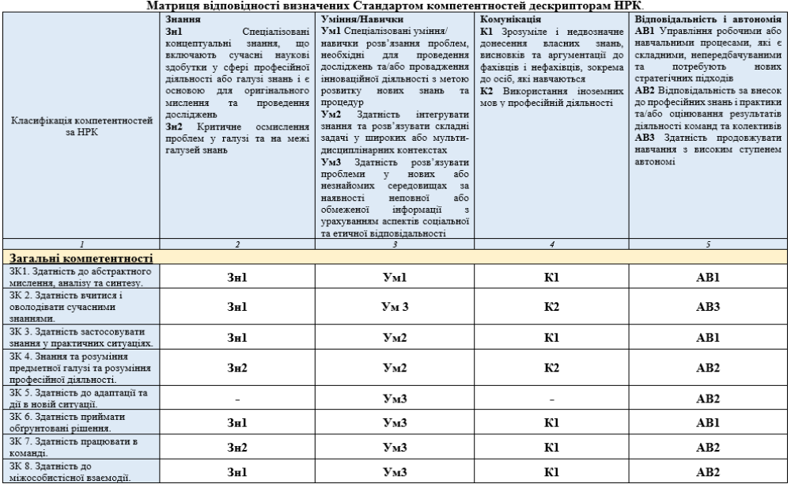

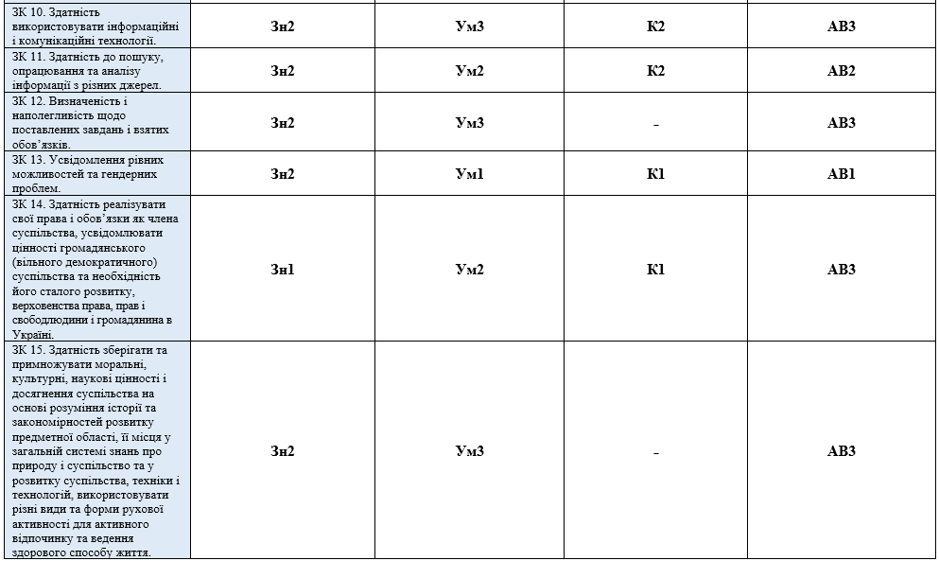
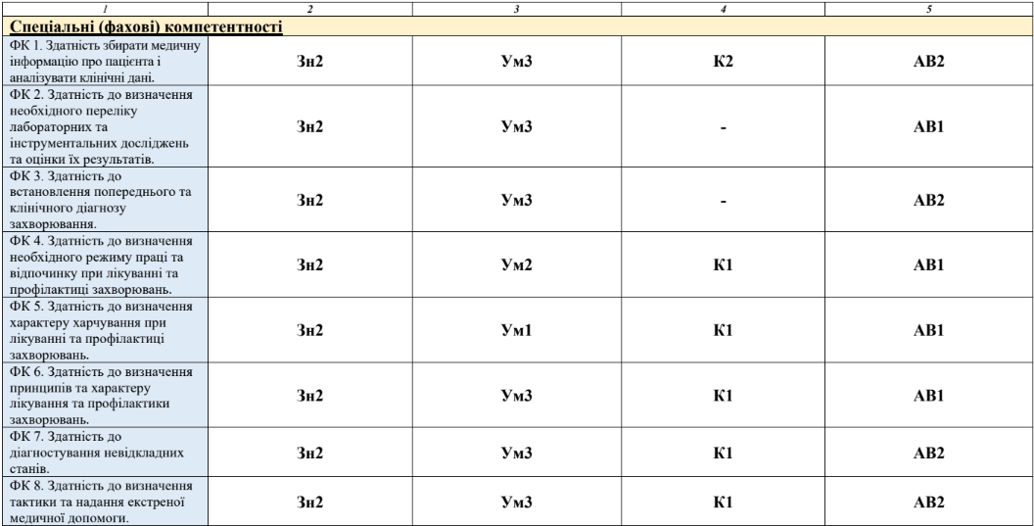

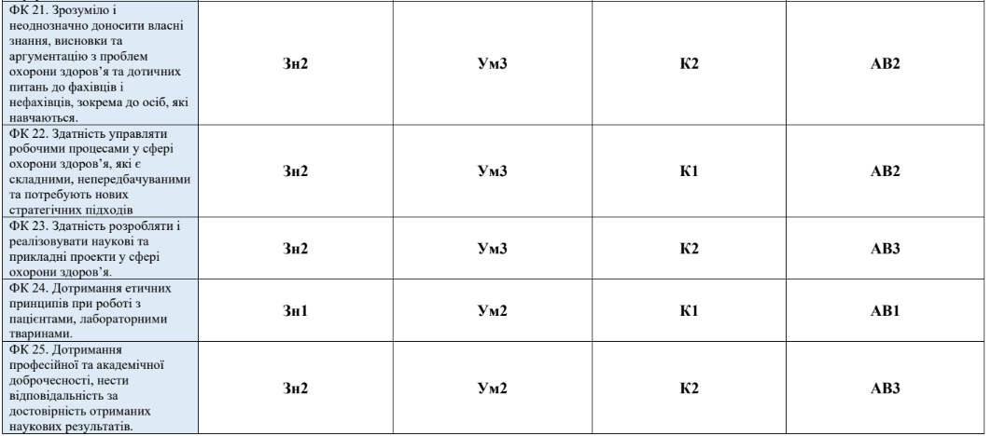
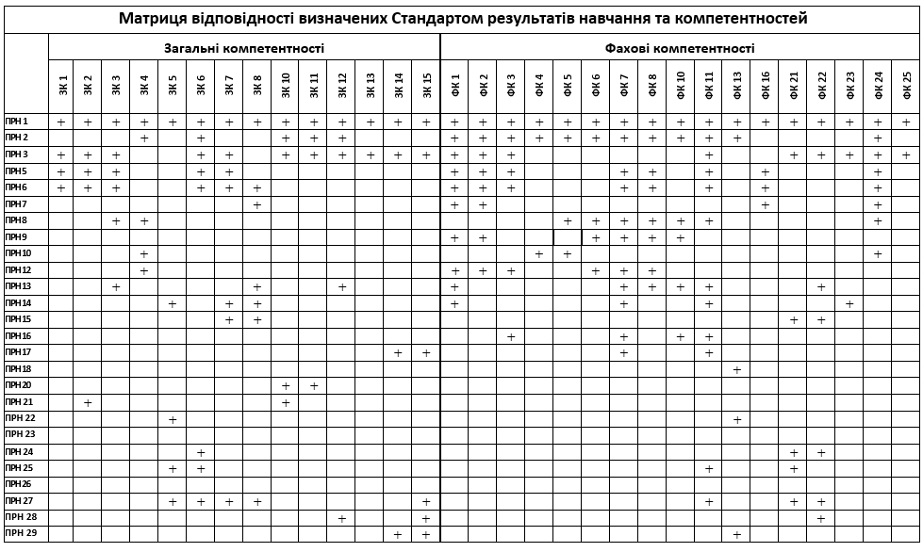
Criteria evaluation results teaching are determined by the Regulations on " The procedure for assessing students' knowledge during current and final control in the discipline at the O.O. Bogomolets National Medical University " (with amendments and additions approved by the Academic Council of the O.O. Bogomolets National Medical University No. 4 dated 11/28/2024).
Current CONTROL provides for 100% questioning of students in the group during a practical lesson with mandatory evaluation of all components of the lesson - test control, oral questioning, solving situational problems, and control of the acquisition of practical skills. every stage class and element of current control student receives the traditional rating of "5", "4", "3", "2", with whose teacher forms average arithmetic assessment by occupation, which is converted into points according to the scale determined by the "Regulations for Discipline Assessment" (see p. 26).
The overall grade for the discipline on a 200-point scale is ranked according to the national scale and the ECTS scale (A, B, C, D, E, FX, F).
Types of control: current, intermediate, final.
Form of control: Final control.

COURSE PROGRAM
" Propaedeutics of pediatrics including nursing practice, basic medical skills in the pediatric department "
Content module 1. The subject and place of pediatrics in the health care system. Child growth and development.
Topic 1. The subject and place of pediatrics in the healthcare system, the main stages of development.
Definition of the science "Pediatrics", and the centuries-old stages of the development of pediatrics in the world and in Ukraine, their significance . The most prominent pediatrician scientists, their contribution to the development of maternity and childhood care in the country. The place of "Pediatrics" in the system of general medicine and in the training of a general practitioner. Tasks of the course "Propaedeutics of Pediatrics".
Topic 2. System of organization of children's health care in Ukraine.
Principles of providing medical care to children in Ukraine. Structure and organization of work of basic health care institutions (HCPs) in which primary medical and sanitary, specialized and highly specialized medical care is provided to children.
Topic 3. Periods of childhood. Features of the neonatal period.
The need for periodization of childhood. Classification of childhood periods, their sequence, essence and duration of each. Critical periods of childhood. Physiological and transitional states in the neonatal period. The concept of the maturity of the newborn; signs of prematurity. Methods of assessing the condition of the child at birth.
Topic 4. Physical development of children, evaluation of anthropometric results. Semiotics of disorders of physical development of children.
Characteristics of the processes of growth and development of children. Patterns of increase in the main anthropometric indicators with the age of the child. The importance of conducting an assessment of the FR, regulated frequency of assessment depending on the age of the child. Methods of evaluating the results of anthropometry. Semiotics of violations of the physical development of children. Factors of positive and negative influence on the physical development of children.
.
Content module 2. Types of infant feeding. Nutrition of children over one year old . Features of metabolism in children.
Topic 5. Natural feeding of infants, its advantages compared to artificial feeding . Introduction of complementary foods.
Quantitative and qualitative composition of breast milk compared to cow 's milk . Immunobiological factors of breast milk and other advantages of natural feeding. Rules and techniques of breast feeding , first application to the mother's breast . Difficulties in breastfeeding. Diet and nutrition of a nursing woman . The child's daily need for basic food ingredients and energy. Methods for calculating the daily volume of food, determining the frequency of meals. Complementary feeding and nutrition correction: recommended products and their volume, timing and sequence of introduction.
Topic 6. Artificial and mixed feeding of infants.
Definition of the concepts of "artificial feeding", "mixed feeding" of infants. Reasons for transferring a child to mixed or artificial feeding. Classification and composition of milk formulas used for mixed and artificial feeding of infants in the first and second half of life. Definition of the concept of " hypogalactia ", its causes, classification, prevention, treatment .
Topic 7. Feeding premature babies.
Features of the gastrointestinal tract of premature infants children, clinical significance. Indications for total parenteral nutrition . Means of enteral feeding of a child with low birth weight depending on gestational age. Methods for calculating the daily amount of milk or milk formulas.
Topic 8. Principles and organization of rational nutrition for children over one year old.
Features of qualitative and quantitative provision of the diet of children older than one year, with basic food ingredients, minor biologically active compounds, and energy. General principles of optimal nutrition: conditions for a balanced diet, optimal nutrition, adequate technological and culinary processing of products and dishes, taking into account the individual characteristics of children. Factors that influence the formation of eating behavior of children of different age groups.
Topic 9. Features of energy, protein, carbohydrate , lipid, water-electrolyte and acid-base metabolism in children.
Definition of concepts: " assimilation ", " dissimilation ", "metabolism of the body". Features of energy, protein, carbohydrate and lipid metabolism in children; laboratory indicators of the state of each of the metabolisms; signs of disorders. The amount of water and its distribution in the body of children of different ages; ways and rate of its loss (physiological and pathological). Features of electrolyte metabolism in young children, signs of violations of their amount and the causes of these changes. Indicators of the acid-base state of the body; features of the mechanisms of regulation of the acid-base state in children.
Content module 3. Anatomical and physiological features of organs and systems in children, clinical examination techniques. Semiotics of syndromes affecting each system and the most common diseases.
Topic 10. Anatomical and physiological features of the nervous system in children. Psychomotor development of children, assessment methods and signs of disorders.
The main anatomical and physiological features of various parts of the nervous system in children, their clinical significance. Definition of the concept of "psychomotor development of children", stages of maturation of basic mental functions. Regulated frequency of assessment of a child's psychomotor development depending on age; assessment methods (development coefficient (QD), epicrisis period, main lines of development).
Topic 11. Methods of clinical examination of the nervous system in children, additional research methods. Semiotics of diseases of the nervous system in children.
Methods of clinical neurological examination of children. Semiotics of the main syndromes of damage and diseases of the nervous system in children. Features of cerebrospinal fluid in normal children of different ages and with pathology.
Topic 12. Anatomical and physiological features, methods of clinical examination of the skin and subcutaneous tissue, additional research methods. Semiotics of diseases of the skin and subcutaneous tissue in children.
Morphological and functional features of the skin and its derivatives in children; how they affect the functions of the skin in young children. Methods of studying the skin and subcutaneous tissue. Semiotics of skin lesions (color changes, vascular changes, primary and secondary elements of skin rash), causes of their occurrence. Causes and consequences of insufficient or excessive development of subcutaneous tissue.
Topic 13. Anatomical and physiological features, clinical examination techniques, additional methods of research of the musculoskeletal system. Semiotics of diseases of the musculoskeletal system.
Features of the mineral composition of bones, the structure of tubular bones and their blood supply in young children, clinical significance. Terms and significance of the appearance of physiological curvatures of the spine, terms and order of eruption of milk and permanent teeth. The concept of "bone age" its clinical significance. Features of muscle development (biochemical composition, histological structure) in young children. Methods of examination of the musculoskeletal system; semiotics of diseases.
Topic 14. Anatomical and physiological features, methods of clinical examination of the respiratory system in children, additional research methods.
Age-related anatomical and physiological features of each of the departments of the respiratory system, their clinical significance. Methods of clinical examination of the respiratory system.
Topic 15. Semiotics of syndromes of damage and major diseases of the respiratory system.
Clinical signs of respiratory tract damage: rhinosinusitis, pharyngitis, bronchitis, bronchiolitis, pneumonia, pleurisy. The most common syndromes of respiratory tract damage in children: obstructive; stenosing laryngotracheitis; congenital stridor, neonatal respiratory distress syndrome, respiratory failure syndrome. Laboratory and instrumental methods of respiratory tract examination.
Topic 16. Anatomical and physiological features, methods of clinical examination of the cardiovascular system in children.
Embryogenesis of the cardiovascular system, the timing of the formation of congenital heart defects and large vessels. Features of blood circulation in the fetus and newborn. Age-related anatomical and physiological features of the heart and vessels, their clinical significance. Methods of clinical examination of the cardiovascular system (features of the topography of the heart, frequency and rhythm of heart contractions, blood pressure in the age aspect).
Topic 17. Additional methods of studying the cardiovascular system. Semiotics of the main diseases of the cardiovascular system in children.
Semiotics of cardiovascular diseases: signs of endocarditis, myocarditis, pericarditis, congenital and acquired heart defects. Instrumental methods of examination (ECG, ECHO-CG, X-ray), their indicators in normal and pathological conditions. Signs of circulatory failure in children.
Topic 18. Anatomical and physiological features, methods of clinical examination of the digestive system in children.
Age-related anatomical and physiological features of the digestive system in children, their clinical significance. Methods of clinical examination of the digestive organs.
Topic 19. Additional methods of examination of the digestive system. Semiotics of syndromes of damage and major diseases of the digestive system.
The main symptoms (nausea, vomiting, heartburn, odynophagia, belching, aerophagia, diarrhea, constipation, others) and syndromes (pain, dyspeptic, others) are characteristic of diseases of the digestive system in children. Laboratory and instrumental (sonography of the abdominal cavity, endoscopic, X-ray) examination methods in the diagnosis of diseases of the digestive system.
Topic 20. Anatomical and physiological features, methods of clinical examination of the urinary system in children, additional examination methods. Semiotics of syndromes of urinary system damage in children.
Age-related anatomical and physiological features of the kidneys, ureters, urinary bladder and urethra in children, their clinical significance. Methods of examination of the urinary system. Laboratory and instrumental methods of examination of the organs of the urinary system. Semiotics of syndromes of damage to the urinary system in children.
Topic 21. Anatomical and physiological features, methods of clinical examination of the blood system in children. Laboratory research methods. Clinical and hematological semiotics of the main syndromes and diseases of the blood system in children
Stages of embryonic hematopoiesis, features of hematopoiesis in the postnatal period. Order and Clinical examination of the blood system. The meaning of the main indicators of the general blood test at birth, the dynamics of their change with the age of the child, the reasons for these changes. Features of the myelogram and hemostasis in the age aspect. Clinical and hematological characteristics of the main syndromes of damage to the blood system in children.
Topic 22. Anatomical and physiological features, clinical examination techniques, additional research methods. Semiotics of diseases of the immune system in children.
Stages of development and the immune system in children. Mechanisms of normal immune response, features in children (critical periods of immune system functioning). Procedure and methods of examination of the immune system. Laboratory and instrumental examination methods: immunological tests of levels I-II, determination of cardio-thymic-thoracic index. Content of the basic concepts of clinical immunology (immune status, immune deficiency, immune system dysfunctions, immunodeficiency state).
Topic 23. Anatomical and physiological features, methods of clinical examination of the endocrine system, semiotics of endocrine gland diseases in children.
Embryogenesis and anatomical and physiological features of endocrine glands in children: thyroid and parathyroid glands, adrenal glands, endocrine tissue of the pancreas, gonads, pituitary gland, pineal gland. Methods of clinical examination of the endocrine system. Semiotics of syndromes of hyper- and hypofunction of endocrine glands.
Topic 24. Patient care, writing a study history of a child's illness.
Familiarization with the scheme of writing a child's medical history (sequence and content of each section): passport part, sections of anamnesis and objective condition of the child. Conducting patient supervision in the presence of the group teacher. Writing a medical history; formulating conclusions, drawing up a plan for conducting laboratory and instrumental examinations. Explanation of individual provisions of the "history" in response to questions from the teacher
Content module 4. Nursing practice, basic medical skills in the pediatric department
Topic 25. Technique of anthropometric measurements in children, evaluation of the obtained data.
Technique of anthropometric measurements in children of different ages (measurement of body length and weight, head and chest circumferences). Evaluation of the obtained data using the methods of standard deviations and centile standards. Calculation of BMI and its assessment in children. Introduction to conducting other anthropometric measurements.
Topic 26. Hygienic hand hygiene.
Hygienic hand hygiene: hygienic hand washing and hygienic hand antisepsis (indications for implementation, performance technique). A multimodal strategy for improving hand hygiene in healthcare facilities.
Topic 27. Personal protective equipment for medical workers.
Personal protective equipment for medical workers, taking into account the degree of infectious risk (indications for use, rules and sequence of donning and doffing).
Topic 28. The role of the nurse in ensuring the diagnostic process.
Examination of pulse and respiratory rate, pulse oximeter technique, blood pressure measurement. Recording of standard 12-lead ECG in children of different ages. Conducting the Ruf'e test .
Taking swabs and washes from the nose and oropharyngeal area. Taking urine samples from children of different ages for research. Taking feces for research, scraping from perianal skin folds for enterobiasis.
Preparation for ultrasound, X-ray, and endoscopic examinations of the digestive and urinary systems. Maintaining medical records.
Blood sampling for research, vacuum systems for blood sampling.
Topic 29. Nurse's participation in ensuring the treatment process.
Technique of enteral administration of drugs: varieties of dosage forms, administration of drugs through the skin and through mucous membranes (instillation of drops and application of ointments in the eye and nose).
Inhalation route of administration of drugs, types of inhalers (advantages and disadvantages), inhalation techniques. Methods of oxygen supply.
Parenteral route of administration of drugs: structure and types of syringes, peripheral catheters; technique of subcutaneous, intradermal, intramuscular, intravenous injections, intravenous drip administration of drugs ); injection complications.
Topic 30. The work of a nurse in the vaccination office.
Organization of vaccination of children in healthcare facilities. Work of a nurse in the vaccination office.
Topic 31. Therapeutic nutrition. Organization of patient nutrition in the departments of a children's hospital.
Therapeutic nutrition, principles and methodology of prescribing for children. Organization of patient nutrition in the departments of a children's hospital, functional responsibilities of a dietetic nutrition nurse.
Topic 32. Basic cardiopulmonary resuscitation in children at the prehospital stage. Stopping bleeding.
Emergency service. Algorithm of actions for basic cardiopulmonary resuscitation at the prehospital stage in children. Automatic external defibrillator: purpose, where it is stored in public places, what the "universal AED sign" looks like, algorithm of application. Methods of stopping bleeding.
STRUCTURE OF THE ACADEMIC DISCIPLINE
" Propaedeutics of pediatrics including nursing practice, basic medical skills in the pediatric department "

Names of content modules and topics | Number of hours (academic)
Names of content modules and topics | Full-time study
Names of content modules and topics | Total | including
Names of content modules and topics | Total | Lek  this | Pract.  knowledge | Himself.  work | East  sick
Content module 1. The subject and place of pediatrics in the health care system. Child growth and development.
Topic 1. The subject and place of pediatrics in the healthcare system, the main stages of development. |  |  |  | 0.5
Topic 2. The system of organizing children's health care in Ukraine. |  |  |  | 0.5
Topic 3. Periods of childhood. Features of the neonatal period |  | 1 | 2.5 | 1
Topic 4. Physical development of children, evaluation of anthropometric results. Semiotics of disorders of physical development of children. |  | 1 | 2.5 | 1
Total module No. 1: | 10 | 2 | 5 | 3
Content module 2. Types of infant feeding. Nutrition of children over one year old. Features of metabolism in children.
Topic 5. Natural feeding of infants, its advantages compared to artificial feeding. Introduction of complementary foods. |  | 0.5 | 2.5 | 1
Topic 6. Artificial and mixed feeding of infants. |  | 0.5 | 2.5 | 1
Topic 7. Feeding premature babies. |  |  | 2.5 | 1
Topic 8. Principles and organization of rational nutrition for children over one year old. |  |  | 2.5 | 1
Topic 9. Features of energy, protein, carbohydrate , lipid, water-electrolyte and acid-base metabolism in children. |  |  |  | 2
Total module No. 2: | 14.5 | 1 | 7.5 | 6
Content module 3. Anatomical and physiological features of organs and systems in children, clinical examination techniques. Semiotics of syndromes affecting each system and the most common diseases.
Topic 10. Anatomical and physiological features of the nervous system in children. Psychomotor development of children, assessment methods and signs of disorders |  | 1 | 2.5 | 1
Topic 11. Methods of clinical examination of the nervous system in children, additional research methods. Semiotics of diseases of the nervous system in children. |  |  | 2.5 | 1
Topic 12. Anatomical and physiological features, methods of clinical examination of the skin and subcutaneous tissue, additional research methods. Semiotics of diseases of the skin and subcutaneous tissue in children. |  |  | 2.5 | 1
Topic 13. Anatomical and physiological features, clinical examination techniques, additional methods of research of the musculoskeletal system. Semiotics of diseases of the musculoskeletal system. |  |  | 2.5 | 1
Topic 14. Anatomical and physiological features, methods of clinical examination of the respiratory system in children, additional research methods . |  | 0.5 | 2.5 | 1
Topic 15. Semiotics of syndromes of damage and major diseases of the respiratory system. |  | 0.5 | 2.5 | 1
Topic 16. Anatomical and physiological features, methods of clinical examination of the cardiovascular system in children. |  | 0.5 | 2.5 | 1
Topic 17. Additional methods of studying the cardiovascular system . Semiotics of the main diseases of the cardiovascular system in children. |  | 0.5 | 2.5 | 1
Topic 18. Anatomical and physiological features, methods of clinical examination of the digestive system in children. |  | 0.5 | 2.5 | 1
Topic 19. Additional methods of examination of the digestive system. Semiotics of syndromes of damage and major diseases of the digestive system. |  | 0.5 | 2.5 | 1
Topic 20. Anatomical and physiological features, methods of clinical examination of the urinary system in children, additional examination methods. Semiotics of syndromes of urinary system damage in children. |  | 1 | 2.5 | 1
Topic 21. Anatomical and physiological features, methods of clinical examination of the blood system in children. Laboratory research methods. Clinical and hematological semiotics of the main syndromes and diseases of the blood system in children. |  | 1 | 2.5 | 1
Topic 22. Anatomical and physiological features, clinical examination techniques, and symptoms of immune system diseases in children. |  |  | 2.5 | 1
Topic 23. Anatomical and physiological features, methods of clinical examination of the endocrine system, semiotics of endocrine gland diseases in children. |  | 1 | 2.5 | 1
Topic 24. Curation.  Writing an educational history of a child’s illness. |  |  | 2.5 | 1 | 4
Total No. 3: | 63.5 | 7 | 37.5 | 15 + 4
Content module 4. Nursing practice, basic medical skills in the pediatric department
Topic 25. Technique of anthropometric measurements in children, evaluation of the obtained data. |  |  | 2 | 2
Topic 26. Hygienic hand hygiene. |  |  | 2 | 2
Topic 27. Personal protective equipment for medical workers. |  |  | 2 | 2
Topic 28. The role of the nurse in ensuring the diagnostic process. |  |  | 6 | 6
Topic 29. Nurse's participation in ensuring the treatment process. |  |  | 6 | 6
Topic 30. The work of a nurse in the vaccination office. |  |  | 2 | 2
Topic 31. Therapeutic nutrition. Organization of patient nutrition in the departments of a children's hospital. |  |  | 2 | 2
Topic 32. Basic cardiopulmonary resuscitation in children at the prehospital stage. Stopping bleeding. |  |  | 4 | 4
Total module No. 4: | 52 |  | 26 | 26
Final control | 10 |  | 4 | 6
Total: | 150 | 10 | 80 | 60

Lecture topics

No. | Topic name | Hour
1 | Periods of childhood, their characteristics. Features of the neonatal period. | 1
2 | Physical development (PD) of children, assessment methods, significance of PD assessment as an integral indicator of children's health status. Signs of PD disorders. | 1
3 | Infant feeding, types of feeding, indications and contraindications for each type. The importance of breastfeeding for the health of the child and the nursing mother. Complementary feeding and nutritional correction. | 1
4 | Anatomical and physiological features of the nervous system in children. Psychomotor development, assessment methods. Semiotics of lesions | 1
5 | Anatomical and physiological features of the respiratory system in children. Semiotics of the most common lesions. | 1
6 | Anatomical and physiological features of the heart and blood vessels in childhood. Semiotics of the most common lesions. | 1
7 | Age-related anatomical and physiological features of the digestive system in children. Semiotics of digestive system lesions in children; main symptoms and syndromes. | 1
8 | Anatomical and physiological features of the urinary system in children of different ages. Semiotics of the most common lesions. | 1
9 | Blood system, causes and nature of age-related changes in the main laboratory parameters. Clinical and hematological characteristics of the main syndromes in the system's damage in children. | 1
10 | Anatomical and physiological features of the glands of the endocrine system in children. Semiotics of syndromes of hyper- and hypofunction of the endocrine glands. | 1
 | Total | 10

Topics of practical classes
No. | Topic | Hour
 | By topics "propaedeutics of pediatrics":
1 | Periods of childhood, characteristics of each. Neonatal period, distribution of newborns by gestational age, signs of morphological and functional maturity/immaturity, borderline states ( transient). Apgar scale. Primary toilet of the newborn. | 2.5
2 | Physical development (PD) of children, characteristics of growth and development processes, patterns of increase in basic anthropometric indicators and their assessment. Semiotics of PD disorders. | 2.5
3 | Natural feeding of infants. Quantitative and qualitative composition of breast milk. Methods for calculating the daily volume of food and diet. Complementary feeding and nutrition correction. The child's daily need for food ingredients and energy . | 2.5
4 | Artificial and mixed feeding of infants. Classification and characteristics of milk formulas for artificial and mixed feeding. Technique of artificial and mixed feeding, criteria for assessing their effectiveness. Complementary feeding and correction of nutrition during artificial and mixed feeding. | 2.5
5 | Principles and organization of rational nutrition for children over one year old. | 2.5
6 | Anatomical and physiological features of the nervous system. Neuropsychological development of children at different ages. Methods and frequency of assessment. | 2.5
7 | Methods of clinical neurological examination of children. Semiotics of the main diseases of the nervous system in children. Features of cerebrospinal fluid in children and semiotics of its changes in pathology. | 2.5
8 | Anatomical and physiological features, clinical examination methods and semiotics of diseases of the skin and its derivatives, subcutaneous tissue. Methods of examination of lymph nodes in children. | 2.5
9 | Anatomical and physiological features, methods of examination of the musculoskeletal system in children. Semiotics of diseases of the musculoskeletal system in children. | 2.5
10 | Anatomical and physiological features of the respiratory system , methods of clinical examination of the respiratory system in children. | 2.5
11 | Semiotics of syndromes of damage and major diseases of the respiratory system. Laboratory and instrumental methods of examination of the respiratory system organs. | 2.5
12 | Anatomical and physiological features of the cardiovascular system in children. Methods of physical examination of the cardiovascular system in children. | 2.5
13 | Additional methods of studying the cardiovascular system . Semiotics of the main syndromes and diseases of the cardiovascular system in children. | 2.5
14 | Anatomical and physiological features, methods of clinical examination of the digestive system in children. | 2.5
15 | Main symptoms and syndromes of digestive system damage in children. Laboratory and instrumental examination methods. Semiotics of main diseases. | 2.5
16 | Anatomical and physiological features, methods of examination of the urinary system organs in children. Laboratory and instrumental methods of examination. Semiotics of syndromes of urinary system lesions. | 2.5
17 | Peculiarities of the blood system in children of different age groups. Methods of clinical and laboratory examination of children with blood system lesions. Clinical and hematological semiotics of the main syndromes and diseases of the blood system in children. | 2.5
18 | Anatomical and physiological features, general semiotics of diseases of the immune system in children. | 2.5
19 | Anatomical and physiological features, examination methods, semiotics of endocrine system diseases in children. | 2.5
20 | Curation of the patient for the purpose of writing a medical history. | 2.5
 | On the topics "nursing practice, basic medical skills in the pediatric department":
21 | Technique of anthropometric measurements in children, evaluation of the obtained data.  Hygienic hand hygiene. Personal protective equipment for medical workers. | 6.0
22 | role in ensuring the diagnostic process. | 6.0
23 | The nurse's participation in ensuring the treatment process. | 6.0
24 | Nurse's work in the vaccination room. Therapeutic nutrition; organization of patient nutrition in the departments of a children's hospital. Basic cardiopulmonary resuscitation in children at the prehospital stage. Stopping bleeding. | 6.0
25 | Work on improving practical skills; preparation of reporting documentation on nursing practice.  Final discipline control (PC) | 2.0  4.0
 | Total | 80

Independent Student Work (ISW)
No. | TOPIC | Number of hours | View  control
1 | Preparation for practical classes (on topics of propaedeutics of pediatrics) | 20 | Current control
2 | Independent study of topics that are not included in the classroom lesson plan: | 4 | Final control
 | The subject and place of pediatrics, the main stages of development. | 0.5
 | The system of organizing children's health care in Ukraine. | 0.5
 | Feeding premature babies | 1
 | Features of energy, protein, carbohydrate, water-mineral, lipid metabolism in childhood. Semiotics of metabolic disorders in children. | 2
3 | Writing an Educational Case History | 4 | Current control
4 | Preparation for practical classes (on nursing practice topics) | 26 | Current control
5 | Preparation for final control (FC): | 6 | Final control
Total |  | 60

Requirements to implementation student individual task
individual tasks in the form of patient care and writing an educational case history.
The assessment of the medical history as a mandatory individual work of the student takes place during its completion in the process of individual work of the teacher with the student.
A score of "5" is given if the student conducted a complete clinical examination of a sick child, described its results, correctly assessed the child's physical and psychomotor development, identified the leading symptoms and syndromes, and the affected organ system.
A grade of "4" is given if the student conducted a complete clinical examination of a sick child, but made inaccuracies in assessing the child's physical and psychomotor development, or identified the leading symptoms and syndromes incompletely or with minor errors.
A grade of "3" is given if the student made individual errors in assessing physical and psychomotor development and in identifying leading symptoms and syndromes.
A grade of "2" is given if the student made significant errors in assessing physical and psychomotor development and in identifying leading symptoms and syndromes.
The work is considered completed if the student receives a positive grade for writing and defending the medical history.
"5" - 8 points,
"4" - 6 points,
"3" - 4 points,
"2" - 0 points.

LEARNING METHODS
When studying the discipline "Propaedeutics of Pediatrics, including nursing practice, basic medical skills in the pediatric department", various teaching methods recommended for higher education are used, namely:
- by sources of knowledge: verbal (explanation, lecture, conversation, discussion); visual (demonstration); practical (practical work, mastering practical skills);
- according to the logic of the educational process: analytical (determination of the general condition of the patient and the main signs of the disease), synthetic (clarification of the relationship between the main signs of diseases, determination of optimal measures for diagnosis, treatment and prevention), their combination - analytical-synthetic, as well as inductive method, and deductive method;
- by the level of independent mental activity: problem-based, partially search-based, research-based.
When teaching the discipline, the following methods of organizing training sessions are implemented:
- clinical case method,
- problem-oriented method,
- method of individual educational, research and practical tasks,
- competitive group method,
- training technology method,
- "business game" method,
- brainstorming method,
- a method of holding conferences using interactive, interdisciplinary and information and computer technologies.
Types of student learning activities include lectures, practical classes, independent work of students, and completion of individual tasks.
Lectures. Preference is given to problem-based, review and conceptual-analytical lectures. During the lecture, students' knowledge is formed, a motivational component and a general-oriented stage of mastering scientific knowledge are provided. Lectures play a role in the quality management of students' independent work.
Practical classes with the organization methodology are clinical, aimed at controlling the assimilation of theoretical material and the formation of practical skills and abilities, as well as the ability to analyze and apply the acquired knowledge to solve practical problems. They include:
- history taking;
- examination of a sick child;
- methods of examining a sick child;
- interpretation of laboratory and instrumental research data;
- assessment of child development;
- manipulation technique
- solving situational problems;
- practicing practical skills on dummies and at the bedside of a sick child;
- maintaining medical records.
Independent student work - is performed by the student independently outside of classroom sessions, and includes: preparation for practical classes, filling out a workbook on the discipline, searching for and studying additional literature, creating algorithms, structural and logical diagrams, writing abstracts, annotations, reports for presentations at practical classes, simulation training, on-call duty in the clinic under the guidance of a teacher, completing tasks on the LIKAR _ NMU platform .

METHODS AND FORMS OF CONTROL, ASSESSMENT OF STUDENTS
Control methods
Theoretical knowledge:
- computer testing,
- individual survey, interview,
- written works structured by content.
Practical skills and abilities:
- control over the implementation of standardized practical skills provided for in the student's practical training plan in the discipline:
- analysis of laboratory and instrumental studies;
- performing medical procedures in pediatrics;
- providing emergency care for children.
Forms of control
Current control is carried out at each practical lesson in accordance with the specific goals of the topic. All practical lessons use objective control of theoretical preparation and mastery of standardized practical skills.
Control of the implementation of independent work, which is provided for in the topic along with classroom work, is carried out during the current control of the topic at the corresponding classroom lesson. Control of the acquisition of practical skills on the corresponding topic is carried out both during the current control and during the final control.
The final examination is conducted in the form of a test after studying all the topics of the discipline.

REGULATIONS FOR ASSESSING CURRENT STUDENT PERFORMANCE
Current control is carried out at each practical lesson in accordance with specific goals for each topic, and involves 100% surveying of students in the group and evaluating all components of the lesson - test control, control of the implementation of practical skills, and solving situational tasks.
For each stage of the lesson and element of current control, the student receives a traditional grade of "5-4-3-2", from which the teacher forms the arithmetic average grade for the lesson, which is converted into points according to the scale "5" - 3 points, "4" - 2 points, "3" - 1 point. If during the formation of the arithmetic average traditional grade for the lesson the student receives "2", then this grade is converted into 0 points.
Results of monitoring the level of knowledge of each component of the lesson.
- The student's readiness for the lesson (initial stage) is checked based on the answers to 10 test questions. In the first practical lesson, these questions are included in the final control.
For a correct answer to 9-10 tests, the student receives the traditional grade "5"; for 7-8 correct answers - a grade "4", for 6 correct answers - a grade "3"; for 0-5 correct answers - a grade "2".
- oral interview is evaluated as follows:
A grade of "5" is given when the student gives comprehensive, accurate and clear answers without any leading questions; presents the material without errors and inaccuracies;
A grade of "4" is given if the student knows the content of the lesson and understands it well, presents the answers to the questions correctly, consistently and systematically, but they are not exhaustive, although the student answers additional questions without errors;
A grade of "3" is given to a student based on his knowledge of the main content of the lesson and a satisfactory level of understanding, he gives answers using leading questions, but answers directly posed questions correctly.
A grade of "2" is given in cases where the student's knowledge does not meet the requirements for a grade of "3 points";
3). Formation of professional competencies.
A grade of "5" is given when the student actively masters the practical part of the lesson and methodically and correctly demonstrates the practical skills provided for by the program; shows initiative when performing independent work.
A grade of "4" is given if the student performs the practical skills required for mastering, but may make individual minor errors that he/she corrects independently.
A grade of "3" is given to a student when he is able to complete basic practical tasks only after appropriate comments and assistance from the teacher.
A grade of "2" is given in cases where the student has obvious difficulties in mastering practical skills even after appropriate comments and corrections from the teacher.
4) To assess the student's mastery of the topic, he is asked to answer the question situational problem.
A grade of "5" is given when the student freely solves structured situational problems of varying degrees of complexity and gives comprehensive and correct answers to all questions asked.
A grade of "4" is given if the student solves situational problems, experiencing difficulties only in the most difficult cases, or gives correct but incomplete answers to questions.
A grade of "3" is given to a student who solves situational problems, experiencing difficulties in simple cases; is unable to independently systematically present the answer.
A grade of "2" is given if the student has obvious difficulties in solving situational tasks and gives incorrect answers to questions.
Assessment of independent work Students' preparation for classroom practical classes is carried out during the current control of the topic at the corresponding classroom class.
Assessment of mastery of topics that are assigned only for independent work is carried out during the final control.
The maximum number of points that a student can score for the current academic activity is 80. It is calculated by adding the number of points corresponding to the "excellent" grade for each practical lesson (3 points for practical lessons 1-24) with the addition of the maximum point for the mandatory individual work on the supervision of a child, writing and defending a child development history (8 points).
The sum of points accumulated by the student as a result of the current study is a component of the overall grade for the discipline. There is no minimum score for admission to the final examination for the discipline for the current examination.
If a student is absent from a practical lesson, he receives an absence. The student learns the missed material (for any reason for missing a lesson, including illness), independently in extracurricular time ( without accruing points ) and draws up a Summary of the missed lesson topic (S), which is a confirmation of the student's fulfillment of the curriculum . The student demonstrates this summary to the group teacher during the next lesson or after the start of attending lessons. The teacher reviews the summary, if necessary, asks to answer certain questions or demonstrate practical skills, or answers the student's questions (consultation).
Having made sure that the student has worked on the topic, the teacher makes a mark in the form of the letter "S" in the column of the missed topic in the "Student Attendance and Achievement Journal" (without assigning a grade) and in the "Register of Accepted Discipline Notes", which is an appendix to the academic journal and shows the dynamics of students' mastery of missed academic topics. The register is subject to weekly control by the head of the department. "Notes" the teacher returns to the student.
If a student was absent from the "Patient Curation" class, he is obliged to conduct the curation individually in agreement with the group teacher, since completing the Individual Task is a mandatory component of the discipline curriculum .
The head of the department constantly monitors the current study of students in the discipline, paying special attention to students at risk (a significant number of "NB" or unsatisfactory grades). At methodological meetings of the department, the results of the current study of students are discussed. For students at risk, in advance of the final control, the opportunity is offered to provide in-depth study of individual topics.
missed lectures are not reworking
The results of current control are carried out twice a year:
- stage control – as of November 30 (fall semester);
- before the final control (PC) in the discipline (spring semester). The following is summarized: a) the percentage of missed classes; b) the number of points accumulated for current activities.
- The percentage of missed teaching hours is calculated from the total number of hours allocated under the program for classroom lessons (90 hours per year).

REGULATIONS FOR ASSESSMENT OF FINAL EXAM
Final control is carried out upon completion of the study of cix topics. Students who have attended at least 75% of classroom classes (lectures and practical classes) are allowed to take the final control. If a student has attended less than 75% of classroom classes, he is considered to have failed to complete the curriculum and syllabus for the discipline, and therefore must re-study the discipline.
The form of the final control is standardized and includes control of theoretical and practical training.
Regulations for conducting final control
Theoretical training control. The student answers 30 tests of format A on the LIKAR _ NMU platform. This stage is considered passed if the student has provided at least 70% of correct answers. The student also solves 2 structured situational tasks on assessing the child's condition with signs and symptoms of the most common childhood diseases and data from laboratory and instrumental examinations.
Practical training test. The student must assess the physical and psychomotor development of a young child and prescribe age-appropriate nutrition, and perform 3 practical skills in examining the organs and systems of a sick child at the patient's bedside.
Final control evaluation criteria
Theoretical part
Test control:
Correct answer to 27 – 30 tests (90-100% of test tasks) – 30 points
Correct answer to 24 – 26 tests (80 -90% of test tasks) – 20 points
Correct answer to 21-23 tests (70-80% of test tasks) – 10 points
20 or fewer correct tests (less than 70% of test items) – 0 points
Each structured clinical task contains 3 questions. The answer to each question is rated out of a maximum of 5 points. A correct but incomplete answer is rated out of 4 points. An answer containing minor errors is rated out of 3 points. An incorrect answer is rated out of 0 points.
A student can receive a maximum of 15 points for solving one problem. For solving 2 problems – 30 points.
Practical part
Assessment of psychomotor development. A student who fully and correctly assesses the child's psychomotor development receives 10 points. If the student made individual inaccuracies in assessing the child's psychomotor development, but is able to correct them independently, he receives 8 points. If the student makes individual errors, but generally demonstrates an understanding of the principles of assessing the psychomotor development of a young child, he receives 6 points. In case of gross errors, the student is assigned 0 points.
Solving the problem of feeding young children.
A student who correctly identifies appropriate nutrition for a young child receives 10 points. If a student makes individual inaccuracies in determining the menu for a young child, he receives 8 points. If there are individual minor errors in determining the menu for a young child, the student receives 6 points. If a student makes gross errors and prescribes age-inappropriate nutrition for the child, he receives 0 points.
Assessment of physical development. If the student has provided a complete and correct assessment of the child's physical development, the performance of the skill is assessed at 10 points. If the student has made some inaccuracies in determining the assessment of the child's physical development, but is able to correct them independently, he receives 8 points. If the student makes some errors, but generally demonstrates an understanding of the principles of assessing physical development, he receives 6 points. In case of gross errors, the student is assigned 0 points.
Assessment of practical bedside skills is carried out as follows:
Excellent, flawless performance of each skill is rated 10 points, good performance (the student makes inaccuracies in performing the skill, but corrects them himself) is rated 8 points, satisfactory performance (the student makes some minor errors) is rated 6 points, unsatisfactory, i.e. incorrect or with gross errors, performance of the skill is rated 0 points.
The maximum number of points that a student can receive during the final test is 120 points.
The final control is considered passed if the student scores at least 60 points (at least 30 points for completing practical tasks and at least 30 points for the theoretical part of the final control).
The minimum grade for the discipline is 111 points.

Distribution of points received by students
No. | Topic | Number of points
1 | Periods of childhood, characteristics of each. Neonatal period, distribution of newborns by gestational age, signs of morphological and functional maturity/immaturity, borderline states (transient). Apgar scale. Primary toilet of the newborn. | 3
2 | Physical development (PD) of children, characteristics of growth and development processes, patterns of increase in basic anthropometric indicators and their assessment. Semiotics of PD disorders. | 3
3 | Natural feeding of infants. Quantitative and qualitative composition of breast milk. Methods for calculating the daily volume of food and diet. Complementary feeding and nutrition correction. The child's daily need for food ingredients and energy . | 3
4 | Artificial and mixed feeding of infants. Classification and characteristics of milk formulas for artificial and mixed feeding. Technique of artificial and mixed feeding, criteria for assessing their effectiveness. Complementary feeding and correction of nutrition during artificial and mixed feeding. | 3
5 | Principles and organization of rational nutrition for children over one year old. | 3
6 | Anatomical and physiological features of the nervous system. Neuropsychological development of children at different ages. Methods and frequency of assessment. | 3
7 | Methods of clinical neurological examination of children. Semiotics of the main diseases of the nervous system in children. Features of cerebrospinal fluid in children and semiotics of its changes in pathology. | 3
8 | Anatomical and physiological features, clinical examination methods and semiotics of diseases of the skin and its derivatives, subcutaneous tissue. Methods of examination of lymph nodes in children. | 3
9 | Anatomical and physiological features, methods of examination of the musculoskeletal system in children. Semiotics of diseases of the musculoskeletal system in children. | 3
10 | Anatomical and physiological features of the respiratory system, methods of clinical examination of the respiratory system in children. | 3
11 | Semiotics of syndromes of damage and major diseases of the respiratory system. Laboratory and instrumental methods of examination of the respiratory system organs. | 3
12 | Anatomical and physiological features of the cardiovascular system in children. Methods of physical examination of the cardiovascular system in children. | 3
13 | Additional methods of studying the cardiovascular system. Semiotics of the main syndromes and diseases of the cardiovascular system in children. | 3
14 | Anatomical and physiological features, methods of clinical examination of the digestive system in children. | 3
15 | Main symptoms and syndromes of digestive system damage in children. Laboratory and instrumental examination methods. Semiotics of main diseases. | 3
16 | Anatomical and physiological features, methods of examination of the urinary system organs in children. Laboratory and instrumental methods of examination. Semiotics of syndromes of urinary system lesions. | 3
17 | Peculiarities of the blood system in children of different age groups. Methods of clinical and laboratory examination of children with blood system lesions. Clinical and hematological semiotics of the main syndromes and diseases of the blood system in children. | 3
18 | Anatomical and physiological features, general semiotics of diseases of the immune system in children. | 3
19 | Anatomical and physiological features, examination methods, semiotics of endocrine system diseases in children. | 3
20 | Medical history. | 8
 | On the topics "nursing practice, basic medical skills in the pediatric department":
21 | Technique of anthropometric measurements in children, evaluation of the obtained data.  Hygienic hand hygiene. Personal protective equipment for medical workers. | 3
22 | role in ensuring the diagnostic process. | 3
23 | The nurse's participation in ensuring the treatment process. | 3
24 | Nurse's work in the vaccination room. Therapeutic nutrition; organization of patient nutrition in the departments of a children's hospital. Basic cardiopulmonary resuscitation in children at the prehospital stage. Stopping bleeding. | 3
25 | Work on improving practical skills; preparation of reporting documentation on nursing practice.  Final discipline control (PC) | 3
 | Total | 80

Conversion of the number of points from the discipline into grades on the ECTS scale
Rating  in points | Rating for  national  scale | Rating  on a scale  ECTS | Explanation
170-200 | Perfectly | A | Excellent (excellent performance with only a few errors)
155-169 | Good | B | Very good (above average with a few errors)
140-154 | Good | C | Good (generally correct execution with a certain number of significant errors)
125-139 | Satisfactorily | D | Satisfactory (not bad, but with a significant number of shortcomings)
111-124 | Satisfactorily | E | Sufficient (performance meets minimum criteria)
60-110 | Unsatisfactorily | FX | Unsatisfactory (with the possibility of reassembly)
1-59 | Unsatisfactorily | F | Unsatisfactory (with mandatory re-study of the discipline)

Converting the number of points from a discipline into traditional grades
Score | Traditional
170 - 200 | 5
140 - 169 | 4
139 - 1 11 | 3
≤ 1 1 0 | 2

If a student receives an unsatisfactory grade in a discipline within the range of 60-110 points (FX), he/she has the right to retake it 2 times: once - by the departmental commission with the participation of the head of the department, the second time - by the commission with the participation of the head of the department and the dean.
Retaking the discipline is carried out according to the schedule drawn up by the department and agreed with the dean's office, so that the interval between attempts or disciplines is at least 3 days. The discipline must be completed before the beginning of the new academic year.
If a student receives an unsatisfactory grade for a discipline within the range of 1-59 points (F), he/she is required to re-study it outside of class time on a paid basis.

Tools for diagnosing learning success:
- Format A test tasks
- Structured tasks for written work
- Practical tasks to test mastery of practical skills
- Situational tasks.
The development of test-control questions, the formation of structured tasks for written papers, situational tasks for interviews and practical tasks used to diagnose the success of learning are based on a list of questions and practical skills that a student must master when studying the discipline "Propaedeutics of Pediatrics, including nursing practice, basic medical skills in the pediatric department."
Sets of practical tasks are formed from a list of practical skills that a student must master while studying the discipline, and represent practical work standardized in terms of performance methodology.

LIST OF QUESTIONS FOR THE FINAL CONTROL
- Definition of pediatrics as a science. The main periods of the formation and development of pediatrics in Ukraine.
- The contribution of prominent domestic scientists to the development of pediatrics.
- Periods of childhood, their characteristics.
- Newborn child. Physiological, transitional states in the neonatal period.
- The concept of maturity of the newborn. Newborn care.
- Morphological features of a prematurely born child, classification of degrees of premature birth.
- Features of the state of functional systems in a premature child.
- Physical development of children of different age groups.
- Semiotics of disorders of physical development of children.
- Natural breastfeeding of infants. Benefits of natural breastfeeding of infants. Importance of breastfeeding for the health of the child and the mother.
- Quantitative and qualitative composition of breast milk and its immunobiological role.
- Methods for calculating daily food intake and diet.
- Supplementary feeding and nutritional correction of breastfed children.
- A child's need for proteins, fats, carbohydrates and calories in children of the first year of life.
- Diet and nutrition of a nursing woman. Difficulties in breastfeeding. Hypogalactia.
- Prevention of hypogalactia and mastitis.
- Mixed feeding. Technique and rules of supplementary feeding.
- Milk formulas used for supplementary feeding.
- Mixed feeding scheme for children of the first year of life. Complementary feeding and nutritional correction.
- Artificial feeding of infants. Classification and characteristics of breast milk substitutes.
- Artificial feeding techniques and criteria for assessing its effectiveness.
- Complementary feeding and nutritional correction during artificial feeding.
- Organization and principles of rational nutrition for healthy children over one year old.
- Organization and principles of rational nutrition for sick children.
- Vitamins, their importance for the development of a child. The importance of vitamins for the metabolic processes of a child's body.
- Technology of preparing dishes for feeding and nutrition of children.
- Targeted counseling for the mother on issues of breastfeeding and child nutrition.
- Targeted counseling for parents on child care for development purposes.
- Neuropsychological development of children of different ages.
- Semiotics of disorders of neuropsychiatric development in children.
- Anatomical and physiological features of the nervous system in children. Types of higher nervous activity in children and their significance for education.
- Semiotics of the main syndromes and diseases of the nervous system in children.
- Features of cerebrospinal fluid in children and semiotics of its changes in pathology.
- Morphological and functional features of the skin and its derivatives in children.
Features of the structure of subcutaneous tissue.
- Semiotics of skin manifestations of allergies, purulent-septic skin lesions and rashes in children's infectious diseases. Semiotics of subcutaneous tissue lesions.
- Anatomical and physiological features of the muscular system in children.
- Semiotics of lesions of the muscular system.
- Anatomical and physiological features of the skeletal system in children.
- Semiotics of skeletal system lesions in children. Main manifestations of rickets, scoliosis , congenital dislocation of the hip joint.
- Anatomical and physiological features of the respiratory system in children.
- Semiotics of lesions and major diseases of the respiratory system. Syndromes of respiratory disorders and respiratory failure, broncho - obstructive syndrome, main clinical manifestations.
- Anatomical and physiological features of the heart and blood vessels in childhood.
- Features of blood circulation in the intrauterine period.
- The main signs of damage to the cardiovascular system in children. Semiotics of congenital and acquired diseases of the heart and blood vessels in children.
- Anatomical and physiological features of the digestive system in children.
- Semiotics of digestive tract lesions and major diseases in children. Acute abdomen syndrome.
- Anatomical and physiological features of the urinary system in childhood.
- Semiotics of the most common diseases of the urinary system in children. Acute and chronic renal failure syndrome.
- Semiotics of microscopic changes in urinary sediment.
- Features of the blood system in children of different age groups. Hemogram and myelogram in children at different age periods.
- Clinical and hematological semiotics of the main syndromes and diseases of the blood system in children.
- Anatomical and physiological features of the endocrine system in children.
- Semiotics of syndromes of hyper- and hypofunction of individual endocrine glands and diseases of the endocrine system in children.
- Features of the functioning of the immune system in newborns and children of other age groups.
- The concept of immunodeficiencies, classification and semiotics of immunodeficiency states.
- Immunoprophylaxis of infectious diseases. Semiotics of post-vaccination reactions and complications.
- Patterns of age-related changes in energy metabolism in children.
- Peculiarities of neuroendocrine regulation of metabolic processes in children. General ideas about metabolic diseases.
- Features of protein metabolism and semiotics of its disorders in children.
- Features of carbohydrate metabolism and semiotics of its disorders in children.
- Features of lipid metabolism and semiotics of its disorders in children.
- Features of thermoregulation in children and semiotics of its disorders.
- Age-related characteristics of water and mineral metabolism in children.
- Violations of water and mineral metabolism, their clinical manifestations.
- Features of the acid-base state of the body in children of different ages.
- Thermal balance of the child's body. Features of thermogenesis and thermoregulation in childhood.
- Semiotics of hypo- and hyperthermia in children of different ages.

List of practical tasks and work for the final control :
- Ability to collect medical history from children.
- Assessment of the child's general condition.
- Anthropometric measurements and assessment of physical development of children of different ages.
- Assessment of the neuropsychiatric development of children of different ages.
- Methods of clinical examination of the skin and subcutaneous tissue in children.
6. Methods of clinical examination of the skeletal system in children.
7. Methods of clinical examination of the muscular system in children.
8. Methods of clinical examination of the nervous system in children.
9. Methods of clinical examination of the respiratory system in children.
10. Methods of clinical examination of the cardiovascular system in children.
11. Methods of clinical examination of the digestive system in children.
12. Methods of clinical examination of the urinary system in children.
13. Methods of clinical examination of the blood system in children.
14. Methods of clinical examination of the endocrine system in children.
15. Features of the newborn examination technique.
16. Evaluation of general clinical blood test data in healthy children of different ages and with pathology.
17. Evaluation of biochemical blood test data in healthy children of different ages and with pathology.
18. Evaluation of general clinical urine analysis data in healthy children of different ages and with pathology.
19. Evaluation of urine analysis data according to Nechyporenko in children.
20. Evaluation of Zimnytskyi test data in children.
21. Evaluation of coprogram data in children of different ages.
22. Evaluation of the results of laboratory examination of cerebrospinal fluid in pathological conditions in children.
23. Evaluation of immunogram results in children of different ages in normal and pathological conditions.
24. Evaluation of electrocardiogram results in healthy children of different ages and with pathology.
25. Evaluation of spirogram results in healthy children of different ages and with pathology.
26. Evaluation of ultrasound examination results in children.
27. Evaluation of the results of esophagogastroduodenoscopy in children.
28. Make a diet for a healthy child in the first year of life.
29. Conducting controlled feeding of a child in the first year of life.

POLICY COURSE
Mandatory adherence to academic integrity by students, namely:
- independent performance of all types of work, tasks, and forms of control provided for by the work program of this academic discipline;
- references to sources of information in case of using ideas, developments, statements, information;
- compliance with the norms of legislation on copyright and related rights;
- providing reliable information about the results of one's own educational (scientific) activities, research methods used and sources of information.

METHODOLOGICAL SUPPORT
All types of educational activities have methodological support: lectures, practical classes, and independent work of students.
Methodological support of the lecture course:
- Lecture abstracts.
- Methodological developments of lectures.
- Lecture presentations.
- Video recordings of lectures.
Methodological support for practical classes:
- Methodological developments of practical classes for teachers.
- Methodological instructions for practical classes for students.
- Variants of test questions and tasks to check the initial level of knowledge on each topic on the LIKAR_NMU distance learning platform.
- Variants of situational tasks to check the mastery of topics and supporting materials:
- algorithms for performing practical skills, medical manipulations, videos
- results of laboratory and instrumental research methods
- dummies, phantoms, etc.
- algorithms for providing emergency care (according to evidence-based medicine standards)
- simulators, electronic directories, computers with appropriate information support
- Variants of theoretical and practical tasks for final control.
Methodological support for students' independent work:
- Methodological guidelines for pre-audit preparation for practical classes.
- Workbook for pre-audit preparation.
- Methodical instructions for performing practical skills.
- Task options for independent work by students.
Methodological materials for students are posted on the LIKAR_NMU distance learning platform and the website of the Department of Pediatrics No. 2.
Tools for diagnosing learning success
The following tools are used to diagnose learning success:
  - Format A test tasks
  - Structured tasks for written work
  - Practical tasks to test mastery of practical skills
  - Situational tasks.
The development of test-control questions, the formation of structured tasks for written papers, situational tasks for interviews, and practical tasks used to diagnose the success of learning are based on the list of questions and practical skills that a student must master when studying the discipline "Pediatrics, including industrial medical practice (professional training) in the pediatric department."
Sets of practical tasks are formed from a list of practical skills that a student must master while studying the discipline, and represent practical work standardized in terms of performance methodology.

RECOMMENDED READING
Basic:
- Clinical examination of a child: a textbook for students of higher educational institutions / O.V. Katilov, D.V. Dmitriev, K.Yu. Dmitrieva, S.Yu. Makarov. - Ed. 3rd ed. updated and supplemented - Vinnytsia: Nova Kniga, 2023. -536 p.: ill.
- Propaedeutics of pediatrics in syndromes: textbook / [O.R. Boyarchuk, M.I. Kinash, O.M. Shulgai and others]; ed. O.R. Boyarchuk, M.I. Kinash. – Ternopil: TNMU, 2022. – 760 p.
- Nutrition of children of the first years of life / Volosovets O.P., Kryvopustov S.P. et al. – Kyiv: MEDPRINT, 2025. – 100 p.
- Propaedeutics of childhood diseases with child care: Textbook 5th edition. Captain T.V. Vinnytsia: Nova Knyga, 2021. - 832p.
- Specialized nursing practice: a textbook edited by I.O. Mityuriaeva - Korniyko, O.V. Vygovskaya, S.Yu. Romanenko, G.V. Saltykova (and others) Kyiv, DP "Express - Advertisement", 2023. - 376 p.
- Emergencies in pediatric practice: a textbook for students, interns of medical institutions of higher education / Yu. V. Marushko [et al.]; Ministry of Education and Science of Ukraine [et al.]. - 2nd ed. revised and supplemented - Kyiv: VSV Medicine, 2020. - 440 p.
- Nelson Textbook of Pediatrics, 2-Volume set, 22nd edition. By Robert M. Kliegman, Bonita MD Stanton, Joseph St. Geme and Nina F Schor. – Philadelphia, PA : Elsevier Inc., 2024 - 4472 p.
Additional:
    - Propaedeutic pediatrics: a textbook for students of higher medical educational institutions of the IV level of accreditation / V. G. Maydannik [et al.]; ed. V. G. Maydannik; - 2nd ed., corrected and supplemented - Vinnytsia: Nova kniga, 2018.
    - Pediatrics: a textbook for students of higher educational institutions of the IV level of accreditation / edited by prof. O.V. Tyazhkoya. – Ed. 5th ed. and additional. – Vinnytsia: Nova Knyga, 2018. – 1152 p. : ill. (pp. 359-375).
    - Nelson's Fundamentals of Pediatrics: in 2 volumes. Volume 1 / Karen J. Markdante, Robert M. Kligman; translation of the 8th English edition. Scientific editors of the translation V.S. Berezenko, T.V. Pochynok. Kyiv: VSV "Medicine", ( 2020) . T1-378p., T2- 426 p.
4. Davidson's Medicine: Principles and Practice: 23rd Edition: in 3 volumes. Volume 1 / edited by Stuart G. Ralston, Ian D. Penman, Mark W.J. Stracken, Richard P. Hobson.: Medicine.- 2020.-258 p.
Electronic information resources
- Order of the Ministry of Health of Ukraine dated 13.10.2024 No. 1590 "On approval of the Criteria for assessing the physical development of children under 18 years of age" https://moz.gov.ua/uk/decrees/nakaz-moz-ukrayini-vid-13-10-2024-1590-pro-zatverdzhennya-kriteriyiv-ocinyuvannya-fizichnogo-rozvitku-ditej-vikom-do-18-rokiv

2. Order of the Ministry of Health of Ukraine dated 14.11.2025 No. 1722 "On Approval of Changes to the Calendar of Preventive Vaccinations in Ukraine"
https://moz.gov.ua/uk/decrees/nakaz-moz-ukrayini-vid-14-11-2025-1722-pro-zatverdzhennya-zmin-do-kalendarya-profilaktichnih-sheplen-v-ukrayini
- Industry standards and clinical guidelines. https://www.dec.gov.ua/cat_mtd/galuzevi-standarti-ta-klinichni-nastanovi/
4. Websites of the Ministry of Health of Ukraine: https://moz.gov.ua/protokoli/
5. https://www.who.int/teams/maternal-newborn-child-adolescent-health-and-ageing/child-health
6. Up To Date. http://www.uptodate.com/
7. BMJ Clinical Evidence https://bestpractice.bmj.com/
8. Medscape from WebMD http://www.medscape.com/
9. Centers for Disease Control and Prevention (CDC) https://www.cdc.gov/
10. The Cochrane Collaboration The Cochrane Library http://www.cochrane.org/
11. Clinical Knowledge Summaries (CKS) http://prodigy.clarity.co.uk/
12. cdc.gov
13. https://www.nice.org.uk/guidance

