https://www.tandfonline.com/doi/full/10.1080/09397140.2019.1663889

https://doi.org/10.1080/09397140.2019.1663889

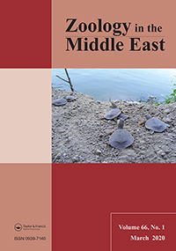

Zoology in the Middle East
Volume 66, 2020 - Issue 1

Review of the Middle Eastern species of Dolichotachina Villeneuve, 1913 (Diptera: Sarcophagidae, Miltogramminae) with the description of a new species
Yuriy Verves Liudmila Khrokalo & Olha Panchuk
Pages 68-75 | Received 25 Jul 2019, Accepted 18 Aug 2019, Published online: 17 Sep 2019

https://doi.org/10.1080/09397140.2019.1663889

Abstract
Dolichotachina separata Verves & Khrokalo, sp. n. is described based on a male from Egypt, and our knowledge of the other Middle Eastern species, Dolichotachina marginella (Wiedemann, 1830), is reviewed. The generic status of Dolichotachina vis-à-vis Metopodiella Zumpt, 1961 is discussed. A list of the 10 (including one fossil) species of Dolichotachina from the Palaearctic, Oriental and Afrotropical regions and 9 species of Metopodiella from the Afrotropical region are presented.
http://www.zoobank.org/urn:lsid:zoobank.org:pub:B8A71BDF-0CC5-493F-9B89-EB483FF90BE7
Keywords:
- Sarcophagidae
- Dolichotachina
- new species
- Palaearctic
- habits

Purchase options *Save for later
PDF download + Online access
- 48 hours access to article PDF & online version
- Article PDF can be downloaded
- Article PDF can be printed
USD 58.00Add to cart
Issue Purchase
- 30 days online access to complete issue
- Article PDFs can be downloaded
- Article PDFs can be printed
USD 141.00Add to cart
* Local tax will be added as applicable

