https://www.dl.begellhouse.com/en/journals/38cb2223012b73f2,1fd981b0251a5b49,78d0714f50b203b6.html

Volume 50, 2014 Issue 3
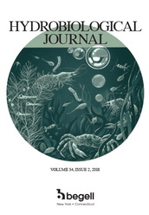
Articles
Purchase $35.00 (open in a new tab) Check subscription Download MARC record (open in a new tab) Get Permissions (open in a new tab)

Ion Processes in the Cell Membranes of the Aquatic Plants under the Toxic Substances Impact
Volume 50, Issue 3, 2014, pp. 80-89
DOI: 10.1615/HydrobJ.v50.i3.90
Get access
K. V. Kostiuk
Ternopil National Pedagogical University Ternopil, Ukraine; National Medical University Kyiv, Ukraine
V. V. Grubinko
Department of General Biology and Methods of Teaching Natural Sci. Volodymyr Hnatiuk Ternopil National Pedagogical University, 2 M. Kryvonosa Str., Ternopil 46027, Ukraine

ABSTRACT
Paper deals with functional response of membranes of the aquatic plants to impact of zinc and lead ions and diesel fuel. Membranes permeability, ion composition of the cells and role of membrane enzymes in adaptation to toxicants are considered.

KEY WORDS: aquatic plants, heavy metals, diesel fuel, sodium ions, potassium ions, magnesium ions, calcium ions, permeability of membranes, activity of membrane ATPases.

