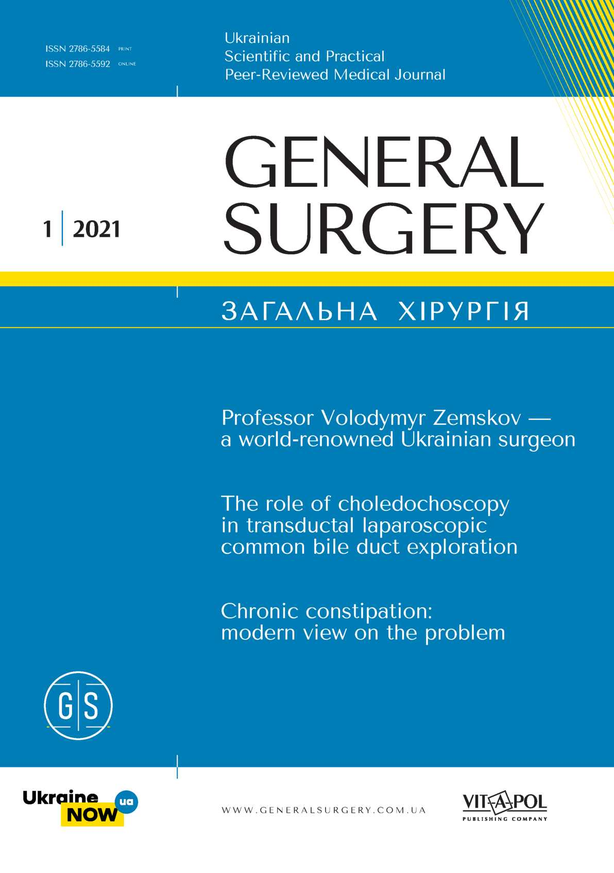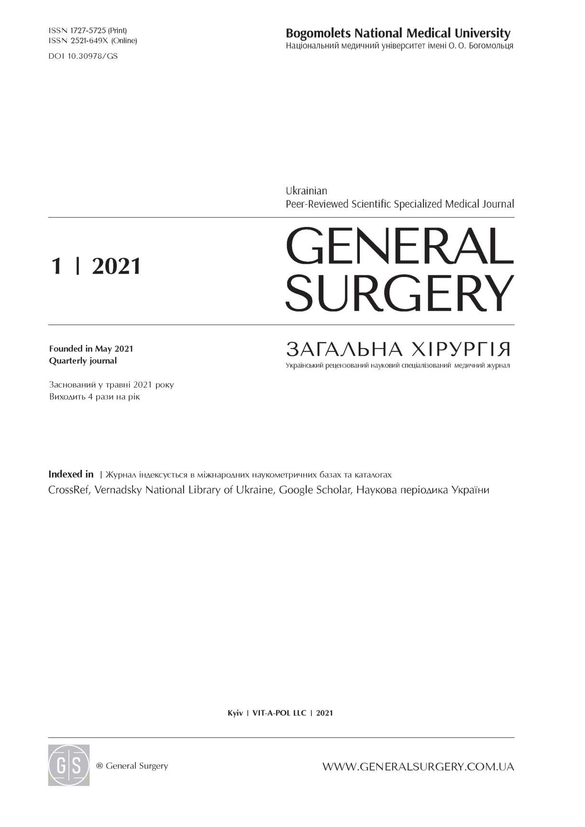

Editor-in-Chief

Susak Y. M. (Ukraine)

**Deputy Editor-in-Chief**

Ioffe O. Y. (Ukraine)

**Editorial Board**

Atamanyuk O. Y. (Ukraine), Dronov O. I. (Ukraine), Dubrov S. O. (Ukraine), Haberal M. (Turkey),

Ioffe O. Y. (Ukraine), Keck T. (Germany),

Khomiak I. V. (Ukraine), Khrapach V. V. (Ukraine), Khomenko I. P. (Ukraine), Kolosovych I. V. (Ukraine), Kopchak K. V. (Ukraine), Korpan N. (Austria),

Kucher M. D. (Ukraine), Lapshyn H. (Germany), Levchak Y. A. (Ukraine), Levytskyi A. F. (Ukraine), Plaudis H. (Latvia), Skivka L. M. (Ukraine), Sliesarenko S. V. (Ukraine), Sokolov V. V. (Ukraine), Strik M. (Germany), Tkachenko O. A. (Ukraine), Tsema I. V. (Ukraine), Unukovych D. (Sweden), Yarema R. R. (Ukraine), Zgrzheblovska L. V. (Ukraine)

**Executive Secretaries**

Markulan L. Y. ([markulan@ukr.net](mailto:markulan@ukr.net))

Teterina V. V. ([vikateterina@ukr.net](mailto:vikateterina@ukr.net))

**Founders**

Bogomolets National Medical University VIT-A-POL LLC

**Certificate of state registration**

KB No 24849-14789P granted May 7, 2021

Approved for printing by the Academic Council of Bogomolets National Medical University Protocol No 4 signed November 25, 2021

**Publishing**

VIT-A-POL LLC

Office 3, 19а Academician Yefremov St., Kyiv, 03179

Tel. +38044 298-00-60. E-mail: [vitapol3@gmail.com](mailto:vitapol3@gmail.com)

Certificate of publishing business entity DK No 4757 granted August 05, 2014

Project manager Bernyk O. M.

Translation and editing Holik O. V.

Design Mamchych V.

Signed for printing December 01, 2021 Circulation 1000 copies Publishing House Avanpost-Prim LLC 3/3 Surikova St., Kyiv, 03035 Certificate of publishing business entity DK No 1480 granted August 26, 2003

Advertisers are responsible for the content of their advertising materials.

Formal permission from the publisher is required for reprints, and citing of the primary issue is mandatory

**Головний редактор**

Сусак Я. М. (Київ)

**Заступники головного редактора**

Іоффе О. Ю. (Київ)

**Редакційна колегія**

Атаманюк О. Ю. (Івано-Франківськ), Дронов О. І. (Київ), Дубров С. О. (Київ), Haberal M. (Туреччина),

Іоффе О. Ю. (Київ), Keck T. (Німеччина),

Хом'як І. В. (Київ), Храпач В. В. (Київ),

Колосович І. В. (Київ), Хоменко І. П. (Київ),

Копчак К. В. (Київ), Корпан М. М. (Австрія),

Кучер М. Д. (Київ), Лапшин Г. В. (Німеччина),

Левчак Ю. А. (Ужгород), Левицький А. Ф. (Київ),

Plaudis H. (Латвія), Сківка Л. М. (Київ),

Слєсаренко С. В. (Дніпро), Соколов В. В. (Київ),

Strik M. (Німеччина), Ткаченко О. А. (Київ),

Цема Є. В. (Київ), Унукович Д. В. (Швеція),

Ярема Р Р (Львів), Згржебловська Л. В. (Київ)

**Відповідальні секретарі**

Маркулан Л. Ю. ([markulan@ukr.net](mailto:markulan@ukr.net))

Тетеріна В. В. ([vikateterina@ukr.net](mailto:vikateterina@ukr.net))

**Засновники**

Національний медичний університет імені О. О. Богомольця ТОВ «ВІТ-А-ПОЛ»

**Свідоцтво про державну реєстрацію**

КВ № 24849-14789Р від 07.05.2021 р.

Рекомендовано Вченою радою Національного медичного університету імені О. О. Богомольця Протокол № 4 від 25.11.2021 р.

**Видавець**

ТОВ «ВІТ-А-ПОЛ»

03179, м. Київ, вул. Академіка Єфремова, 19а, оф. 3

Тел. (44) 298-00-60. E-mail: [vitapol3@gmail.com](mailto:vitapol3@gmail.com)

Свідоцтво суб’єкта видавничої справи ДК № 4757 від 05.08.2014 р.

Відповідальний секретар Берник О. М.

Переклад та редагування тексту Голік О. В. Комп’ютерна верстка Мамчич В.

Підписано до друку 01.12.2021 р.

Наклад 1000 прим. Ум. др. арк. 11,16

Друк ТОВ «Видавничий будинок «Аванпост-Прим»

03035, м. Київ, вул. Сурикова, 3/3

Свідоцтво суб’єкта видавничої справи

ДК № 1480 від 26.08.2003 р.

Відповідальність за зміст рекламних матеріалів несе рекламодавець.

Передрук опублікованих статей можливий за згоди редакції та з посиланням на джерело

Printed on acid-free paper

Надруковано на безкислотному папері



**Зміст CONTENTS**

5 EDITORIAL

BIOGRAPHIES

6 Professor Volodymyr Zemskov —

a world-renowned Ukrainian surgeon Y. Susak, S. Zemskov, D. Dubenko

ORIGINAL RESEARCH

1. The role of choledochoscopy in transductal laparoscopic common bile duct exploration

**K. Atstupens, H. Plaudis,**

**E. Saukane, A. Rudzats**

1. The role of endoluminal interventions in the preparation of high-risk patients with super-obesity for bariatric surgery

**O. Y. Ioffe, M. S. Kryvopustov,**

1. **P. Stetsenko, T. V. Tarasiuk,**

**Y. P. Tsiura**

24 Changes in the filtration function

of the spleen after surgery following traumatic organ injuries

1. **V. Kolosovych, I. V. Hanol**

31 Totally extraperitoneal inguinal hernia repair versus Lichtenstein repair: a one-year follow-up study

1. **O. Havrylov, O. V. Shulyarenko**

36 Results obtained after the surgical

treatment of Graves’ disease depending on the levels of anti-thyroid antibodies S. L. Shliakhtych, V. R. Antoniv

СТОРІНКА РЕДАКТОРА

БІОГРАФІЇ

Професор Володимир Земсков — всесвітньовідомий український хірург Я. Сусак, С. Земсков, Д. Дубенко

ОРИГІНАЛЬНІ ДОСЛІДЖЕННЯ

Роль холедохоскопії при черезпротоковому лапароскопічному дослідженні загальної жовчної протоки

**К. Атступенс, Х. Плаудіс,**

**Е. Саукане, А. Рудзатс**

Роль ендолюмінальних втручань у підготовці пацієнтів високого ризику із суперожирінням до баріатричної операції

**О. Ю. Іоффе, М. С. Кривопустов,**

1. **П. Стеценко, Т. В. Тарасюк,**

**Ю. П. Цюра**

Зміни фільтраційної функції селезінки після оперативних втручань з приводу травматичних ушкоджень органа

1. **В. Колосович, І. В. Ганоль**

Порівняння тотальної екстраперитонеальної пластики пахової грижі та пластики за Ліхтенштейном:

1 рік спостереження

**Г. О. Гаврилов, О. В. Шуляренко**

Результати хірургічного лікування хвороби Грейвса залежно від показників антитиреоїдних антитіл С. Л. Шляхтич, В. Р. Антонів

**General Surgery** Загальна хірургія **• 2021 • №1**

***3***

**CONTENTS Зміст**

CLINICAL CASE КЛІНІЧНИМ ВИПАДОК

42 A case report

of severe acute pancreatitis with infected necrosis and concomitant Coronavirus Disease-19 (COVID-19): a nosocomial infection or delayed respiratory manifestation of viral disease?

**Y. Susak, O. Tkachenko,**

**O. Lobanova, L. Skivka**

Повідомлення про випадок тяжкого гострого панкреатиту з інфікованим некрозом та супутньою коронавірусною хворобою-19 (СОУГО-19): внутрішньолікарняна інфекція чи відтермінований респіраторний вияв вірусної хвороби?

**Я. Сусак, О. Ткаченко,**

**О. Лобанова, Л. Сківка**

48 Associated projectile inferior vena cava wound with subsequent pulmonary artery missile embolization: a case report and literature review

1. **Tsema, I. Khomenko,**

**Y. Susak, D. Dubenko**

Поєднане поранення нижньої порожнистої вени з уламковою емболією легеневої артерії: клінічне спостереження та огляд літератури

**Є. Цема, І. Хоменко,**

**Я. Сусак, Д. Дубенко**

REVIEWS ОГЛЯДИ

1. Early and late complications after gastric bypass:

A literature review **V. O. Nevmerzhytskyi**

Ранні та пізні ускладнення після шунтування шлунка.

Огляд літератури **В. О. Невмержицький**

67 Chronic constipation:

modern view on the problem. A review

1. **M. Leshchyshyn, Y. M. Susak,**

**O. I. Okhots’ka, P. L. Byk,**

**L. Y. Markulan, O. V. Panchuk**

Хронічні запори: сучасний погляд на проблему. Огляд літератури

1. **М. Лещишин, Я. М. Сусак,**

**О. I. Охоцька, П. Л. Бик,**

**Л. Ю. Маркулан, О. В. Панчук**

8O INFORMATION FOR AUTHORS ДО УВАГИ АВТОРІВ

***4***

**General Surgery** Загальна хірургія **• 2021 • №1**

Original Research *Оригінальні дослідження*

UDC **616.34-007.43-031:611.957-089.844-089.12 ISSN 2786-5584 (Print)**

DOI <http://doi.org/10.30978/GS-2021-1-31> **ISSN 2786-5592 (Online)**

**Totally extraperitoneal inguinal hernia repair versus Lichtenstein repair: a one-year follow-up study**

H. O. Havrylov 1, O. V. Shulyarenko 2

1. Clinic Medikom, Kyiv
2. Bogomolets National Medical University, Kyiv

**Oleg Shulyarenko:** [oleg.v.shu@gmail.com](mailto:oleg.v.shu@gmail.com)

1. **O. Havrylov,** <http://orcid.org/0000-0002-8425-8134>

**O.V. Shulyarenko,** <http://orcid.org/0000-0002-6780-8587>

The inguinal hernia has an incidence of 27—43 % in males. Surgical repair is the most accepted treatment to prevent the development of complications. Laparoscopic inguinal hernia repair has become popular worldwide and includes the use of a laparoscopic technique for mesh placement behind the defect.

Objective — to assess whether totally extraperitoneal (TEP) inguinal hernia repair shows benefits over Lichten­stein repair in intraoperative and one-year follow-up postoperative outcomes for male patients with primary unilateral inguinal hernia.

Materials and methods. 53 males were randomly allocated to two groups. Group 1 included 27 patients who underwent totally extraperitoneal hernia repair using self-gripping lightweight mesh, and group 2 included 26 patients who were treated surgically with Lichtenstein repair using lightweight mesh.

Results. Both groups were comparable in mean age, type of hernia, body mass index and patient’s distribution according to the European hernia society classification. TEP repair takes on average a little less time as compared to Lichtenstein repair, and this difference is not statistically significant. The mean of visual analogue scale for pain scoring in the first 24 hours after surgery as well as in the next 24 hours is statistically significantly smaller in group 1 compared to group 2. The mean time taken to return to work was 2.15 times longer in group 2 than in group 1, and the difference was statistically significant.

Conclusions. Totally extraperitoneal hernia repair shows potential benefits over Lichtenstein repair for primary unilateral inguinal hernias as it causes less pain in the postoperative period and ensures early return to work.

Keywords

totally extraperitoneal hernia repair, Lichtenstein repair, inguinal hernia, surgery

ARTICLE • Received 2021-10-18 • Received in revised form 2021-11-01 © General Surgery, 2021

The inguinal hernia has an incidence of 27—43 % in males. Surgical repair is the most accepted treat­ment to prevent the development of complications [6, 12, 13]. Mesh repair is generally preferred in in­guinal hernia surgery. Open non-tension mesh hernioplasty has been the «gold standard» in inguinal hernia surgery for a long time [1]. At first, the lapa­roscopic inguinal hernia repair (LIHR) was intro­duced by R. Ger et al. in 1990 [5]. LIHR has become popular worldwide because laparoscopic placement of mesh behind the defect where, according to La­place’s Law, the same forces that cause hernia are used to reinforce the repair [4]. The totally extraper­itoneal method (TEP) established by J. L. Dulucq in

Europe allows access to the pre-peritoneal space and avoids the need for a peritoneal incision [3].

Objective — to assess whether totally extraperi­toneal inguinal hernia repair shows benefits over Lichtenstein repair in intraoperative and one-year follow up postoperative outcomes for male patients with primary unilateral inguinal hernia.

**Materials and methods**

53 males with primary unilateral inguinal her­nia were enrolled in the study and operated in the clinic «Medikom» from 2016 to 2019 years. Pa­tients over 18 years of age with primary unilateral

**General Surgery** Загальна хірургія **• 2021 • №1**

***зі***

*H. O. Havrylov, O. V. Shulyarenko*

evident uncomplicated inguinal hernia who fit for both laparoscopic and open approach were included in the study. All of them were randomly allocated to two groups: group 1 included 27 patients who un­derwent totally extraperitoneal inguinal hernia re­pair by our method (patent of Ukraine No 102998) using electric bipolar welding hemostasis and self-gripping lightweight mesh with polypropylene fi­bers and polylactic acid micro hooks, and group 2 included 26 patients who were treated surgically with Lichtenstein repair [10] using electric bipolar welding hemostasis and lightweight mesh. Preop­erative evaluation was based on proper analysis of the medical history, full clinical examination, labora­tory investigations and ultrasound of the abdominal cavity, pelvis and inguinal area. Early postoperative therapy included pain relievers, correction of cardio­vascular and respiratory disorders, antibacterial and anticoagulation therapy. Table shows patient demo­graphics and patient distribution in both groups ac­cording to the European hernia society (EHS) in­guinal hernia classification [11].

The following parameters were evaluated: oper­ating time, pain severity within the first 24 hours and within the next 24 hours after surgery (using 10-balls VAS score), postoperative complications over a 12-month follow-up period, mean time taken to return to work.

The statistical software package was used in this study. The independent ‘t’ test was used to compare age, operating time, severity of postoperative pain, mean time taken to return to work. Quantitative data are presented as mean and average deviation from the mean (M ± m). p < 0.05 was considered sta­tistically significant. Patient distribution based on EHS-classification and on direct/indirect inguinal hernia type were were analysed by Chi-square test (X2). p < 0.05 was considered statistically significant.

**Results and discussion**

Table shows that the difference in mean age, type of hernia, body mass index and patient distribution according to the EHS classification was not statisti­cally significant between the two groups. Therefore, both groups were comparable.

Indirect hernia appeared to be the most common type of hernia in both groups.

The operating time in minutes was 36.78 ± 0.61 in group 1 and 37.08 ± 0.82 in group 2 (p > 0.05). The difference is not statistically significant. It means that the TEP repair takes on average a little less time as compared to Lichtenstein repair.

In group 2 both inguinal nerves were recognized in 14 (53.85 %) patients, the ilioinguinal nerve in

Table. **Patient demographics and patient distribution in both groups according to the European hernia society inguinal hernia classification**

|  |  |  |
| --- | --- | --- |
| Variable | Group 1 | Group 2 |
| Age, years | 39.7 ± 2.08 | 38.62 ± 2.33 |
| (19—60) | (18—61) |
| Inguinal hernia type direct/indirect | 5/22 | 4/22 |
| Body mass index, kg/m2 | 24.15 ± 0.35 | 23.96 ± 0.38 |
| European hernia society inguinal | hernia classification | |
| PM1 | 1 | 1 |
| PM2 | 3 | 2 |
| PM3 | 1 | 1 |
| PL1 | 4 | 5 |
| PL2 | 12 | 10 |
| PL3 | 6 | 7 |

All p > 0.05.

Quantitative data are presented as mean and average deviation (M ± m).

The data range is given in brackets.

1. (15.38 %) patients, the iliohypogastric nerve in 3 (11.54 %) patients, and no nerves in 5 (19.23 %) patients.

The pain score during the first 24 hours after sur­gery was 2.41 ± 0.11 balls in group 1 comparing to 3.04 ± 0.17 in group 2 (p < 0.05). It suggests that the difference in pain score was significant, so we can conclude that within the first 24 hours patients in group 1 had a less pain score compared to group 2.

The pain score within the next 24 hours was

1. ± 0.09 (M ± m) balls in group 1 versus 1.88 ± 0.09 in group 2 (p < 0.05). The difference is statistically significant. Thus, within the first 24 hours and within the next 24 hours, patients in the laparo­scopic group experienced less pain than patients in the open surgery group.

In group 1, the postoperative complications were noted in 1 (3.7 %) patient who developed port site seroma. The seroma was punctured under ultra­sound supervision.

In group 2, the postoperative complications oc­curred in 2 (7.69 %) patients. One of them devel­oped surgical wound seroma, another one devel­oped surgical wound hematoma. All these patients underwent puncture under ultrasound supervision, and the hematoma was coagulated.

***32***

**General Surgery** Загальна хірургія **• 2021 • №1**

*H. O. Havrylov, O. V. Shulyarenko*

The mean time taken to return to work was 7.96 ± 0.15 (M ± m) days in group 1 and 17.08 ± 0.17 (M ± m) days in group 2 (p < 0.05).

No wound infection, chronic pain, or recurrence was found in both groups over a 12-month follow- up period.

Surgical equipment and surgical techniques are constantly evolving, so the surgeons can choose from the most popular ones. To quote J. Bruce of Edinburgh: «The final word on hernia will probably never be written» [9]. The introduction of tension­free repair using prosthetic mesh represented a new era in inguinal hernia repair [14]. Nonabsorbable mesh types such as polypropylene, polytetrafluorethylene, and polyester were initially used for her­nia repair. Among these, heavy polypropylene mesh was most commonly used because it had many ben­efits such as being flexible, strong, easily cut, read­ily integrated by surrounding tissues, and resistant to the infection. However, postoperative pain and foreign body sensation constantly bothered pa­tients, and thus lightweight and ultralightweight meshes were developed. However, although the use of the lightweight mesh resulted in much less postoperative pain and reduced foreign body sen­sation compared with the use of the heavyweight nonabsorbable mesh, decreased intraoperative control and increased recurrence rates were more common. To maximize both intraoperative control and postoperative comfort as well as minimize the recurrence rates, partially absorbable prostheses have been recently developed and are made up of nonabsorbable materials, such as polypropylene as a standard, and absorbable materials, such as polyglactin that allows leaving less foreign material in the recipient’s body without compromising the me­chanical resistance [15].

Preperitoneal mesh reinforces the internal in­guinal ring, the Hesselbach’s triangle and annulus femoralis, where the inguinal hernia sac develops. Therefore, preperitoneal repair is indicated for the treatment of indirect, direct and femoral hernias. The mesh was used in group 1. It is made up of monofilament polyester and a resorbable polylactic acid gripping system which perfects true tension­free repair. The microhooks cover the entire upper side of the material and allow anchoring the mesh to the tissue. Therefore, a smaller suture is required, and there is less chance of nerve entrapment that can be a reason for postoperative pain. Thus, the use of such self-fixing mesh in laparoscopic surgery is safe and feasible and may reduce postoperative pain. Our study confirms the hypothesis that the fixation of the mesh with sutures in group 2 is a time-con­suming procedure and accounts for the majority of

the operating time. Consequently, open mesh repair is much more appropriate for all varieties of ingui­nal hernias such as sliding, irreducible, strangulated hernia as well as for patients with co-morbidity [2].

Seromas are known to be the most common post­operative complication after TEP inguinal hernia repair [15], and they also occurred most often in this study.

The mean of VAS for pain scoring within the first

1. hours after surgery as well as within the next 24 hours gives evidence of less severe acute pain in the laparoscopic repair group as compared to Lictenstein repair group and this difference is statistically significant. TEP repair produced less surgical trau­ma than open Lichtenstein hernia repair method. This result is similar to the results obtained in simi­lar comparative studies done in the past [7, 8].

The mean time taken to return to work was 2.15 times longer in group 2 than in group 1. It also con­firms the fact that TEP repair produced less surgical trauma than open Lictenstein hernia repair method.

There were no life-threatening complications, no recurrence of hernia over a 12-month median fol­low-up period in both groups. However, additional studies are necessary for further investigation of the previously observed recurrences.

The laparoscopic approach provides magnifica­tion of the surgical field for inspection of the entire myopectineal orifice well, allowing surgeons to re­pair any unexpected hernias simultaneously. Conse­quently, the recurrence rate can be reduced [3]. Our study noted the following benefits of laparoscopic surgery: less pain in the postoperative period, faster recovery and appropriate safety.

In this study, no mortalities were documented. In the literature, the mortality rate after an elective hernia repair doesn’t exceed 0.2 % and is related to the existing comorbidities [13].

**Conclusions**

Totally extraperitoneal hernia repair shows poten­tial benefits over Lichtenstein repair for primary unilateral inguinal hernias as it ensures less pain in the postoperative period and early return to work. Continuous innovations and improved technolo­gies will ultimately determine whether totally ex­traperitoneal hernia repair will become a generally accepted method in surgery.

A**cknowledgements**

**The authors gratefully acknowledge the support of the Bogomolets National Medical University administration and the Clinic «Medikom» administration and its staff.**

**General Surgery** Загальна хірургія **• 2021 • №1**

***33***

*H. O. Havrylov, O. V. Shulyarenko*

D**eclaration of interests**

**Authors declare that they have no conflicts of interest. Funding. No grants or support were used in this study.**

E**thics approval and written informed consents statements**

**All procedures, performed in the study and involving human participants, were carried out in accordance with the ethical standards of the institutional and/or national research committee and with the 1964 Helsinki declaration and its later amendments or comparable ethical standards.**

**Written informed consent was obtained from all individual participants included in the study.**

A**uthor contributions**

1. **O. Havrylov: the implementation of the research;**

**O. V. Shulyarenko: to the design of the research, the analysis of its results and manuscript writing.**

R**eferences**

1. Anadol AZ, Akin M, Kurukahvecioglu O, et al. A prospective comparative study of the efficacy of conventional Lichten­stein versus self-adhesive mesh for inguinal hernia. Surg Today 2011;41(11):1498-503. <https://doi.org/10.1007/s00595-011-> 4545-8.
2. Bowling K, El-Badawy S, Massri E, et al. Laparoscopic and open inguinal hernia repair: Patient reported outcomes in the elderly from a single centre-A prospective cohort study. Annal Med Surg. 2017 Oct;22:12-5 <https://doi.org/10.1016/j.amsu.2017.08.013>
3. Dulucq JL, Wintringer P, Mahajna A. Laparoscopic totally extra­peritoneal inguinal hernia repair: lessons learned from 3100 her­nia repairs over 15 years. Surg Endosc 2009;23:482-6. <https://doi>. org/10.1007/s00464-008-0118-3.
4. Feleshtynsky YaP, Shtaier A. An improved transabdominal pre- peritoneal alloplast for recurrent inguinal hernias after Lichten­stein’s surgery. EUREKA: Health Sciences.; 4 (2020):77-81. doi: 10.21303/2504-5679.2020.001364.
5. Ger R, Mishrick A, Hurwitz J, Romero C, Oddsen R. Management of groin hernias by laparoscopy. World J Surg. 1993;17(1):46-50 <https://doi.org/10.1007/BF01655704>.
6. Hachisuka T. Femoral hernia repair. Surg Clin N Am. 2003;83:1189-1205. <https://doi.org/10.1016/S0039-> 6109(03)00120-8.
7. Ielpo B, Duran H, Diaz E, et al. A prospective randomized study comparing laparoscopic transabdominal preperitoneal (TAPP) versus Lichtenstein repair for bilateral inguinal hernias. Am J Surg. 2017 Jul 19: S0002-9610(17)30662-1. <https://doi.org/10.10l6/>]. amjsurg.2017.07.016.
8. Kozol R, Lange PM, Kosir M, et al. A prospective, randomized study of open vs laparoscopic inguinal hernia repair. An assess­ment of postoperative pain. Arch Surg. 1997;132(3):292-5. <https://doi.org/10.1001/archsurg.1997.01430270078015>
9. Legutko J, Pach R, Solecki R, et al. The history of treatment of groin hernia. Folia Med Cracov. 2008;49:57-74.
10. Lichtenstein IL, Shulman AG, Amid PK. Twenty questions about hernioplasty. The American surgeon. 1991;57(11):730-3.
11. Miserez M, Alexandre JH, Campanelli G, et al. The European hernia society groin hernia classification: simple and easy to remember Hernia. 2007;11:113. <https://doi.org/10.1007/s10029-> 007-0198-3.
12. Nichitailo ME, Bulik II. Sovremennye aspekty endovideokhirur- gicheskogo lecheniia slozhnykh i retsidivnikh pakhovykh gryzh [Modern aspects endovideosurgical treatment of complex and recurrent inguinal hernias]. Klin Khirurgiia. 2010;(3):10-6. Rus­sian.
13. Simons MP, Smietanski M, Bonjer HJ, et al. International guide­lines for groin hernia management. Hernia Surge Group. Hernia. 2018;22 : 1-165. <https://doi.org/10.1007/s10029-017-1668-x>.
14. Usher FC. Hernia repair with knitted polypropylene mesh. Surg Gynecol Obstet. 1963;117: 239-40.
15. Yang HW, Kang SH, Jung SY, Min BW, Lee SI. Efficacy and safety of a novel partially absorbable mesh in totally extraperito­neal hernia repair. Annals of surgical treatment and research. 2017;93(6):316-21. <https://doi.org/10.4174/astr.2017.93.6.316>.

**Порівняння тотальної екстраперитонеальної пластики пахової грижі та пластики за Ліхтенштейном: 1 рік спостереження**

Г. О. Гаврилов, О. В. Шуляренко 2

1. Клініка «Медіком», Київ
2. Національний медичний університет імені О. О. Богомольця, Київ

Пахова грижа виникає у чоловіків у 27—43 % випадків. Хірургічне втручання — найбільш прийнятний метод лікування, що дає змогу уникнути розвитку ускладнень. Лапароскопічна пластика пахової грижі набула популярності у світі завдяки лапароскопічному встановленню сітки за дефектом.

Мета — оцінити переваги тотальної екстраперитонеальної пластики пахових гриж порівняно з операці­єю Ліхтенштейна в інтраопераційний період і протягом 1 року після операції у пацієнтів чоловічої статі з первинною однобічною паховою грижею.

Матеріали та методи. Випадковим чином 53 пацієнти розділили на дві групи залежно від способу ліку­вання: 1-ша (п = 27) — тотальна екстраперитонеальна пластика з використанням полегшеної сітки, яка самофіксується, 2-га (п = 26) — операція Ліхтенштейна з використанням полегшеної сітки.

***34***

**General Surgery** Загальна хірургія **• 2021 • №1**

*H. O. Havrylov, O. V. Shulyarenko*

Результати. Обидві групи були однорідні за середнім віком, типом грижі, індексом маси тіла та розподі­лом пацієнтів за Європейською класифікацією герніологів. Тривалість виконання тотальної екстраперитонеальної пластики пахових гриж в середньому була статистично незначущо дещо меншою порівняно з операцією Ліхтенштейна. Середнє значення за візуальною аналоговою шкалою для оцінки болю про­тягом перших 24 год після операції, а також протягом наступних 24 год було статистично значущо менше в 1-й групі. Середня тривалість відновлення працездатності в 2-й групі була в 2,15 рази статистич­но значущо більшою, ніж у 1-й.

Висновки. Потенційні переваги тотальної екстраперитонеальної пластики порівняно з операцією Ліхтенштейна в хірургії первинних однобічних пахових гриж полягають у меншій інтенсивності післяопе­раційного болю і швидшому відновленні працездатності.

Ключові слова: тотальна екстраперитонеальна пластика грижі, операція Ліхтенштейна, пахова грижа, хірургія.

**Автори**

**Шуляренко Олег Володимирович:** [oleg.v.shu@gmail.com](mailto:oleg.v.shu@gmail.com)

**Г. О. Гаврилов, лікар-хірург, завідуючий хірургічним відділенням,** <http://ordd.org/0000-0002-8425-8134>

**О. В. Шуляренко, лікар-хірург, к. мед. н., асистент кафедри загальної хірургії № 2, http://orcid.org/0000-0002-6780-8587**

**FOR CITATION**

I Havrylov HO, Shulyarenko OV. Totally extraperitoneal inguinal hernia repair versus Lichtenstein repair: a one-year follow-up study. General Surgery (Ukraine). 2021:1;31-35. <http://doi>. org/10.30978/GS-2021-1-31.

**General Surgery** Загальна хірургія **• 2021 • №1 35**